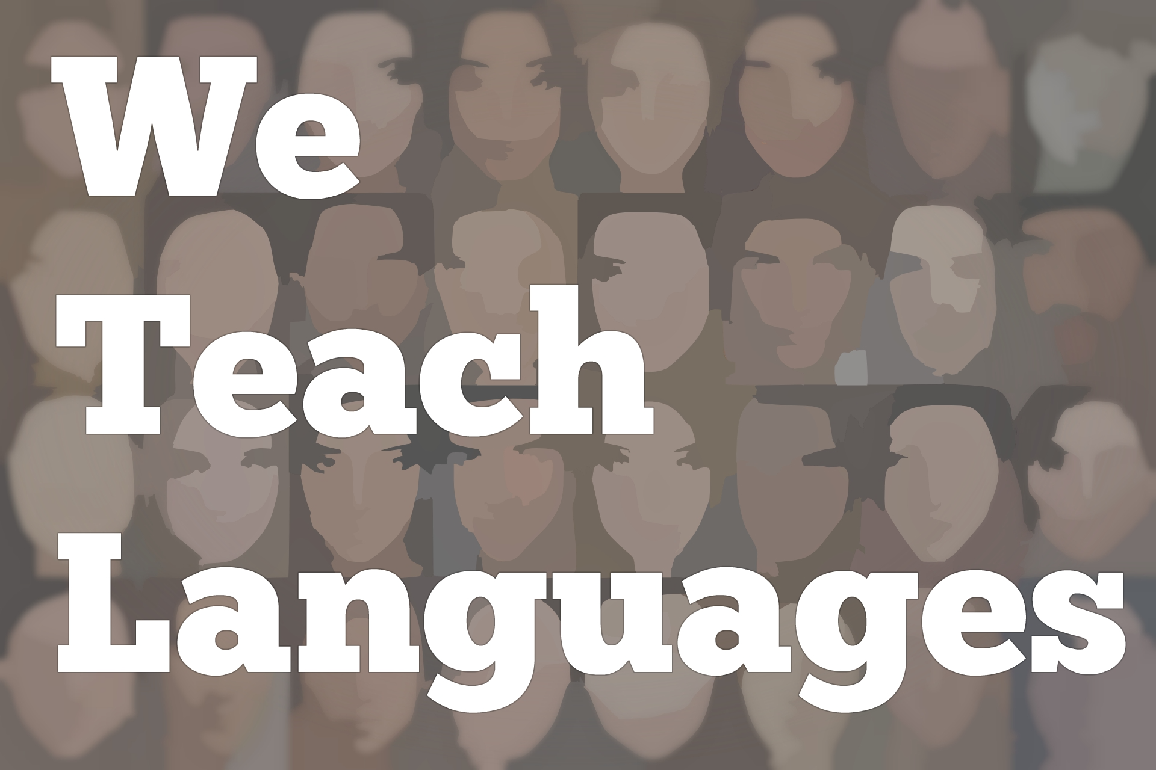
Ep-105-Mandy-Amy-Part-II

Stacey Margarita Johnson: [0:01] This is "We Teach Languages," a podcast about language teaching from the diverse perspectives of teachers.
[0:10] [music]
Stacey: [0:15] I'm Stacey Margarita Johnson. Today on Episode 105, we return to my interview with Mandy Manning, the 2018 National Teacher of the Year, and Amy Andersen, the 2018 New Jersey Teacher of the Year, both of whom happen to be language teachers.
[0:35] Mandy teaches English as a Second Language. Amy teaches American Sign Language. In this second half of my interview with them, we are going to turn our attention to advocacy and policy. You're going to hear some amazing stories about the power of language and language advocacy.
[0:57] After you listen, if you want to know more about Mandy's organization, Teachers Against Child Detention, I have made sure to put a link to that and a few other things in the show notes.
[1:10] To get started, I asked Amy about how her students are making use of the Seal of Biliteracy in her American Sign Language program.
[1:20] [music]
Amy Andersen: [1:24] Seal of Biliteracy, I was part of the pilot program. My ASL students at the high school were the first, I mean definitely in our high school and some of the first to participate. We've participated every year. This year, I think 8 out of 11 passed, and the bar to pass is pretty difficult.
[1:43] It's the same requirement that's given to teacher candidates to become teachers of the deaf or educational interpreters after four years of college. It's the same score.
Stacey: [1:53] Wow.
Amy: [1:54] Seal of Biliteracy, it is definitely a huge motivator. Then, giving just rewards where they're deserved.
Mandy Manning: [2:08] I just want to add, too, what a benefit it's been for my students to do the Seal of Biliteracy, as well. We now have it set up in our community to where my students can immediately take the test in their first language.
[2:27] A lot of my kids end up being able to forego the language requirement by demonstrating fluency in their first language, which then gives them the Seal of Biliteracy when they graduate.
Stacey: [2:39] That's wonderful. Do you have other partnerships with other institutions or other groups that maybe help you create a university pipeline or help you find your students other opportunities?
Amy: [2:51] Yeah. There's a local university, Stockton University. Mandy actually visited on Monday. They asked her to come and talk all about Teachers Against Child Detention with their students. I just started teaching as an adjunct at Stockton. My ASL students got to then go and hear Mandy, which is awesome.
[3:13] One of the things that came about in collaboration with a deaf professor at Stockton who teaches deaf studies and creative writing, and she's an author, and then there's a senior who's also deaf. She's my teaching assistant. Every time we're in class, there's a deaf expert in class with the students.
[3:35] Anyway, the three of us work together because they had American Sign Language in their health sciences department labeled as a communication disorder within disability studies. The deaf student, Jan, actually is the one who started the movement last year, and got a petition. It was all over Facebook, in "Deaf News."
[3:59] This year, when I started, we had some meetings and, finally, we're able to get...They were calling it sign language, called American Sign Language because that's what it is, and moved into the language department. Then they added two more levels.
[4:13] As soon as we can find an amazing deaf professor or fluent ASL professor that would like to come in and start a program, they really want it. We're moving towards having ASL minor at that university.
Stacey: [4:27] That's amazing. That's a huge success story. That's amazing.
[4:32] [audio skips]
Stacey: [4:32] [laughs]
Mandy: [4:32] incredible things in her state and with her local universities. There's legislation that is passing because of this woman.
Stacey: [4:47] I want a summary of the legislation.
Amy: [4:49] There are two national bills that have become laws in some states. One is LEAD-K, it's L-E-A-D--K. That's language equality accessibility for all deaf children so that they can be kindergarten-ready. That focuses on ages zero to five, and language access, a balance of information to parents.
[5:12] Typically, when a baby is diagnosed as deaf within the first couple of days of birth, then the first people that the parents talk to were doctors who will often say, "We're so sorry." Understandably, hearing parents are grieving, and what are we going to now do because they didn't take ASL, fall in love, and become part of deaf culture.
[5:35] It's scary. Doctors will say, "We'll, there's a way to fix this." We can talk about hearing aids, or, we can talk about this operation, neither of which are real conversions into becoming hearing, just isn't necessary, anyway.
[5:50] Parents don't get the other side of the information, which is, there's this beautiful thriving community with arts and literature, in theater, in history, a shared language, who are PhD, in the highest of academia, or lawyers, or doctors.
[6:09] ASL was their link to building a foundation in the language that's 100 percent accessible instead of expecting babies to learn a spoken language through the movement of lips, when only 30 percent of the language is understandable by moving of the lips.
[6:27] That's just ridiculous. We may put those things in place. One of them is a deaf education advisory committee that's part of the New Jersey Department of Education. That has already been put in place. I'm part of that committee. LEAD-K has now been passed through the Senate Education Committee, the Assembly Education Committee, Senate Appropriations that passed on the full Senate floor.
[6:55] Now, we just have to do Assembly Appropriations in Assembly Floor, then it'll be ready to be signed by the governor. New Jersey would be, I think, the 14th state to have that been passed as a law. From K-12, there's the Deaf Child Bill of Rights that protects children's rights and sets up a standard for assessing benchmarks.
[7:22] Not just having this attitude, "OK. Well, that's good enough." "They did OK." No. We can have the same exact expectations for our deaf students and we should. Those two pieces of legislation are getting close. They're on the way to going through, which is amazing.
[7:42] I worked in conjunction with a group of deaf advocates, as well, and professionals in getting that through. Then there was a proposal that I wrote with some deaf colleagues also to modify the Early Intervention that's currently in place. This goes back to the woman I was talking about in our deaf community, who then started working in one of the daycares.
[8:08] Your 65 percent of parents with children are both working. They're not home with their child. The current Early Intervention system all over the country is family-centric so that provider goes into the home for an hour, they do their thing, and then the parents are home with the baby the rest of the week and can implement those strategies.
[8:28] That's not reality. There's a little, [inaudible] , who was 18 months old, in daycare for 10 hours a day with his hearing twin. I was his teacher for the deaf for Early Intervention. His mom was super excited, and learning and taking ASL classes on her own.
[8:45] It didn't matter how much that happens because we figured out, it was like 60 percent of his waking hours were in a daycare where nobody signed. He had zero access to language. There was no progress happening. It just seemed common sense your teachers in the daycare are not certified teachers.
[9:08] They do not meet certification requirements. Why not find a deaf daycare worker with the same qualifications or background to come in and be that language model? It was a big fight.
[9:23] His mother had to really be like this fierce mama bear not giving up, not accepting no because they were like, "Well, we've never done that before," like New Jersey Early Intervention. "On this form that we fill out, there's no space that says deaf ASL specialist." [laughs]
[9:42] I was like, "All right. Then, we're going to do something that says paraprofessional, [inaudible] . That's what we're going to check." Then, "Well, can we find a deaf volunteer?" I was like, "No. I am a native user of this language to come in for free but, me, as a hearing person, I'm going to then take it..." No, that's totally disrespectful.
[10:06] Then the last thing was there's very few people in this area who could probably do it. When I was like, "Actually, here's 20 copies of the resume of somebody that I know who would love to do this."
Stacey: [10:18] [laughs]
Amy: [10:21] They said, "All right. We'll give it a try," and this little boy's language just exploded like a meteor.
Stacey: [10:29] He was desperate for input. That's all that was missing.
Amy: [10:33] Yup, and as soon as he got it, we can see videos of him [inaudible] before she started working with him and it's just this blank cut off, like, "What on earth is going on around me?" Then afterwards, he's completely connected and talking about the moon and why is the moon in the sky and it's daylight hour, and where is the dog that always shows up in the morning? He's like two.
Stacey: [10:55] That sounds like a two-year-old.
[10:57] [laughter]
Stacey: [11:00] That's wonderful. Anyway, I'm just thinking about how critical it is for language development to be saturated with input at that age and how this child was at risk. Because of the work you've done, he's on a path to success in his native language. That's amazing.
Amy: [11:25] Yeah.
[11:25] [crosstalk]
Stacey: [11:25] Thank you.
Amy: [11:25] I feel it's very flabbergasting to me, because it's not this Amy Anderson idea. You need to have, what goes in is what's going to come out.
Stacey: [11:34] [laughs] Yeah.
Amy: [11:35] Why are we doing this? Anyway, the proposal then, that I submitted to the legislators was, "Can we now add that service?" There was a nice, little spot on the paper that people can check off, and do that for deaf babies all over New Jersey.
[11:52] They said yes and they gave us $550,000 last year. They just renewed it again for another year. It was like three weeks ago. We had our first training for 28 deaf adults to become deaf mentors. That training will continue and that was paid for by the money from the proposal.
[12:13] Then the following weekend, they had our schools for the deaf, Katzenbach School for the Deaf, posted it's first play group with deaf babies. 11 families went. It was free, but it was financed by the workers by that proposal. That's the exciting part, and I get, going into that room with it's, "Here's all 28 deaf-adult," like, "Here, it's happening," and seeing it come to fruition.
[12:39] Also, giving those well-deserved employment opportunities to really skip book knowledgeable. That's our gold mine and we're not tapping into it. Now, those employment opportunities with the adults as well, so it's a win-win for everybody, but especially for the babies.
Stacey: [13:00] I think about all the other hearing babies at Kohl's Daycare also, who are now becoming bilingual because they have access to a second language 10 hours a day at school.
Amy: [13:10] It's so cool.
Mandy: [13:11] It makes me think about Amy talked about my two deaf students.
Stacey: [13:16] Yes, I would love to hear more about that.
Mandy: [13:21] They came from Syria in 2016. Our assumption was that they had just recently become deaf, but it didn't take me very long...
Stacey: [13:30] [laughs]
Mandy: [13:30] to realize that they were not gaining anything from being in class, and so there was no output. There was none, like zero output. I was like, "If they had any kind of hearing, there would at least be noises."
[13:48] There was nothing, so I figured out that they were profoundly deaf. Just relating it back to this story about Paul. These kids were 15 and 16 when they came into my class and born deaf. I finally found out that indeed they were born deaf. The family has four kids and three of them are deaf.
Stacey: [14:08] Interesting.
Mandy: [14:09] Yeah, both hearing parents. It's an interesting situation. Their entire life in Syria, they were just in regular school, so they never learned Arabic. They didn't know sign language. Here are these kids, 15 and 16 years old, with no language.
[14:24] That's why the work that Amy is doing is so important, because how can you grow up having no input for 15, 16 years of your life until you're old enough to be able to advocate for yourself? These kids, because they're brand-new refugee kids, they can't advocate for themselves. That's where I came in.
Amy: [14:48] Talk about what you did.
[14:49] [laughter]
Stacey: [14:50] Yeah, I would love to hear that, because the research, actually, isn't very optimistic for a 15-year-old who has never been taught language.
Mandy: [14:58] First of all, both of the kids are different. One's a girl and one's a boy. The girl happens to be really amazing, academically minded. She just knows what it means to be a student, so she has been picking it up quite well.
[15:12] The boy is struggling more because he needs more patience. It took me a really, really long time to even get someone to believe me, that they were both certainly deaf, because around the district was that they just needed AM/FM systems and that this was going to magically make it, so that they could hear me and then...
[15:31] [laughter]
Amy: [15:32] To amplify zero.
Mandy: [15:33] Yes. [laughs] Finally, I tried all these different avenues. We have so much bureaucracy within our school systems that one lone teacher in my school district is huge. One lone teacher reaching out to audiology, it'd be like, "No, no. These kids are actually deaf," just wouldn't work. They just wouldn't listen to me.
[15:55] I just happened to run into this school nurse in the workroom one day. I was like, "Can you help me with this? I can't get anyone to listen to me. These kids need something else."
[16:06] It was now getting close to the end of the semester. These poor kids are sitting in my class, brand-new, learning nothing. They were copying from those board and they're not understanding anything. They just know that they're supposed to write something down. Finally she, because school nurses are really amazing, [laughs] very assertive...
Stacey: [16:30] For those of us that are lucky enough to have a school nurse these days.
Mandy: [16:35] That's including four, five school nurses [inaudible] . She helped me get connected with the people that I need to get connected with. I don't know why they listened to her but not me. I don't know, but they did.
[16:48] Finally, I got audiology to come along and recognize that these kids were profoundly deaf, and that maybe we needed to look into some sign language support, but they needed something more than that immediately. The school nurse also helped me find a deaf instructor out in the community who was offering free ASL classes.
[17:08] Because we were so far behind, and because I knew these kids needed something right away, I went to the classes with them. That's where I started to learn sign language, so we were learning sign language together. Then I started to use that sign language in class with the students as well.
[17:28] That was this added benefit, because sign language is actually quite intuitive. A lot of the signs make very much sense when you're using them along with oral language, and so I started to implement sign language along with our instruction language learning in the class.
[17:48] The kids were starting to communicate then with their peers. They were developing friend groups. They started to have community and then because of that, ASL class outside of school, they got connected with the deaf community in Spokane.
[18:03] Their families started to do social things with the deaf community. They have this big fair that all the deaf families go to, and they got to go to that. I got to go to that that year. That was really fun and interesting.
[18:17] My family was learning sign language, but one thing that I didn't expect to come out of that, I had another student who had some learning difficulties because he had an illness that had caused him to have several minor stroke, and once he started to learn sign language, he started to learn.
[18:37] It was the most interesting thing, because he is a hearing student, but for whatever reason, when we started to use the sign language, he was able to make that connection. Then his learning started to grow. We had all of these benefits from bringing in this additional language into our classroom.
[19:00] We do talk a lot about what does it mean if a kid is 14, 15, 16 years old and they don't have language. These kids are showing us that it's never too late. It's never to late to learn and it took me a year and a half. I'm going to admit that. It took me a year and a half to finally get everyone on board. They both have interpreters, because there was some boopiness with that as well.
Stacey: [19:22] [laughs]
Mandy: [19:22] They both have their own interpreter, who goes to classes with them. They've upped the amount of sign language instruction they have at school and they're still going to the sign language classes on their Saturdays.
[19:34] It's been really amazing that just a little bit of advocacy, because people also are like, "Oh, you spend so much time," which it really isn't. It's like 15 minutes extra to send emails or to go down and have a conversation.
Stacey: [19:47] Mandy, you just told me that you started learning an additional language alongside of your kids outside of your job?
Mandy: [19:56] Yeah.
Stacey: [19:57] That's more than a little advocacy. You've...
Amy: [19:59] [laughs] Every Saturday.
Stacey: [20:01] really done something wonderful for them. Was it mandated by your job or you just took it upon yourself?
Amy: [20:07] It's the right thing to do.
Mandy: [20:08] Yeah, most educators, I'm not going to say that they'll spend their Saturday learning sign language, but I'm also. I love learning languages. We, at our heart, want to do what's best for our kids.
[20:22] Sometimes, that means we spend a lot of extra time learning something new ourselves, so that we can be there for our kids, but at the end of the day, yes, I will admit that going to the sign language classes was something that was extra, but I'm talking about the advocacy because I very well could have just not done that part.
[20:43] The benefits to my entire class could not have been there and I would have missed out on a really great opportunity for not only these two kids but for all the kids.
Stacey: [20:54] I'm really interested in this idea of students who are learning English as a Second Language in pretty difficult circumstances, because of their age and the trauma that they've experienced and whatnot, or because of other learning differences or [laughs] physical differences.
[21:13] Then ASL provides them with a non-threatening third thing to learn, which seems like we shouldn't add more learning but actually it unifies them and it brings joy and allows for different levels of communication. It seems this is totally non-intuitive but I can completely see why it would work.
Mandy: [21:35] Yes, we know in language learning, we use total physical response. We're encouraged to gesture. Why wouldn't we use sign language?
Stacey: [21:46] Why not use an existing complete language system?
Amy: [21:50] Yes, talk about Teachers Against Child Detention. That's amazing, that what you've done.
Mandy: [21:56] That's OK. As a teacher of immigrant students, we can't be detaining immigrant children in prison. That's what Teachers Against Child Detention is about. If anyone wants more information, they can go to the website teachersagainstchilddetention.org and figure out how to get involved.
Stacey: [22:16] I know for a fact that many language teachers are passionate about that issue and working on it from different angles, we'll be able to send a lot of traffic your way.
Mandy: [22:26] Awesome. Thank you.
Stacey: [22:27] Amy and Mandy, it was just such a pleasure to get to talk with you this morning.
Mandy: [22:32] Thank you, Stacey.
Amy: [22:32] Thank you, so much.
[22:34] [music]
Automated Voice: [22:35] We would love to hear your feedback on this episode. You can find us on Twitter or Facebook @weteachlang, or you can leave a comment on the episode page on our website, weteachlang.com.
[22:52] We would love to say a special thank you to the PEARLL Foreign Language Resource Center for partnering with us to buy transcripts and other professional development resources related to the episodes.
[23:04] You can learn more about PEARLL by going to pearll.nflc.umd.edu. Thanks so much for listening. Bye-bye.
Podcast transcripts are provided through a partnership with PEARLL (Professionals in Education Advancing Research and Language Learning), a Title VI Language Resource Center at the National Foreign Language Center at the University of Maryland. Find additional transcripts: www.pearll.nflc.umd.edu/podcast
Transcription by CastingWords

