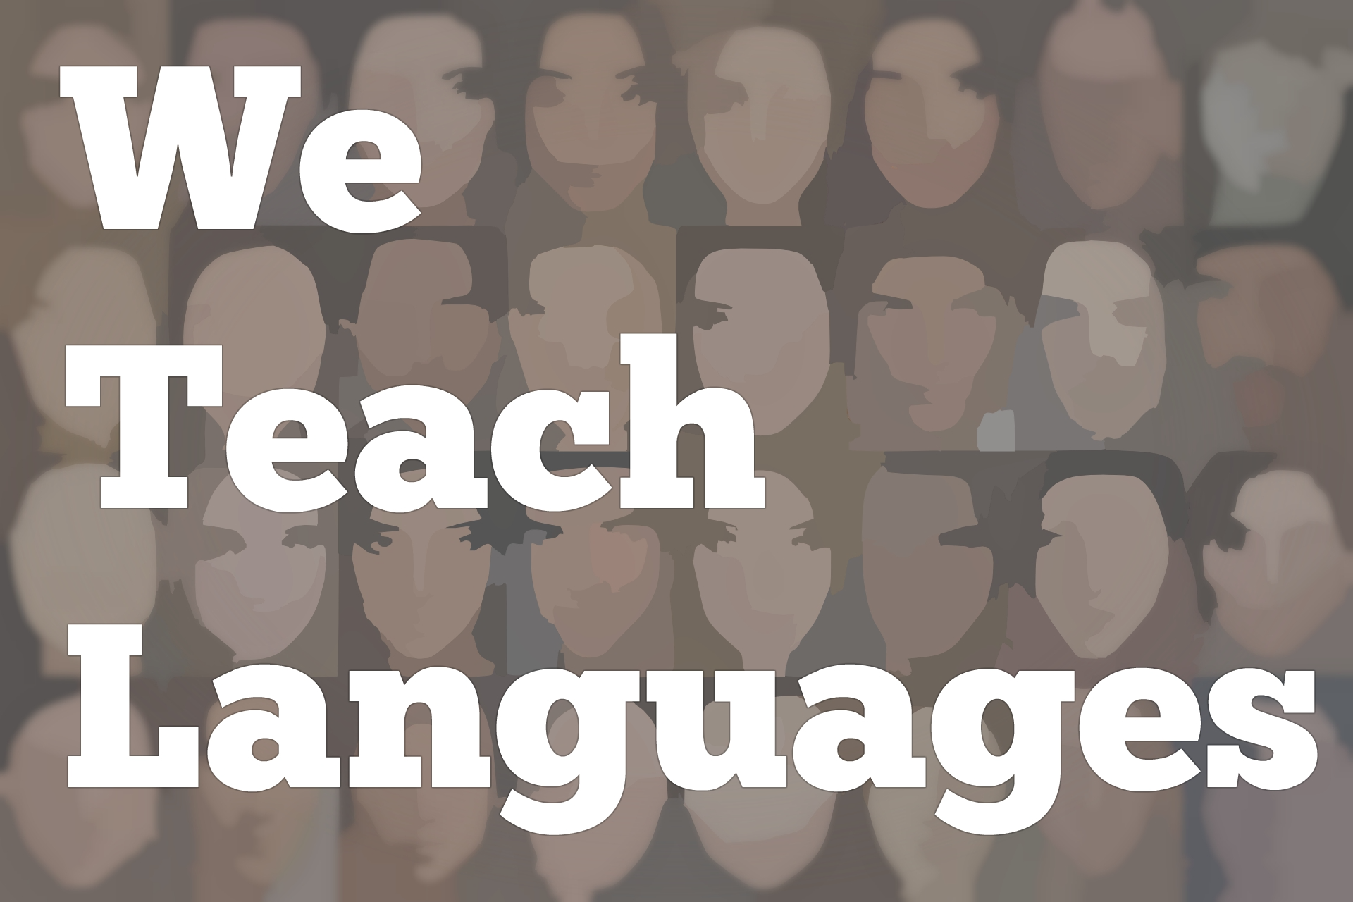
We Teach Languages Episode 107: We Teach _______ Languages with Shannon Mason

Stacey Margarita Johnson: [00:00] This is "We Teach Languages," a podcast about language teaching from the diverse perspectives of teachers.
[00:09] [music]
Stacey: [00:13] I'm Stacey Margarita Johnson. Today, on episode 107, we are going to talk about how we describe the languages we teach. We will hear from a few past guests, Mandy Manning, Amy Andersen, and Ellen Toubman. I'm also going to share an interview I recently conducted with Dr. Shannon Mason about her research on this topic.
[00:38] To start us off, I put up a poll on Twitter a couple of weeks ago that got over 500 votes in three days. I was really [laughs] impressed with that. I asked people what word or words they would use to fill in the blank in the statement, "I teach a blank language."
[00:59] Since Twitter limits me to four options in a poll, I chose what I suspected are the most common terms in the US context as the first three choices -- foreign, world, and second. Do you teach a foreign language? Do you teach a world language? Do you teach a second language? Is there a difference between those three terms?
[01:21] Then for the fourth option, which was other, I asked people who chose that to leave a note with more information in the replies. Dozens of folks did leave notes in the replies, actually. It was fun to read all of the threads that popped up, describing what terms people prefer and why.
[01:42] I want to start off by saying, like with most things in language teachings, it all depends. I don't have any strict rules for myself about which term is best. There are particular terms I prefer in some contexts. There are terms that have more baggage than others.
[02:02] The clear winner in the poll was the term, world language, with 60 percent of the vote. In the show notes, I'm going to link to a few of the tweets that gave some more rationale for why they prefer world language or why they don't prefer some of the other terms.
[02:20] Nelly, for example, said, "I chose world language. However, in a conversation, I say, 'I teach French.' I use world language when referring to my department. I dislike foreign because foreign for who? It imparts the idea of otherness, which is what I try to dismantle in my classroom."
[02:41] She got plenty of likes and responses to that as well. Several other people commented the same thing, that maybe the word foreign has baggage about otherness and exclusion that we're trying to avoid in our classrooms.
[02:54] Regarding the complexity of the term, foreign, that was part of my recent conversation with Amy Andersen and Mandy Manning. If you haven't checked out their two-part interview yet, you can find the links in the show notes. It's episodes 104 and 105.
[03:11] In and amongst our conversation, the first half was all about teaching culture. The second half was all about advocacy and policy. There was a little aside that we had that didn't make it into either of those two episodes about what terminology we use to describe our field. I wanted you to be able to hear it as Mandy gives us her take, and Amy and I both respond.
[03:35] [music]
Mandy Manning: [03:39] Can I just mention, too? Because this has just been a little thorn. I think it's important that we use the term, world language, rather than foreign language, because it humanizes this aspect of it. These are languages that we all use because we're human beings. We just happen to be from different cultures or from different communities.
Stacey: [04:01] That's a big debate in the profession. One of the things, my co-author and I often use the term, community languages, because there are literally hundreds of languages spoken in the US. I go back and forth between foreign, world, and community, depending on who I'm talking to.
Mandy: [04:20] Maybe, that's the key, is to be very intentional about which term we use for which language.
Stacey: [04:26] All the languages that we teach are all community languages. You can find communities of speakers right here.
Mandy: [04:33] That's really important, particularly with ASL, because there's nothing foreign about a person who is born deaf.
Stacey: [04:43] An American Sign Language. [laughs]
Mandy: [04:46] I think that we've been socialized to use that language. If we're more intentional about how we speak about languages, indigenous languages, we should be saying indigenous languages.
Amy Andersen: [05:01] It's saying foreign was a way to exclude ASL as a valid language. It's right here. It's in America. This assumption's based on English. It doesn't count as a language. Then being able to have a different term. Community works with community or...
[05:19] [crosstalk]
Mandy: [05:18] I love that. I love that. I'm going to start using that. Thank you.
Amy: [05:22] Me too.
Stacey: [05:23] It originated in Great Britain as a whole when they were trying to make sense of all the different languages that were spoken. French is a foreign language, but Hindi is actually a language that is part of our community and part of our history. How do we make sense of that?
[05:40] I should also correct myself from that audio clip. You heard me say that the term, community languages, originated in Great Britain.
[05:49] I have since done some more reading and found sources that indicate that the term was widely used in Britain but originated in Australia as a way for Australian teachers and researchers to be more inclusive of indigenous and widely spoken non-English languages in Australia.
[06:09] Community languages may have a lot of potential in the United States as well as we are also a country that has many widely spoken minority languages that are very simply, not foreign. They belong here, as much as any other language does. That's a term that I've enjoyed including in my vocabulary in the last few years.
[06:35] You'll also remember Ellen Toubman from episode 98. She recently called in to tell us why she prefers the term, world languages.
[06:45] [music]
Ellen Toubman: [06:45] This is Ellen Toubman. My favorite thing to say is, "I teach a language," because that takes all the judgment out, whatsoever. If I have to put a word in front of it, I would like to say world language, because I believe that it's the most inclusive.
Stacey: [07:02] The inclusivity question is so important, especially for Mandy and Amy's questions of whether the terminology we're using is being inclusive of indigenous languages and sign languages that might already exist in our community and are in no way foreign.
[07:23] Does the term, world, do a better job of including indigenous and sign languages? I know some folks in the Twitter thread about the poll mentioned that Bill Van Patten brought up that there's a technical definition of world languages, which would exclude a lot of languages that aren't widely spoken. I will put a link to that tweet in the show notes so you can check that out.
[07:51] The way the term, world, is used by most language teachers, it is intended to be more inclusive, right? On the other hand, the way foreign is used is often intended to not be exclusive either. 26 percent of the people who responded to the poll chose the term, foreign.
[08:13] I often use the word, foreign, as well in conversation and when I talk about my field as a whole, because that term is sort of a necessary part of my work. Let me explain. [laughs]
[08:26] You see, I teach a methods class in a master's program that prepares teachers of English language learners. The program has two different methods courses. One is called Methods for English as a Second Language or ESL. The other is called Methods for English as a Foreign Language or EFL.
[08:46] In this context, the term, second, is meaning that if you're teaching English language learners in a place where English is the predominant language. For example, if you're teaching immigrant and refugee students English here in the US, that would be ESL or English as a Second Language.
[09:06] However, the track I teach in, which is the EFL track, implies that the teacher will be teaching English as a subject in school or working as a tutor in a country where English is not the predominant language. For example, teaching English in a private language academy in Spain or in a high school in China.
[09:27] The specific methods and challenges associated with the two contexts are so different. We actually have two different methods courses. The ESL methods class is so different from the EFL methods class that I teach.
[09:41] I actually am not even qualified to teach the ESL class. I would not be a good choice to guide, teach our candidates through an ESL class. That's not where my experience lies.
[09:54] There are lots of times in my professional life when I use the word, foreign, not to talk about languages that don't belong here or languages that aren't mine, but to talk about the difference between a second language context and a foreign language context as far as who the students are and what the language environment they're in is contributing to their development.
[10:19] About six percent of our poll respondents chose the word, second. I've also heard it suggested by various people as a value-neutral replacement for the term, foreign. Maybe, it has less baggage. I suspected the folks who were suggesting second as a replacement for foreign don't work in a context like mine where those two terms are mutually exclusive. [laughs]
[10:44] I also saw some folks in their responses to the poll mention that, "Why do we call it a second language if, for many of our students, it's actually their third or fourth language that they're acquiring?" The whole field of second language acquisition is a shorthand for acquiring some language later in life that's not your mother tongue.
[11:09] Second language acquisition is the term we have all agreed on. It's not necessarily only about second languages. Somrtimes, it's about 3rd or 4th or 12th languages.
[11:22] There's a lot of jargon and shorthand embedded in these terms. I find second language very hard to let go of as well. [laughs] Sometimes, it just seems to be the right word for the job. I have to admit that there's always baggage. These terms don't come value-free.
[11:43] Another term that came up in the comments was heritage languages, which if you're not familiar with heritage language teaching, we did a couple of episodes on heritage language teaching back in December that I'll link to in the show notes, so you can learn more.
[11:58] Heritage language teaching is when you are teaching language to students who have a linguistic or cultural connection to the language. The language is not quite being taught the way a native language course would, but it's not quite being taught the way a foreign language course would either. It's something else.
[12:18] Helping, for example, English language learners to fully develop their first or home language might not actually even be heritage language classes. Those might be language arts classes that just happen to be in the student's native language.
[12:35] Also, in the poll results, we heard teachers of classical languages and less commonly taught languages identifying themselves by that specific terminology to describe the community of language teachers and the type of language teaching that they do. There's just so much variety.
[12:50] I was left wondering, "Is there a term that all of us can comfortably fit under?" There was an entire group of folks on the online poll who responded that they didn't want to add anything in the blank and would rather just leave it as, "I teach a language, period."
[13:11] There were also quite a few people who wanted to substitute the name of their particular language, saying, "I teach Latin," or "I teach Arabic." All of those responses, choosing languages without an identifier around it or just talking about a specific language, that all lines up well with the approach of today's guest, Dr. Shannon Mason, an Australian researcher and teacher who lives and works in Japan.
[13:39] I had the chance to talk to Shannon a little bit about her study of how Australians talk about language education and how that does or doesn't align with the official terminology in policy documents and research.
[13:54] Let's jump in to hearing Shannon tell us about her recent research on the topic.
[14:00] [music]
Dr. Shannon Mason: [14:04] Professor John Hajek, who's at Melbourne University, and I wanted to look at how language education from preschool to university was represented in the media. Particularly, we focused on the print press.
[14:20] We did searches of 10 years of articles. We identified 261 articles, and we analyzed those to look at a bit variety of things of what's being said and what policies are being mentioned and who's being cited. Then one of the things we looked at is what terminology is being used.
[14:41] In Australia right now, the official name of our discpline is Languages with a capital L and in the plural. In the past, it's mostly been Languages Other Than English, often abbreviated LOTE. That's something that's not used anymore and hasn't been for about 10 years.
Stacey: [15:02] Do you know why that fell out of favor?
Dr. Mason: [15:04] It's officially fallen out [laughs] of favor. There is a lot of people, including myself, that pushed to get rid of that term, LOTE. There's a few reasons. Firstly, a lot of students and a lot of teachers, a lot of parents don't know what LOTE is. It's not immediately obvious what LOTE is.
[15:27] With a subject that already has limited visibility in the curriculum, we think that it's important that it has more obvious visibility. If you talk about the Chinese, "Let's get out your Chinese notebook. You need this textbook for Japanese. We're going to be studying Italian this year." It's immediately obvious. Whereas LOTE, what does LOTE mean?
[15:53] At the same time, we also had SOSE, which is Studies Of Society and Environment. There's all these acronyms bouncing around. That's one thing. Also, I think that the fact that it puts a dichotomy of English and everything else, Languages Other Than English.
[16:14] It's the same reason why in Australia, foreign language is not really used very much. It's never been used in any of our policy documents, in any of our official policies or programs because it's that pushing away of the other words.
[16:30] We would argue that LOTE, or Languages Other Than English, is exactly the same, is that it puts that wall up between English and everything else.
[16:38] Then the other thing is that LOTE is one. Whether you're teaching Spanish, or French, or Japanese, everything is LOTE. What happens in Australia is that when there is not a teacher available, they'll just get another teacher of any LOTE.
[17:00] When I started teaching, my very first year, I came into a school where they had been studying German. The students didn't even know it. They had to start learning Japanese. I came on that as a first-year teacher. Why are we studying Japanese now? We've been doing German. Where's our German teacher?
[17:22] The ability to just exchange one for another so easily when obviously that's going to have a detrimental effect on students. I've written a blog post on that. It's called, "I hate LOTE."
Stacey: [17:37] Great. I'm going to ask you to send me the link to that blog post, so I can include it in the show notes.
Dr. Mason: [17:45] Awesome. There's so many issues with the term, LOTE, that it has thankfully, finally been pushed out of official rhetoric. It's still being used a lot in schools.
[17:57] It's something that I talked about a lot with teachers, is that, "Look, it's not part of anything. It's not part of our reporting system. It's not part of our curriculum documents. Why are schools still using LOTE in their book lists or on their timetables?"
[18:15] One of the things that we found that was very interesting in our research is that the most common...Of course, we're not searching for the generic language or languages because that's in every article. We're looking at specific terminology. The most commonly used specific terminology is foreign languages, foreign language.
[18:38] That is a term that's never been used in any Australian policy document even since 1980's when our first national language policy was created. There has never been any mention of foreign languages. We've avoided using that term.
[18:56] Any Australian-based journals, we don't use the term, foreign language, but it was the term that was used most frequently in the press, which was surprising to us.
[19:08] Why are they choosing a term to describe a subject that's never been called a foreign language, that's being called in the past Languages Other Than English? We see that petering out over the 10-year period that we analyzed.
[19:24] We can see that as the term is removed from the official policy, then it's also being removed from the media discussion. As for foreign language, it's been constant throughout the 10-year period.
Stacey: [19:38] That was very interesting. There are some cultural forces around that terminology that are bigger than what our language policy can tackle
Dr. Mason: [19:50] That's right. There is, as you said, this issue. There's a little bit of baggage with that term, foreign. There's been pushes to use world languages or additional language, a way of saying that, just only a handful of times. It's not something that's being picked up in mainstream media in Australia.
[20:15] There is this challenge. I had to talk about these things, because I think we know the importance of language and the power that language holds. It's not just words. There's baggage attached to it. When the media is constantly talking about foreign languages, what they're saying is, learning something that's not belonging to you.
[20:41] It's not about you bringing in and learning another culture and another language, and it becoming a part of you. It's still keeping that distance. We'll teach. We want to learn this new skill, but it's still something that's outside of you. Whereas language teachers, maybe, success can be measured by the language becoming part of our students, not as some separate thing that they're studying.
[21:15] I guess one of the main things that we notice in this study was that it's the politicians who are driving the agenda. They're talking about language education for economic prosperity, for harnessing economic trade in China, or developing relationships with Indonesia.
[21:42] What language education is presented to the Australian public is that it's something that we can use for our own benefit.
Stacey: [21:52] Completely onboard with that, the idea that learning a second language isn't about developing relationships with people who speak that language or just the inherent benefits of knowing more than one language. It's about economic value.
Dr. Mason: [22:06] That's right. It's not about communicating with people. It's about communicating with economies.
[22:13] We know that in motivation research, our students don't choose languages because they're concerned about getting a job, brokering deals in China. It's just not part of their thinking. One of the issues we're facing in Australia is that, maybe, depending on the state...In my state, it's 5 percent. It's up to 12 percent in our most successful state, Of students leaving high school with a language, 5 percent.
[22:50] If you're delivering this message to students and their parents who often have some influence in their subject choices, they're not going to be motivated or excited by an economic rationale for learning a language.
Stacey: [23:07] Shannon, thank you so much for chatting with me. A lot of listeners are going to identify with everything you said. What's happening in Australia is definitely also the battles we're fighting in the States. Thank you so much for sharing.
Dr. Mason: [23:21] Cheers. Thank you. Have a great night.
[23:27] [music]
Stacey: [23:27] We didn't answer any questions today. [laughs] I have just as many, if not more, options for how to describe my field as I did when I started asking these questions. It has been interesting to just become more aware of the connotation of some of the different words that I choose and to hear what everyone else's preferences are as well.
[23:51] I would love to hear more about what terms you use and if you use different terms in different contexts.
[23:57] You can find us on Twitter or Facebook at weteachlang, or you can leave a comment on the episode page of our website, weteachlang.com.
[24:07] [background music]
[24:08] We would love to say a special thank you to the PEARLL Foreign Language Resource Center for partnering with us to provide transcripts and other professional development resources related to the episodes. You can learn more about PEARLL by going to PEARLL, P-E-A-R-L-L.nflc.umd.edu.
[24:32] Thank you so much for listening. Bye-bye.

Podcast transcripts are provided through a partnership with PEARLL (Professionals in Education Advancing Research and Language Learning), a Title VI Language Resource Center at the National Foreign Language Center at the University of Maryland. Find additional transcripts: www.pearll.nflc.umd.edu/podcast

Transcription by CastingWords

