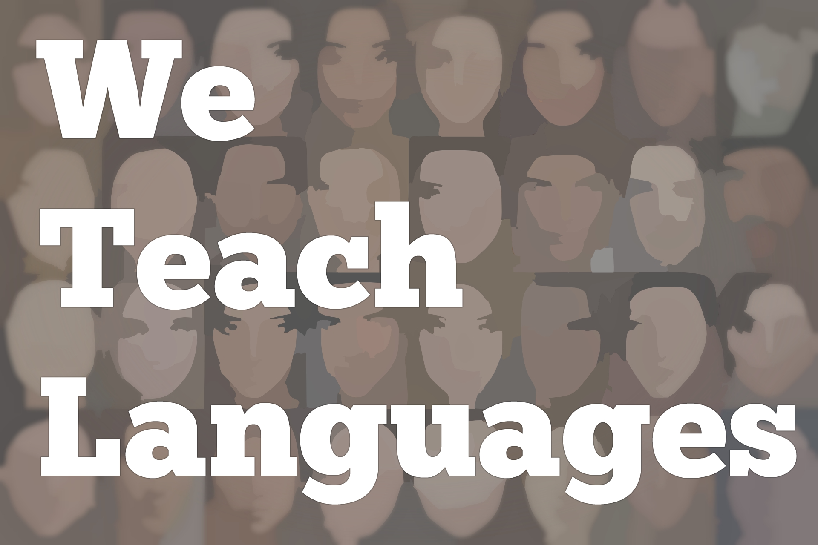
We Teach Languages Episode 113: Mind, Body, and Voice Skills with Justin Slocum Bailey

Stacey Johnson: [0:00] This is We Teach Languages, a podcast...
[0:03] [background music]
Stacey: [0:03] about language teaching from the diverse perspectives of teachers. I'm Stacey Johnson. Today, on episode 113, Justin Slocum Bailey is interviewed by Janina Hanson about a recent workshop that he put together on the topic of Mind, Body and Voice Skills for Language Teachers.
[0:31] Janina sat down with him during a break in one of their workshop times and recorded them discussing their own experiences with mindfulness and silence and a lot of other related topics.
Janina Hanson: [0:48] Hello. My name is Janina Hanson, and I teach Spanish for middle school at Latin School of Chicago. Today, we have an excellent guest with us. Hi, Justin.
Justin Slocum Bailey: [1:03] Hi, Janina. Thanks for having me.
Janina: [1:05] Thank you for making the time.
Justin: [1:08] Not just on the show, but at your school.
Janina: [1:08] You're always welcome. Thank you for being here.
Justin: [1:11] My pleasure. It's been tons of fun.
Janina: [1:13] Yes, it has. I think we've got so many great ideas that all teachers are ready to start planning for the next academic year. Can you tell us a little bit about you and your teaching experience as a language teacher?
Justin: [1:28] In a way, it started when I was really young. When I was in eighth grade, I was tutoring older students in French and things like that. I've always been into languages, and I've had this teacher spirit. I was the kid who, my favorite thing to do in any class, was a solo presentation in front of the entire class.
[1:47] I went on and I focused on linguistics, and on English and German literature in college, but I ended up with a teaching job in Los Angeles. I was a high school teacher in Los Angeles for about 10 years. I taught mostly Latin and English language arts, and guitar because I had a background in classical guitar.
[2:08] I would look for opportunities. I would teach like crash courses in French to travel groups. One time I taught a Hebrew crash course and things like that, because I'm interested in that and I studied. I've always been involved in language teaching in some way. My classroom experience is at a high school in Los Angeles.
Janina: [2:23] Wonderful. Now, as you've mentioned, today we are gathered at Latin School, and you are working on a workshop with us about Mind, Body and Voice skills for Language Teachers. Can you tell me what motivated you to create this workshop?
Justin: [2:39] Mind, Body and Voice Skills for Language Teachers. Two main things. One is that I do a lot of teaching with people observing, sometimes, specifically, in order to do a demonstration. Sometimes I'm just teaching and there are people who happen to be watching.
[2:54] Whenever I got feedback on those courses, what seemed to work, either learners themselves would report back what seemed to work for them, or observers would say, "Wow, this was really helpful whenever I did this."
[3:06] I noticed that of all those things, a huge percentage had to do with things that I was doing with my body, how I was moving, where I was positioning myself, and with my voice, how I was speaking, how I was varying my voice.
[3:22] Because I hadn't been planning on doing that stuff, wasn't doing it consciously. It was just happening. I've had background and training in body and voice stuff, both in acting which helps the body and voice stuff. Actually, with the body stuff, martial arts which generates a lot of body awareness and things like that.
[3:40] I was just doing these things naturally, but I thought, "Wow, if people are so focused in on this, it's making such a big difference, maybe I should actually think a little more carefully about the role of these things and do them on purpose, and figure out, 'OK, when I do this, it helps in this way and codify it a little bit, so it can be shared with other people.'"
[4:03] That was the one main strand is people's feedback. The other had to do, and this gets a bit more into the mind part, because, as you read, Mind, Body and Voice Skills teach it. We're all stressed. Teachers are stressed. Students are stressed. We have sources of anxiety and that's objectively horrible for people. It's objectively horrible for learning.
[4:25] You can look at any study that you want on the ill effects of stress and anxiety on learning and for that matter on teaching. I have a long history of mental illness, and that had started affecting my teaching and my relationships with my students, how I felt about my job, my relationships with other people.
[4:51] I got to the end of my rope, and I said, "I have to change something pretty fundamental about my teaching for me to be more at peace and in the moment. Because if I'm ahead about all the things that make me harm myself, for example, no one's going to be learning.
[5:07] It was almost for myself that I started incorporating more mindfulness techniques in the class. Especially inventing some ways to do some mindfulness training, that also provided input in the target language, so that we could kill two birds with one stone.
[5:23] Again, for myself, but of course, everyone needs it. Students have all these stressors. We talked about it in the workshop today. It reduces your working memory. Lots of ways make learning harder.
[5:36] To sum up one strand, people's comments on my movement and voice, and the other, my sheer need to be more at peace, to use my energy and my thoughts to serve me and the students better.
Janina: [5:48] Well, being here in your workshop, I see that it's a need. To be honest with you, I didn't think of it. Do I need to learn more about this? Now that we're here, we're having fun. It's very relaxing. It made me think about what other things I'm bringing to my classroom without even me thinking about it.
[6:08] Even my breathing, I was driving back home yesterday and I thought, "OK, I feel like my breathing is really bad." I'm holding my breath all the time, which is something I never thought of. Now, I feel more conscious about it even having this conversation with you right now.
Justin: [6:22] Wow, that's so cool to hear. You and I have the same breath problem because I do the same thing. When I turn my attention to my breath, I realize how a lot of times I'm holding my breath. Other people, their thing is they breathe fast. Other people breathe shallow.
[6:37] It's also extra exciting to hear that you, literally yesterday, in your car afterwards, were thinking about these things. Something I've noticed, another participant came up to me today actually, and for the listeners, we're at lunchtime on day two of a two-day workshop.
[6:53] Another participant came up to me and said that she used some of the techniques from yesterday with her seven-year-old last night while they were doing their reading time. Both your comment and her comment reminds me...this is something that has happened over and over again.
[7:09] When I've shared some of these ideas, whether in a workshop or in a video or who knows what, is it's some of the quickest application, quickest benefits, the quickest way to change your life is with some of these things, without having to learn a whole new teaching techniques or systems and things like that.
[7:31] I've got goosebumps. Tell the listeners that I have goosebumps.
Janina: [7:34] I'm excited already. [laughs] Yes, he does. I can see them all.
Justin: [7:39] I'm showing them to Janina here. Even though it's warm here in Chicago, it's beautiful.
Janina: [7:39] It is beautiful.
Justin: [7:40] I have goosebumps hearing about this immediate effect on you. Thanks for sharing that.
Janina: [7:44] I was very excited to notice it myself. Anyway, something we've discussed in our workshop today was also about the importance of your vocal skills. What would you say is the most important vocal skill for a language teacher?
Justin: [8:01] I often call the most important, maybe another way to say this, the most undervalued, the most overlooked or underused skill. If you're listening to the podcast, you can pause it right now and make your guess.
Janina: [8:14] Please do.
Justin: [8:14] Yes.
[8:15] [pause]
Justin: [8:15] Welcome back from that pause. Silence.
Janina: [8:21] Can I say wow? I was not expecting that, even when I've heard it at the workshop. That was just that.
Justin: [8:27] Silence is the most underused vocal skill of teachers, not just language teachers, teachers in general. Probably one of the most underused skills of humans. Silence is so powerful, especially in a context, in a world where so much noise.
[8:44] Some of the noise is actual audio noise. Some of it is just the general distractions that we have. We get so few opportunities for silence that if we can punctuate our speech and our lessons with genuine silence, it's a huge contrast to people's normal lives.
[9:02] We discussed, anytime you generate a sudden contrast, it grabs attention. Silence can be an amazing attention-grabber. It can also be a way of, right after you say something, giving people time to process what you just said.
[9:18] I think we talked about this yesterday. If you establish that as an actual thing that you do sometimes, it actually buys you the chance to be silent and think sometimes, whether that's responding to an adverse situation with a student, whether you're not sure what question to ask next to foster discussion, who knows?
[9:37] Establishing that silence is so much for you. That's not even getting into your vocal health and your vocal longevity. People talk too much. People talk too loud in general. Not just in a way that's annoying, but a way that's bad for their vocal cords and their vocal tract.
[9:55] The number one way to be nice to your voice is to be silent more. It could be hard for people to do. People aren't comfortable with silence. If I may, one or two more things, just to prove how important this is and how undervalued the silence thing is. It builds anticipation. If you're talking and then you stop, and you look around, people listen to what you say.
[10:21] I think partly because silence is so rare and so difficult, people associate it with wisdom and with saying important things. I can do a lot for us as people whose job is to be good communicators and to have students attend to the things that they hear and read in a language.
Janina: [10:40] Today I've noticed and I've mentioned that to you too, where you were talking about silence and then how you move from one side of the room to another side of the room.
[10:49] You reminded us always not to walk and talk, rather take your time, walk to whatever you need to be at, take advantage of that silence, generate the anticipation for your students to make sure that they're following you, that they're listening. It is so powerful. All of us, our eyes were completely on you, waiting for whatever was happening next.
Justin: [11:16] Just to know and feel attacked. It's not evil to talk and walk at the same time. Walk and talk.
[11:21] [laughter]
Janina: [11:21] There are a lot of people who point out that if you're doing those two things, if you're moving around a lot and talking at the same time, it takes some attention away from your voice.
[11:30] You can kill two more birds with one stone by injecting silence, and avoiding the distraction that might come from talking while you're moving to a whole other part of the room.
Janina: [11:41] I'm guilty of that. I think that I don't noticed it myself. I am seeing myself sometimes...
Justin: [11:45] Yeah, all of us.
Janina: [11:43] I'm like, "OK, here are the papers and we're going to do this." and the kids were like, "What?" Yeah, I've done it many times. We've discovered and we've talked about today was about the idea of unbreaking the brain breaks.
Justin: [11:59] Unbreaking brain breaks, yeah. Maybe not like a core content from this workshop, but because brains need breaks. We have done a lot of brain breaks, and I've developed this concept. I'm sure a lot of listeners do this, anyway.
[12:14] I've started thinking about a bunch and strategizing about it, which is you do your brain break. Let's say you get up and you move around. Well, I'll use the example, if I may, of what we did today.
[12:27] I learned this from Faith Loucks who's a Chicago person. She I think learned it from maybe Diana Noonan or another people. There's this long line. It's not my idea. The brain break is you hold a piece of paper up high and you let go. You let it fall and everyone claps. This is fast as they can, as many times as they can, until it hits the ground.
[12:46] Then you can be more or less done, because the brain break has accomplished the purpose of the brain break, which is to get up a bit, move around, reset the brain. But if you choose to, this activity has also bought you some interest. It created an interesting scenario for you to talk about in the target language.
[13:08] For example, what I did today is I had people in stages sit down, stay standing if you clap 10 times or more, 11 times or more, and so on, and that's something you can do in the target language with your students. We narrowed it down to the last two people.
[13:22] I think we had Nava and Michelle. You vote like who do you think clapped more times, all this in the target language, as much stuff as you want. You can even tally the votes and talk about who got more votes, whatever you want to do to take advantage of this attention now that already is on the setting. It was super fun. It turned out to be the final...
Janina: [13:44] They both had the same amount of claps between 17 and 19. They were not sure.
Justin: [13:49] They had the same amount of claps, and they both clapped 17 and a half times.
Janina: [13:50] 17 and a half, that's right.
Justin: [13:52] Then we clap for them 17 and a half times, and there was much rejoicing. There's a rhythm in any class. When you do the exact same thing for a while, gradually attention wanes.
[14:07] When you do a new thing like a brain break, it can be good to take advantage of the fact that you've renewed some energy and renewed some attention. We use the attention or the situation created by the brain break to do some more talking in the target language.
Janina: [14:22] We had a great time.
Justin: [14:24] It's more about unbreaking the brain break.
Janina: [14:27] I love it. I think many of us will also plan on doing that next year. It's great. Well, as I've participated in your workshop, I do have to say that I have loved it. We still have the afternoon. We're looking forward to it.
Justin: [14:39] Wait till the afternoon. There might be total carnage.
Janina: [14:43] I can anticipate that it's going to be great and so many things to think about. What I like about it is it's not just for language teachers, but many teacher because all these skills are much needed in our profession.
Justin: [14:58] The vast majority of the stuff, absolutely, could go for any teacher even for any human.
[15:02] What I'm working on, adding in more and more, is things like these, what we're going to do right after lunch, the second person story asking concept, or these other guided listening type things, where students are also hearing the target language and using their imagination, things like that, so that it's language specific.
[15:19] You're absolutely right. No one can ever go wrong focusing a little more on their breathing, or being a little more conscious about are they straining their voice, or things like that, just anywhere in life.
Janina: [15:30] That's what I'm going at.
Justin: [15:31] I'm so happy to hear and honored to hear that you've collected some good stuff from it. That's why we do this stuff. It's energizing. It makes me happy.
Janina: [15:39] For our listeners wanting to get in touch with you, how can they reach out to you?
Justin: [15:44] Probably the most straightforward way is on Twitter, where I am @indwellinglang. That's short for indwelling language as in living in the language and also the language living in you, indwelling language, which is also the website. We have a blog, other resources and things like that, indwellinglanguage.com. There's a contact form there.
[16:04] Twitter or the contact form at indwelling language.com. I always love hearing from people. I especially love hearing from people when they try a thing that I've shared, and maybe worked, but didn't quite work the way I had predicted it would, or the way that I'd hoped it would.
[16:20] They, being a professional and thoughtful teacher, tweaked it some way and that made it work for them. When people report that back to me, then I can share the ideas of, "Hey, here's the way that I usually do this.
[16:32] Janina, from Chicago, she tried it with her students. It wasn't as ideal, maybe for a certain reason, or they were younger or super small class, or who knows what, but she tried this tweak." Then I can share all those ideas.
[16:44] Obviously, listeners feel free to get in touch with me about anything, but I'm always especially excited to hear, to learn from you and your teaching ideas and your tweaks on things maybe that I'm doing so that I can improve my practice.
Janina: [16:56] For those who spends on Twitter, you're pretty active on Twitter too.
Justin: [16:58] I go in spurts. Sometimes I'm gone from Twitter for a while, sometimes very active. I'm definitely not following all the classic social media marketing rules of beyond there four times a day and things like that. I use it when I think of it. I try not to be bound to it. Feel guilty if I haven't been on there for a while.
Janina: [17:20] Justin, thank you so much for making the time. We appreciate it.
Justin: [17:21] Oh my gosh, thank you for having me. Thank you.
[17:24] [background music]
Stacey: [17:26] We would love to hear your feedback on this episode. You can find us on Twitter or Facebook @weteachlang, or you can leave a comment on the episode page on our website at weteachlang.com.
[17:41] We would like to say a special thank you to the Pearll Foreign Language Resource Center for partnering with us to provide transcripts and other professional development resources related to the episodes. You can learn more about Pearll by going to pearll.nflc.umd.edu. Thanks so much for listening. Bye-bye.

Podcast transcripts are provided through a partnership with PEARLL (Professionals in Education Advancing Research and Language Learning), a Title VI Language Resource Center at the National Foreign Language Center at the University of Maryland. Find additional transcripts: www.pearll.nflc.umd.edu/podcast

Transcription by CastingWords

