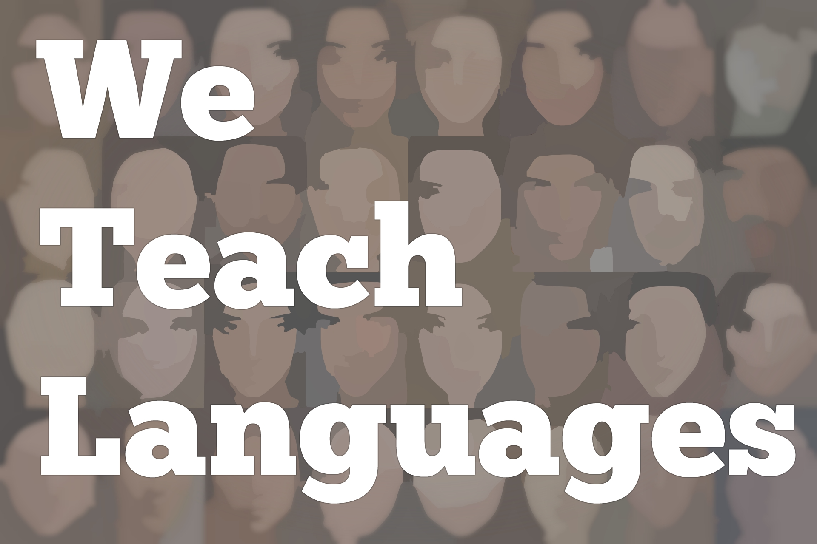
We Teach Languages Episode 114: Blended Learning and Inquiry Projects with Kristin Kvasnyuk
[00:00] [background music]
Stacey Margarita Johnson: [00:00] This is "We Teach Languages," a podcast about language teaching from the diverse perspectives of teachers.
[00:08] I'm Stacey Margarita Johnson. Today on Episode 114, Maris Hawkins interviews Kristin Kvasnyuk about some of the successes she's had teaching in a blended format, which means part online and part face-to-face. They also talk a little bit about Kristin's student inquiry projects. Kristin has shared a lot of resources with listeners, so make sure to check out the show notes after you listen.
[00:43] [music]
Maris Hawkins: [00:47] Hi. I'm Maris Hawkins. I'm here with Kristin Kvasnyuk. Kristin, if you can tell us a little bit about the school where you teach and your classes that you teach.
Kristin Kvasnyuk: [00:58] I am a middle school teacher at Bullis School in Potomac, Maryland. I teach sixth, seventh, and eighth grade Latin and that's all.
Maris: [01:09] We're here also to talk about your blended class. A little history is that we both taught a blended class in our eighth grade classes. Can you just explain what a blended class is for us? I think it means different things for different schools.
Kristin: [01:25] We decided to split our eighth grade Latin 1B program into a regular class and a blended class. They have similar curricula, but the blended class meets twice face to face per week, and twice in an online fashion.
[01:41] Because it's middle school, our administration decided to still have a proctor there, but it's not me. It's someone who is there to make sure everything's OK. The students really have to work independently on their own, or with each other, to accomplish all the tasks.
[01:56] It's my job to create that blended day. Our learning management system is [indecipherable] PowerSchool Learning. It used to be Haiku. I will create a page on there that has all of their activities and tasks, resources, videos, a way for them to communicate with me. Everything they need for that day is on that page, and they're directed there each day.
[02:21] I need to make all of those activities and prepare for them. Also, I can monitor them as the students are working. I can see from wherever I am as they complete questions, as they ask each other or myself questions on Padlet, they can...We use a variety of different technological tools that capture data that I can look at and monitor as they work.
Maris: [02:48] I think that's a little different because other times, blended classes can use a premade curriculum too. You're actually designing, and we both designed all of the activities through that day.
[03:01] Speaking of technological tools, what are your favorites to use in the blended class? I know there's a lot.
Kristin: [03:08] There are so many. They're so many great ones. I'll start off actually with a recommendation from you, which is Seesaw. I love it. It is an online journaling program. It's free to use. It's free to have multiple classes. Students log in and they can submit a variety of items. They can do writing, videos, images, voice memos. There's a whole bunch.
[03:39] When they submit those items, Seesaw keeps track of all of it. I can see what one student is working on or I can see what everyone submitted on a particular day or for a particular assignment. They also can interact with each other. They can like each other's items. They can comment or respond. That creates a nice community online for them.
[04:03] One thing I love that they added recently is the ability for me to create an activity. Before, I would have to give directions on our learning management system, and they would just do it in Seesaw.
[04:16] Now I can create an actual activity with all the instructions. I can use prompts that are obviously words, but also images or videos, etc., that a student will see pop up when they log in. They'll know this is the assignment I need to be working on. All of that gets organized into one place.
[04:33] I also use EdPuzzle, which is extremely popular, and what I would think of as its reading counterpart, which is ActivelyLearn. Both of those, I believe, have really robust free programs. My school does have a subscription to EdPuzzle.
[04:49] We can do a lot of fun things with that. It's a great way to just be assigning videos or a lot of great Latin content online right now. I can have students watching, commenting, and answering questions as they work.
[05:02] ActivelyLearn has the same thing, but for reading material. It can be reading material I create, something from the Internet, something that I borrow and upload as a PDF. All of that is available there. Then of course, there are certain ways to assess your students online. Things like courses Quizlet, Quizizz, and Gimkit. All of those are super helpful as well.
Maris: [05:34] Going back to both EdPuzzle and ActivelyLearn, one thing that I really like about both of those is it will section it up for the students. Especially for when they're listening to something, it's easy to go back and replay and listen to what they need, and it's individual for each student.
[05:53] Same thing with ActivelyLearn, because it chunks their reading. The other thing that I love about ActivelyLearn is that, depending on your settings, you can have the students see what everyone else submits after they submit. It's one way for them to check whether or not they got the correct answer.
Kristin: [06:11] Yes. Both of those are things that I can be creating or commenting on in real time. Even if we're not in the same space, if we're both looking at the same item at the same time, they can see my immediate feedback, which of course, the students love.
Maris: [06:26] That's so important with blended and online learning, and also just with technology in general and why technology can be so valuable is that immediate feedback that really helps students learn.
[06:39] As you've been developing the blended class, what have you found is important as you're developing it when you're teaching a foreign language blended class?
Kristin: [06:49] That's a great question. I would say keeping things balanced, making sure that they are doing a lot of reading, writing. That they're doing it in different and engaging ways. That I keep things fresh and novel, and really take advantage of all of these tech tools that are available.
[07:08] Also, in Latin, we don't do a lot of speaking. Certainly, I tend to reserve that for our face-to-face days. Really getting in reading, writing, listening. One thing that is nice is that with blended, because I'm pulling from so many online resources, they probably hear more other people speaking Latin than my regular students do just because I'm put in this position of finding all these great resources, and they have the opportunity to listen.
[07:36] Thank you to the spoken Latin community out there for posting things that my students, if they have an extra moment or free time where they decide that they would like to listen more, they can because it's on there on that blended day for them to choose.
Maris: [07:51] On the podcast, there's an earlier episode where someone talks about the research behind that, that actually students acquire more vocabulary when they're hearing it from multiple voices as opposed to your own, which I think is valuable.
[08:05] The other thing that I agree 100 percent. When I first developed my blended class, it ended up being so much output driven. My original vision was to have them come in and actually journal in Seesaw...Well, at the time, they had a blog, but in the end journal in Seesaw, and do that every day to get them started.
[08:29] But I found it was way too output driven, and I wasn't giving them enough input. So I switched. Since we had the two days, I did the one journal, and then the second time was in EdPuzzle. Again, they still had that consistency. It either starts with the journaling or in EdPuzzle, but I'm making sure that I'm giving them enough input so they're not just writing, writing, writing.
Kristin: [08:52] Yes, absolutely.
Maris: [08:53] Since this is your second year teaching the blended class, what have you changed from the first year to this year?
Kristin: [08:59] That's a great question. What have I changed? I would say it's a constant process. As I look over what I did last year, I'm always thinking is this the best way for me to do this? Sometimes, the answer is yes. Sometimes, there's already something brewing in my mind. Like I would like to add this or change this.
[09:22] A lot of the time, it does have to do with that input part, where it's like there's even more resources now, or I'm going to write a new story because I don't like the thing I found last year. Finding always more, and sometimes different input for them to be learning from.
[09:40] It's about also adjusting to the students because year to year, they differ so much. What I found is that this particular group this year seems to sometimes fly through what I do, so I overpack the days. I left them the must-dos. It's OK to say it's for later or what might qualify as homework. I like to give them as many things as possible.
[10:04] I think we'll eventually talk about my inquiry projects, but I like to have them always able to do something even if it's a separate independent project, because if they are really getting through the material quickly, which is part of what blended can allow a student to do, I want them to know that they can use their time effectively to be improving their Latin or increasing their interest in the topic on their own.
Maris: [10:31] I agree. I remember that was the first thing, and we talked about this a lot too, where you have to ask the students, especially in the beginning, was this too much? Was this too little? Where did you get hung up?
[10:45] Some of that, you can see online. But some, because we'd be next door, I would just pop in and say, "Hey, did this take you too long?" Or I could see they were still working on the second activity and I have a third activity, and I just said scrap it. We'll save it for the next day.
Kristin: [11:01] Exactly. I do find that my face-to-face days end up being that "how are things going" conversation, because, you're right, I can see a lot of it. But then there are other parts that I won't really know. Why did this trip you up? Or, I noticed that you started with the third item first. Why did you decide to do that?
[11:18] That's our chance to talk about the problems they're having or questions they have, which I think is nice because it makes them confront those issues. They're like, "Ooh, now I know that I do prefer this kind of activity" or "I'd rather review this at the end of class or maybe I'd rather review it at the beginning."
[11:35] They learn more about themselves as learners and become more advocates for themselves because they know here is the teacher. I need to talk to her about all these things that I came across yesterday.
Maris: [11:46] That segues into why do you feel like your students love blended? I know from now talking to students in the upper school, I've had many students say that blended both Latin and Spanish is one of their favorite classes. Why do you think that's so?
Kristin: [12:03] That's great to hear. So many reasons. I think it seems counterintuitive, but they create such an amazing community. I think if I had to guess why, it's because of those days when I'm not there. When I'm there, they want to talk to me. But when I'm not there, they are talking to each other, pretty much the whole class.
[12:25] They're helping each other. They're counting on each other. That creates a strong sense of community. It is May now, and I already have students saying how much they're going to miss our class next year, and how they're all talking about trying to find ways to get together. I think that is amazing.
[12:44] The other part is what I was talking about earlier with moving at their own pace. There's always going to be a student who gets through the work quickly. There's always going to be a student who needs more time.
[12:54] This allows them to spend as much or as little time as they need on each individual item. They're never waiting for peers to catch up. They can if they want to, if they're working together and helping each other out. But it allows a freedom that isn't necessarily available in other classes.
[13:10] The last thing I'll say is I think my independent inquiry projects have been a real hit. I was nervous introducing them, but it's basically the only homework I give where they're having to research an interest of their own that has something to do with the Roman world, Greek world, ancient world, Latin.
[13:33] Their creative imagination is their only limitation. They have been impressed with themselves with what kinds of things they've done and what they've learned, and what they've learned from each other. Going back to that community piece as well.
Maris: [13:48] I know that they've had some really fascinating topics. Can you highlight a couple of different topics? Because they've been so wide.
Kristin: [13:59] Varied and wide, absolutely. Some of the topics [laughs] have included...Last year, I had a student research Roman board games. He created, through the use of our BIT lab, his prototype for a Roman game. Of course, a lot of the evidence we have is spotty, so he just had to infer and come up with his own solutions for how this game could really work in a real environment.
[14:28] I certainly had a lot of people do Roman or Greek food. I will say this year I actually had someone cook food from...
Maris: [14:35] Ooh.
Kristin: [14:35] Yes. From a Roman recipe book.
Maris: [14:38] Wow.
Kristin: [14:38] She looked at the recipe book and in Latin, found some translations and did some translating of her own, and did to the best of her ability follow the recipe to create some Roman treats. Which were, according to students, actually pretty good. That was fun.
Maris: [14:54] Did you all recline while eating?
[14:56] [laughter]
Kristin: [14:56] You know, we didn't. But...
Maris: [14:58] Next time.
Kristin: [14:59] Definitely next time. We were all seated around one communal table. That was nice. But yeah, we should have been reclining.
[15:07] This year, I had a girl do jewelry. That was really cool. I personally had some photos I could share with her from museums. She realized how much jewelry has not changed over the centuries, millennia. That was interesting. Just talking about the value of stones, the value of precious metals, and why we value them. The societal meaning behind it. Why do we wear it?
[15:33] I've had students do Roman military, Roman medicine, Roman astronomy and astrology and how that's all connected. I've had students do Olympics and sports, things like that. Also, now we have someone who wants to actually put on an ancient Greek play.
Maris: [15:55] Wow.
Kristin: [15:56] I'm looking forward to see how that turns out. It's very ambitious, but she's also the one who cooked the food from the recipe book, [laughs] so I have a lot of faith.
Maris: [16:05] How many inquiry projects do they do a year?
Kristin: [16:09] They can only manage two. The second one is a little shorter on the timeline. I introduce it in September. That first set goes basically till January. January is when we have the presentations. That first one takes a while to get going, but once it's there, it's amazing.
[16:29] I feel like the products that come from the first set are better than the second because at the end of the year, students are also stressed about exams and things like that. I have to encourage them to remember that it's going to be OK. You're going to sort it all in.
[16:29] I think in January, we had a full week. Every student took 45 minutes of explaining their research, talking about what they did, the process of coming up with their product. Then sharing that product.
[17:00] I had one student create a battle reenactment on some virtual platform that he's familiar with. We got to watch a battle play out according to what he found were Roman military tactics and strategies.
Maris: [17:14] Oh my gosh.
Kristin: [17:16] It was incredible. That was like 15 minutes of a video. We have to dedicate this long symposium type week to get through everything, which is amazing. We'll have our second one, of course goes from that point in January through May. We'll have another week at the end of May to do it all over again.
Maris: [17:36] That's amazing. It's fascinating to hear what they end up coming up with. I think the other thing that you're great at is finding the connection to Rome or Greece, or whatever. I remember for example, last year, there was a student who loved airplanes.
[17:56] Obviously, airplanes don't exist, but then he did a whole presentation on Roman roads. You're really good at finding that idea that will hook them into project as well.
Kristin: [18:03] I love having inspire each other. That Roman transportation roads -- I think it was a documentary that he did -- I think inspired later a different student to work on Roman concrete.
[18:21] Then she actually used ice cream as a metaphor for the concrete, made her own ice cream, and used ingredients to show how the Romans used different natural ingredients to create their very, very strong concrete. They also are great influencers on each other.
Maris: [18:36] Also, I was wondering, when we're thinking about this, what do you think that a non-blended teacher could incorporate into his or her teaching, or also how has teaching a blended class influenced your other teaching?
Kristin: [18:52] Great question. I will say I feel like of course so many of those tech tools can be incorporated into a non-blended class. The other thing I would say about that is all of that data can be so valuable and inherently affects your teaching so that if you are using those tools, you will naturally see a transformation in how you run your class.
[19:18] You're seeing all this immediate feedback yourself and realizing, OK, let me do that again. Let me try a different way of teaching that. Or, wow, we got that faster than I thought we would, let's move on. I think that can be great.
[19:33] The other thing I found is that because I now have all of this writing, students on blended days are doing a lot of writing, and I can use those samples to communally edit. I'll bring in printouts of just things that were in anonymously, of course they'll then claim things as their own.
[19:51] We'll work on it and be like, can we understand what this person is saying? Great. How would you react to this person? What would you say to this person? Do you agree? I'm able to use the things they produce to create new ideas and think of ways to talk about their writing or the feedback that I'm getting.
Maris: [20:08] That's interesting. I haven't done that much recently. I like that.
Kristin: [20:11] [laughs]
Maris: [20:11] Can we do that? Steal your idea. Any other thoughts?
Kristin: [20:17] Oh my gosh. Do a blended class.
[20:20] [laughter]
Kristin: [20:22] I jumped in feet first. I was excited to try this and see what I could do with my knowledge of technology and Latin, and throw them together. I am so grateful that I did. I don't know if it's possible in every circumstance.
[20:39] Obviously, we have a one-to-one program here that enables this. But I think it provides an opportunity for you as a teacher to grow, and it is shocking how much the students take advantage of all the benefits of it.
[20:53] Even at the eighth grade level, we talk a lot about blending classes in upper school or high school. Of course, college online classes are extremely prevalent. It's amazing to see how even at the younger levels, this kind of learning is still so helpful and loved by the students themselves.
Maris: [21:13] You're right. The fact that they end up gaining more independence. I think eighth grade is a perfect year to do that because that's when they're ready to spread their wings. That independence that they're able to get from it really does transfer. Because we've done this for a couple of years, we have talked to the kids later and they say too the independence that they get from it.
[21:39] I agree. When I was teaching a blended class in the middle school level, you also have to be purposeful about your face-to-face days because you can't necessarily do the activities that you want to save for your blended days. You wouldn't have really maximized that face-to-face time. It does just make you more purposeful all around.
Kristin: [21:55] Yes. I completely agree about that. I spent more time planning my blended days than any other class because it has to be very precise. You have to be thinking about the best utilization of exactly what you said. A face-to-face day versus a blended day.
[22:10] What activities make more sense on what time of days? On a Monday versus a Friday? We have rotating schedule beginning of the day, end of the day. It's a lot to think about.
Maris: [22:20] Exactly. Thank you so much for talking to me.
Kristin: [22:25] Thank you.
[22:25] [music]
Stacey: [22:24] We would love to hear your feedback on this episode. You can find us on Twitter or Facebook, @weteachlang, or you can leave a comment on the episode page on our website at weteachlang.com.
[22:41] [background music]
Stacey: [22:41] We would like to say a special thank you to the PEARLL Foreign Language Resource Center for partnering with us to provide transcripts and other professional development resources related to the episodes. You can learn more about PEARLL by going to pearll.nflc.umd.edu.
[22:59] Thanks so much for listening. Bye-bye.

Podcast transcripts are provided through a partnership with PEARLL (Professionals in Education Advancing Research and Language Learning), a Title VI Language Resource Center at the National Foreign Language Center at the University of Maryland. Find additional transcripts: www.pearll.nflc.umd.edu/podcast

Transcription by CastingWords

