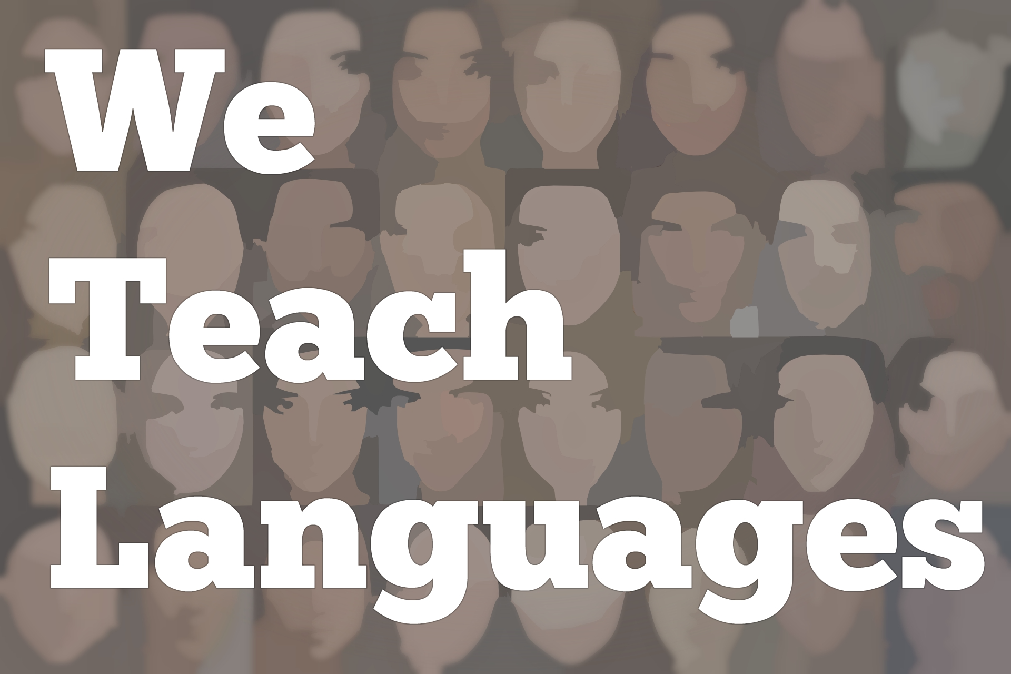
We Teach Languages Episode 120: Professional Development for Graduate Student Instructors with Katie Angus

Recorded Voice: [0:00] This is "We Teach Languages," a podcast about language teaching from the diverse perspectives of teachers.
Stacey Johnson: [0:11] I'm Stacey Johnson. Today, on Episode 120, Margaret Kelly interviews Dr. Katie Angus about professional development for graduate student instructors. In addition to the interview, I also have links in the show notes to several of the resources mentioned as well as a few extra resources about specific strategies for professional development.
[0:40] If you are a language program director or coordinator and you're thinking through how to help your graduate students develop as teachers, check out the show notes. For sure, there's a few and just some other really good useful professional development links that I think you'll enjoy.
[1:00] Now, I'll hand it off to Margaret.
[1:02] [background music]
Margaret Kelly: [1:02] All right. If you could just start off by telling me where you teach, how long you've been, and your involvement at your school?
Dr. Katie Angus: [1:16] I am at the University of Southern Mississippi which is in the Town of Hattiesburg. There's about 50 to 60 thousand people in Hattiesburg. As the name implies, we serve primarily Southern Mississippi, the Coast, lots of students from Louisiana, Alabama, and online as well.
[1:35] My students, a lot of them are first-generation college students. We have a lot of tutors. Our students have jobs, families. To meet their needs, we have a lot of online classes and hybrid classes in addition to our face-to-face ones.
[1:52] At Southern, I teach in the Undergrad French Program as well as the Graduate MATL Program. MATL stands for Master of Arts in the Teaching of Languages. In these languages, the three emphases we have are TESOL, Spanish, and French.
[2:08] I teach everything from 101 French, to advanced content classes that I've developed in comic books, theater. I also teach the core graduate classes in the MATL program. I have been teaching at Southern for over five years. This is my sixth year now.
Kelly: [2:29] Awesome. I was reading about your dissertation, and I saw that it was on meeting the needs of foreign language teaching assistants. I wanted to know what inspired you to write about this topic. What were your findings? How would you translate this to your involvement in teaching the courses in the MATL program?
Dr. Angus: [2:46] The inspiration for my dissertation was both practical and personal. Personally, it was a topic that was interesting to me because, when I started my masters, I had a really fantastic TA coordinator who helped me and the other novice TAs really feel prepared and confident to teach in the classroom.
[3:09] I wanted to help other TAs feel the same. When I started my PhD at the University of Arizona and was asked to be the mentor TA for all the French TAs, that was a really important experience for me because I met with them weekly to talk about peer observations, assessment, issues they were encountering.
[3:28] Then I later became the assistant to the director of basic languages. Mentoring TAs was something that I had done in helping to prepare them to be teachers. I wanted to look at how other TAs across the country were preparing to be teachers, as well.
[3:42] From a practical point of view, I thought that it was something that would help me stand out on the job market because so many programs have TAs. To be able to prepare those TAs better for jobs, I thought that would help me become more marketable.
[4:01] My findings, well, some of them aren't too surprising. There are a lot of resources out there for TAs, and they aren't taking advantage of them for various reasons and time being the most common. The thing that surprised me the most that I found was that many TAs didn't even see the connection or the relevance between these professional development activities or PDGSI and their careers.
[4:28] For example, there would be a student in literature who when I asked, "Do you do any webinars about teaching professional development, or do you go to any conferences?" They say, "No, that's not my specialty, that's not my field."
[4:43] The exit survey that graduates take when they finish their PhD, it asks them what their job is going to be in the future. If they have one, is it primarily research or teaching? The survey shows that, typically, graduates are going to be teachers, professors in positions that are teaching-intensive.
[5:06] Even if your specialty is, I don't know, some literature from the Renaissance, you might need to teach French 101. You might need to create a Gen Ed class. These TAs weren't really seeing the connection of what they are trained to do academically and what they might have to do in the future.
[5:27] Also, they didn't consider that when they are evaluated annually or for a 10-year promotion, it's not just the research that's looked at, that they need to consider their teaching, research and service.
[5:41] When I am teaching classes in the MATL program or just mentoring the students, I try to focus on all three of those aspects, teaching, research, and service, and also considering that they don't have a lot of time. These are students. They are taking classes and teaching.
[5:59] I try to incorporate professional development into the classes. We require them to join a professional organization. We encourage them to go to conferences. I've even got a graduate student with me on a project to a conference.
[6:15] Because I know that if you don't have the experience, yourself, it gets pretty intimidating to apply to a conference or even just network around the conference. I like to take them under my wing.
[6:28] Then when they are writing cover letters for the job market or I am writing letters of recommendation for them, I try to encourage them to spread their letter into teaching, research, and service. I write my letters in a way that focuses on those three aspects.
Kelly: [6:45] Teaching is pretty obvious. Research is pretty obvious. What would you define as service? Is that attending the conferences and stuff, or is it being active in the community, outside of just being a student and a TA?
Dr. Angus: [7:00] I like to think of it as primarily being a good colleague. If there is a local conference is the student going to help out at the conference? Because often, students can get discounted attendance registration at the conference if they help out.
[7:18] Or have they taken on another graduate student to be their mentor in the program? Do they share materials with that student and with their colleagues? It also does entail service to the community especially when relevant to their field of study.
[7:36] For example, if someone studies Spanish and they see a need in the community for Spanish speakers. That would be something very relevant to their field that I would encourage them to do. There are also a lot of organizations on campus that graduate students can get involved in.
[7:53] It's also a good practice for the faculty to be on committees and graduate student organizations like the student government board, for example.
Kelly: [8:01] That's great advice. Do you have any articles or resources on these topics that we've discussed that you would think would be important or helpful for TAs that are currently out there right now?
Dr. Angus: [8:14] I do think it's important to just know the state of professional development for TAs. You could check out some of my recent articles in the "Foreign Language Annals" or "CALICO." I have one coming out in the "ADFL Bulletin."
[8:27] There are plenty of resources out there that can help graduate students get some professional development and network and learn about the fields without investing too much time. Because, as I said before, graduate students and everybody, honestly, are pressed for time.
[8:44] For example, if you join ACTFL, the American Council on the Teaching of Foreign Languages, there's a reduced rate for graduate students, and then there're special interest groups that you can join. There's a special interest group about teacher education.
[8:58] Then you can get emails about relevant topics there, and you can also send out emails and ask questions to people. A lot of these groups also have Facebook groups that you can join and resources from there.
[9:13] I know the American Association of Teachers of French has a really active Facebook group, for example. CALICO has graduate student groups. These are ways to stay involved in little doses but frequently. There's one thing I wanted to mention, as well, We're talking about ACTFL.
[9:34] They have a program that connects experienced teachers with novice teachers and it's free. You can apply to get a mentor. Who knows? Maybe even you and that mentor might be at a conference together and you can actually meet-up face-to-face instead of just skyping throughout the year.
Kelly: [9:51] That's amazing. Do you have anything right now you're working on that you're excited about?
Dr. Angus: [9:56] Well. I'm hoping to work more with the MATL students at Southern Mess. One of the articles that I am currently working on is actually being co-authored by a former student of our program, Nicky Ficks.
[10:12] We presented at an international conference about language teacher education. We're writing up that article. It's going to be about her journey as a language teacher. Instead of trying to generalize about the experience of professional development, now I'm going to look at one particular person's journey.
Kelly: [10:35] It would be great to read that. I know Nicky, as well, and she's pretty amazing. I'm excited to read her account of becoming a language teacher. Do you have any recommendations for teachers who might be looking for professional development or maybe a little bit of inspiration?
[10:49] You mentioned all ready about the ACTFL, the mentor program that they offer as well, and their emails also. Is there anything else that you can add that comes to mind about professional development or ways for teachers or TAs, as well, to get inspired?
Dr. Angus: [11:02] For me, the big one is social media. There are also a lot of free webinars that are available through publishers, and it's only an hour of your time here and there. Some of the webinars are getting really quite, I don't want to say involved.
[11:21] It's not just someone talking at you. You can interact with them. You can ask questions. Sometimes you can even draw on the screen. I find those to be really helpful to be able to hear different perspectives of teachers across the country.
Kelly: [11:33] Awesome. Well, that's all the questions I have. Thank you so much for joining me and taking time out of your very busy life. I appreciate it so much. Thank you.
Dr. Angus: [11:45] It was my pleasure.
[11:47] [music]
Recorded Voice: [11:47] If you have questions or comments related to today's episode, we would love to hear from you. You can reach out to us in multiple ways, all of them are available at our website weteachlang.com/contact.
[12:01] You can also find us on Facebook and Twitter, @weteachlang. We would like to say a very special thank you to the PEARLL Foreign Language Resource Center for partnering with us to provide transcripts and other professional development resources related to the episodes.
[12:22] You can learn more about PEARLL by going to pearl.nflc.umd.edu. Thanks so much for listening. Bye-bye.

Podcast transcripts are provided through a partnership with PEARLL (Professionals in Education Advancing Research and Language Learning), a Title VI Language Resource Center at the National Foreign Language Center at the University of Maryland. Find additional transcripts: www.pearll.nflc.umd.edu/podcast

Transcription by CastingWords

