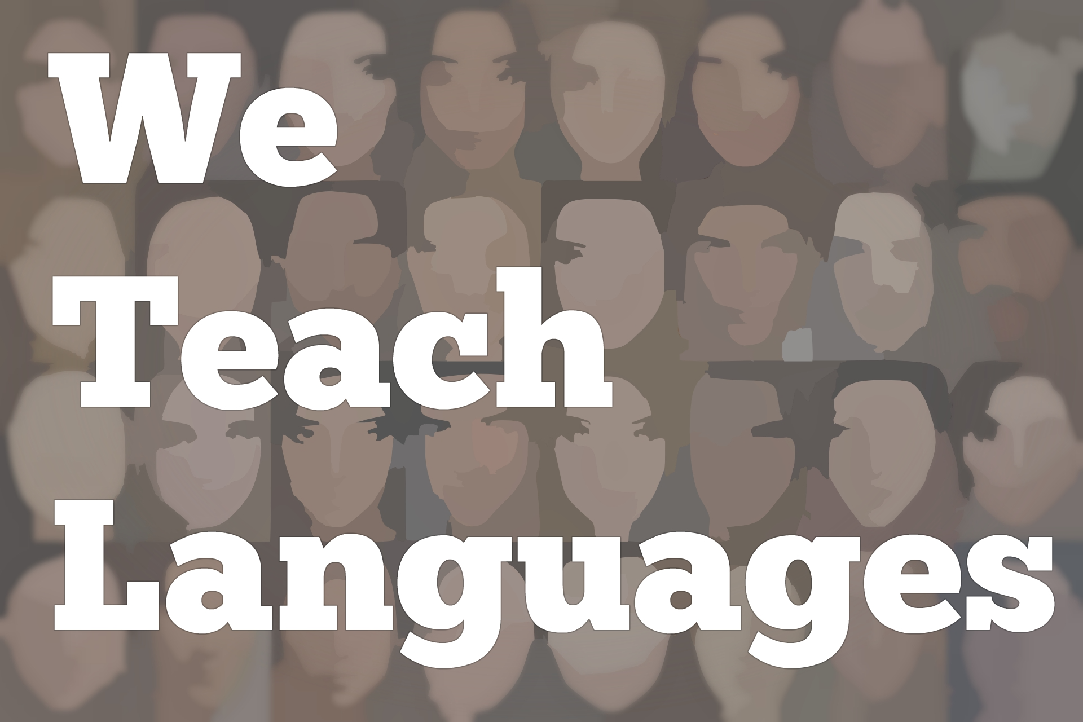
We Teach Languages Episode 128: Serving Bilingual Students and Getting around Harmful Parts of the Curriculum with Holland White

Stacey Margarita Johnson: [0:00] This is "We Teach Languages," a podcast about language teaching from the diverse perspectives of teachers.
[0:10] [music]
Stacey: [0:13] I'm Stacey Margarita Johnson. Today, on Episode 128, Jiaqian Chen interviews Holland White about her experiences teaching English language arts in a school where she had a lot of bilingual students who were learning English as an additional language.
[0:31] [music]
Jiaqian Chen: [0:31] Hi, I'm Jiaqian Chen. Today, I'm going to interview Holland White about teaching English language learners. Holland was a teaching assistant of my Foundations of English Language Learners Education class at Vanderbilt.
[0:49] Hi, Holland. Can you tell us something about your teaching context, your students, and your school?
Holland White: [0:56] I taught for four years at the high school level. I taught 9th grade, 10th grade, and 11th grade English language arts.
[1:03] I didn't specifically teach an ESL class, but I had a lot of students who were classified as English learners, and I taught in Austin, Texas, which is pretty close to the Mexico border, so most of my students spoke Spanish as their home language or as their first language.
[1:24] A lot of them are pretty proficient as far as their bilingual skills. Let's see. The school was considered a Title I school, meaning that I think there's maybe 90 percent of my students received free or reduced lunch, meaning their families were from a lower socioeconomic context.
[1:47] That also affected class sizes and funding, so I tended to have really big classes of students. I had to be responsible for getting them books and little things like that. That's where my teaching background is.
Jiaqian: [2:04] What do you think excellent language teaching looks like?
Holland: [2:11] I think excellent language teaching is a tough question, but I would say first and foremost, before any of the higher-level teaching can go on is that I think you have to have a good relationship with your students, and they have to trust you.
[2:28] I think that working in a context where a lot of my students were bilingual and a lot of my students were either Latino or African American, then coming in as a white, mostly monolingual teacher who doesn't have the same background makes it so that I don't seem as trustworthy.
[2:49] I think the first part of being a good language teacher is building that relationship and rapport so that students can trust you so they're not thinking you're just there to be like, "No, you're wrong, and you're dumb, and you don't have these skills, so that means that something's wrong with you."
[3:04] I think that's the first part, and then I think that the second part would be being patient with their growth over time, because I think that especially for students who don't speak English as their native language, I think growth happens gradually. It doesn't happen all at once.
[3:22] I think you have to trust in the process over time, as long as you keep working with them and then you keep challenging them, that growth will happen.
[3:32] Maybe even it doesn't happen in your classroom, but it might happen the next year. Then they come back and they're like, "Oh, I learned all these things." You're like, "Good. I knew that was happening somewhere in there."
[3:42] Yeah, I think that that challenging part is good too. You don't want to just keep doing things at the level that you think that the students are at, but you want to make sure that you're supporting them at higher levels so that they can get there. That's that zone of proximal development kind of model. I think that's important for language teaching.
Jiaqian: [4:00] As you have mentioned a challenging part. What was the most challenging part when you were a novice teacher?
Holland: [4:06] I think my first year of teaching, the most challenging part was figuring out how I could get around some of the parts in the curriculum that I knew were harmful for my students.
[4:25] Some of the grammar exercises and some of the weird, very disconnected texts that we were supposed to teach, figuring out, is this something I really have to do, and what would be better, and I know what would engage my students more.
[4:40] I think a lot of times teachers tend to be rule-followers, because probably a few years ago, if you're a teacher, it means that you were maybe a good student in school and it worked well for you. Part of that is you followed rules and you did what was expected.
[4:53] I think part of being a good teacher is knowing, if you're really a student-centered teacher, knowing, "This is not good for my students, and let me figure out something that's better," at the same time respecting the administration and saying, "I get why you wanted to do this. However, this is what I know to be a better practice and this is what I can look at research and know is a better practice."
[5:17] I would say negotiating that "What's expected of me?" versus "How can I serve my students the best way possible?"
Jiaqian: [5:28] Thank you. I remember that you shared your experience of keeping a record of conferences. Why do you think it's important?
Holland: [5:38] In different ways every single year, in reading and writing units with my students, I always kept a record of our conferences.
[5:48] That would be when we one-on-one sat down and said what was going on, "What are you working on right now on this piece?" or if they're reading a book independently or in partnership, not only just what's going on in the plot but "How are you making sense of this?" and thinking about comprehension and meta-cognition and all that stuff.
[6:06] I typically kept records of that every time I sat down to talk with them, because I wanted to not only just remember what we talked about so that I could sit down with the kid two weeks later and not ask the exact same questions I had the last time we sat down, but be able to grow on that, and also for me to have a record of their growth that wasn't tied to test scores, because sometimes the tests don't measure what they're actually doing or their ability.
[6:37] If I had this thing in writing, like, "Man, they were actually thinking about this, this, and this, and they did this, this, and this," and I have it in my own way of keeping a record of that, I think it helped me to see them as capable, but also if there were questions from administrators or anything like that, I had that record as well.
[6:56] Then even just handing it to students and letting them look through this and let them see all the stuff that they had done throughout the year was always an interesting, fun thing.
Jiaqian: [7:05] And see their own progress.
Holland: [7:07] Yeah, exactly.
Jiaqian: [7:08] Do you have any recommendations for teachers like you who teach adolescents?
Holland: [7:12] I would say my number-one recommendation is to recognize all of the knowledge and skills and abilities that your students come into your classroom with already -- that they're not just there as this empty vessel to be filled with your knowledge, but they come in with all of these practices and skills already.
[7:39] My job is to be able to recognize what they can already do and to build on that. I think that's the biggest thing, the biggest recommendation, and, like I said at the beginning, forming relationships. I think that is a huge part of being able to teach adolescents, like teaching at the high school level.
[7:58] Kids would tell me, "I'm not doing anything in that teacher's classroom because I don't like her," which is ridiculous. You have to be like, "OK, that just looks bad on you," but also, it's a truth that you have to have those relationships for kids to trust you and then that learning process to occur.
Jiaqian: [8:17] The last question. Do you have any recommendations for teachers like you who want to develop their profession, or maybe just a bit of inspiration?
Holland: [8:30] Yeah. I know when I was a teacher, I made sure that I was involved in different national organizations. I worked with the National Writing Project. I did a summer institute with them, and I would go on Saturday workshops.
[8:44] It was nice to be out of school but with like-minded teachers who cared about their students enough to get up on a Saturday morning and want to talk about teaching after a long week. I think sometimes we get so bogged down in the day-to-day of "Oh, I have to do this, I have to do that" that you forget why you wanted to teach in the first place.
[9:07] I think sometimes being a part of those organizations can help focus your intentions of, "This is why I was interested in literacy teaching, and this is what it's all for." I think finding those groups is really important to sustain your teaching career.
Jiaqian: [9:27] This is super-true. This is a Chinese word, choosing your initial original purpose or goals. Sometimes you will just forget that while you're doing other things, while you're busy with other things. I totally agree with you.
Holland: [9:46] Yeah.
Jiaqian: [9:47] OK, thank you for today's interview.
Holland: [9:49] You're very welcome. It was nice to talk with you.
[9:53] [background music]
Stacey: [9:57] If you have questions or comments related to today's episode, we would love to hear from you. You can reach out to us multiple ways. All of them are available at our website, weteachlang.com/contact. You can also find us on Facebook and Twitter @weteachlang.
[10:17] We would like to say a very special thank you to the PEARLL Foreign Language Resource Center for partnering with us to provide transcripts and other professional development resources related to the episodes. You can learn more about PEARLL by going to pearll.nflc.umd.edu.
[10:45] Thanks so much for listening. Bye-bye.

Podcast transcripts are provided through a partnership with PEARLL (Professionals in Education Advancing Research and Language Learning), a Title VI Language Resource Center at the National Foreign Language Center at the University of Maryland. Find additional transcripts: www.pearll.nflc.umd.edu/podcast

Transcription by CastingWords

