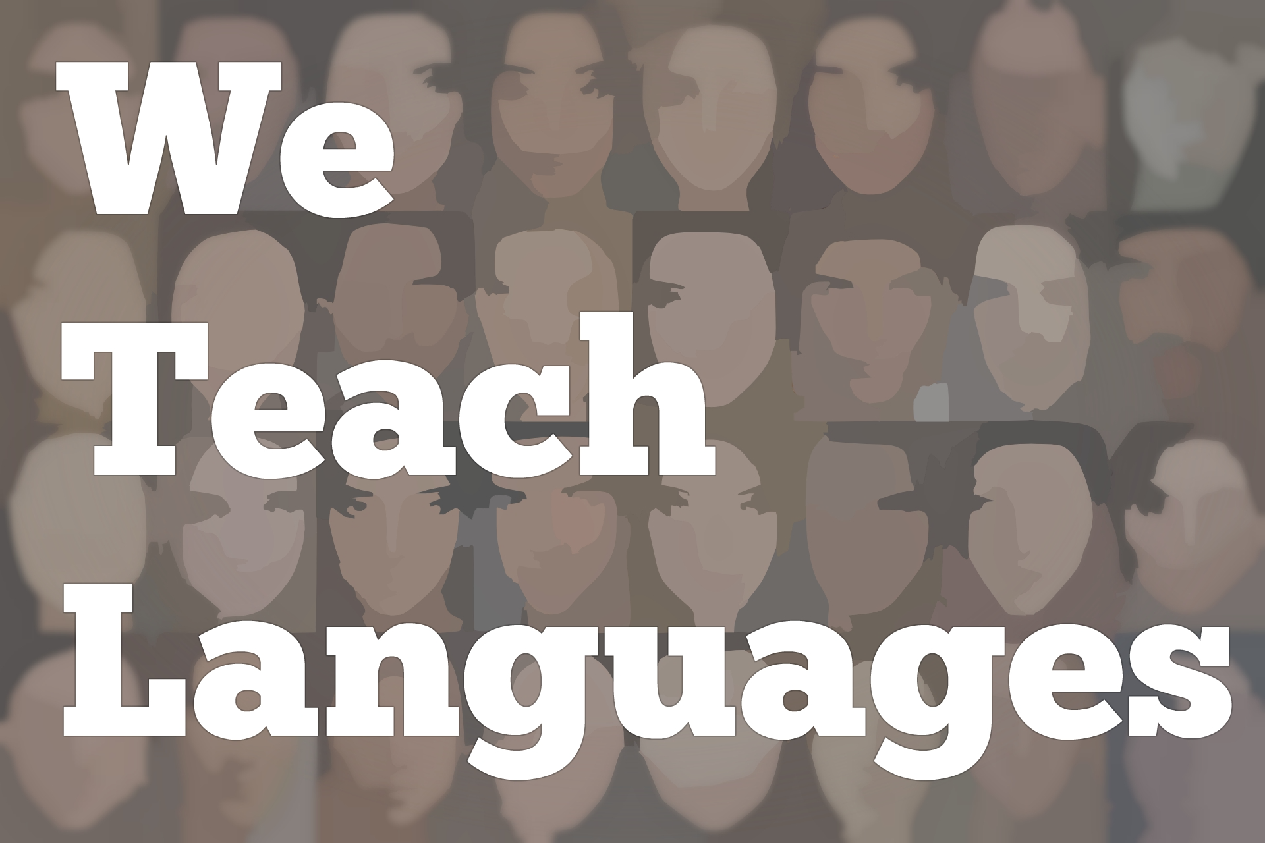
We Teach Languages Episode 135: Indigenous Language Revitalization, Teacher Development, and NILI with Robert Elliott
[00:00] [background music]
Stacey Margarita Johnson: [00:00] This is, "We Teach Languages," a podcast about language teaching from the diverse perspectives of teachers.
[00:11] I'm Stacey Johnson, and today on episode 135, I'm going to share a conversation I recently got to have with Robert Elliott, Associate Director of the Northwest Indian Language Institute, or NILI, at the University of Oregon.
[00:27] NILI works with Native American tribes to support and strengthen language preservation and revitalization efforts. This interview is part of a crossover episode with "Leading Lines," another podcast I work with, that focuses on educational technology.
[00:45] What you're going to hear in this, We Teach Languages episode is the portion of my conversation with Robert that focuses on what NILI offers language teachers, and how language teachers can be part of indigenous language revitalization.
[01:02] If you are interested in learning more about how technology can be used through teacher training and curriculum development to promote language preservation, language revitalization, language documentation, and a little bit about the history of the eradication of Native American languages that's led to these efforts.
[01:26] I would very strongly encourage you to listen to this second part of this conversation, which is available through the Leading Lines podcast. I'm going to put a link to that episode in the show notes, or you can just search for leadinglinespod.com, and check out episode 73 with Robert Elliott.
[01:47] [background music]
Stacey: [01:48] That said, on to the interview.
[01:50] I thought maybe I could wait for us to get started, it would be just for you to introduce yourself and tell us, where do you work and how did you come to work there?
Robert Elliott: [02:04] My name is Robert Elliott and I work at the Northwest Indian Language Institute, or NILI, at the University of Oregon in Eugene, Oregon. I've been with NILI for about 10 years now.
[02:19] At NILI, we work with language revitalization, working predominantly with endangered languages from around the Pacific Northwest from Washington, Oregon, Idaho, and Northern California. We also work with languages in Alaska, Mississippi, and Florida.
[02:41] I did a workshop in Costa Rico, and we've been to France and Spain, and worked also in Poland.
[02:52] There's endangered languages around the world, which is something that I'm not always aware of. I've been focused mostly on North American indigenous languages, but it is a global phenomenon, this language loss that the world is currently experiencing. The flipside of language losses, language revitalization, and that's what we do at NILI.
Stacey: [03:14] How did you come to work at NILI?
Robert: [03:16] I was actually trained as an ESL instructor. I went to grad school in San Francisco Bay Area and worked with ESL there for maybe 10 years before we moved to Oregon. Since my father is native, he is [inaudible] , but he was separated from his mother when he was two years old.
[03:41] When we moved to Oregon, I was first hired by the ESL unit that's at Oregon, the AEI, American English Institute, they have there. At first, that was where 100 percent of my job was, but I was always interested in the NILI that we have this institute on campus.
[04:01] At first, I just started volunteering with NILI, helping out with filming and technology stuff, because that's one of my specialty areas within language as a language teacher trainer, language educator.
[04:15] They asked me to be on a project, and then it was two projects, and then eventually about eight years ago, my entire position was moved over to NILI. I became developing some online courses that we did there and on different projects, and then became an Associate Director about five or six years ago. I haven't looked back since.
[04:38] I also do teacher education at the University of Oregon, where I teach a lot of technology classes and other types of classes for future language teachers.
[04:49] One of the things about the University of Oregon is it's the LTS, Language Teaching Studies, program through the linguistics department. It's not an ESL program. It's not a French program. It is intentionally designed to be for multiple languages including indigenous languages.
[05:08] Right now, we have three speakers of different languages from North America who are master's students within that program.
Stacey: [05:18] That's awesome.
Robert: [05:19] Yeah, it is. We do have a number of ESL people that train to become ESL teachers, French, have Spanish, things like that, but we are intentionally [inaudible] multilingual unit and supporting indigenous languages, and there's no training places around that have that.
[05:38] Having NILI on campus and having me as a faculty member in both NILI and the indigenous language work, and also being able to work with students who will become teachers of indigenous languages, I think that's pretty unique and pretty lucky to have all of that at Oregon.
Stacey: [05:56] I imagine there might be two different kinds of people listening today. The kind of first person might be someone who does not teach indigenous language or a North American language, but wants to know what they can do to be useful or to somehow be involved to help the effort. That's where I would definitely fall into.
[06:19] I only teach Spanish, which is a colonial language. If there's some way that I can be useful, I would love to.
[06:25] The second thing is there might be teachers listening who teach languages that have very small communities or speakers, or they might be North American indigenous languages and they might be wondering are there services or are there opportunities to get more involved with the center and get better at what they do.
[06:43] I was wondering if you might have a message to share with each of those two groups of listeners.
Robert: [06:49] Sure. For the first type of listener, the one who's a language teacher and just wants to be more supportive of language minorities of North America, maybe language work. The most important thing is to, first of all, educate yourself a little bit about who are the people that are the traditional stewards of the land that you're currently on.
[07:24] You've seen this happening at least in Oregon and out here in the West a little bit is, a lot of times in a lot of Native conferences I've been at, where there's often land acknowledgment. We have one, for example, on our website.
[07:42] The Kalapuya people were the original inhabitants of the Willamette Valley, and their descendants today live on the Siletz and Grand Ronde reservations of Oregon.
[07:53] Starting with, we have that on our website. A lot of people have that now on their websites or conferences people do a little land acknowledgment. Just by knowing who those people were and where are they today, maybe informing yourself is vital and then telling people about that whenever possible.
[08:18] I also think as a language educator that, I've seen people who will have their classroom where maybe there's a large group of Spanish speakers or Chinese speakers in the classroom in an ESL classroom and then a teacher might say, "OK, guys, let's stay in English the whole time. Come on, because this is your opportunity," and just this...almost like an English-only sentiment to the classroom where the end justify the means.
[08:46] Of course, we want our students to be as fluent as possible. That's our goal to make fluent speakers of whatever target language we're working on. We need to see languages more holistically as part of a system in the way that made the prelingual approach to it.
[09:06] People use whatever parts of language that they have to accomplish their goals and to validate support those different languages, and make space and room for them. To not maybe unconsciously or consciously promote the value of one language over another, that this is more valuable, then other language is not useful.
[09:32] I think sometimes those messages come across if we're not careful and not respectful of all the identities, all of the languages that our students might have.
Stacey: [09:45] I'm feeling convicted right now. I think sometimes in my advocacy for my own department, which is Spanish and Portuguese, I definitely veer into, "Spanish will be more useful to you than any of the other options you have available to you," which usually means than any of the other languages you could take here, trying to position the productive value in economic terms maybe.
[10:17] I hope I'm not doing that, [laughs] but I think I probably do just in my enthusiasm for advocacy, so I need to be more careful about that. That was a really good word, thank you.
Robert: [10:27] Yeah. I'm thinking a little bit also, when I used to teach ESL in the Mission District of San Francisco where it was 99 percent Latino/Latina/Latinx population that we had there, but there was often assumption that everybody was a Spanish speaker, which became pretty clearly not the case when you probe beneath the surface.
[10:49] There were so many different indigenous languages that were the first language of a lot of the speakers that we had there. Just the assumptions that we have often can be questioned, [laughs] I guess.
[11:03] I think, as a teacher, asking and finding out and learning should never end and there's so much...I don't know a lot about the languages of Mexico and Central America. I know a little bit, but there are so many different languages out there and they are so interesting.
[11:23] Our students have so many different perspectives when they bring those to the classroom. I think, yeah. I think, as language teachers more generally, we have a duty to inform people about facts and not just...
[11:37] I think there's a lot of myths that float around that we should be able to dispel. [laughs] For example, some parents might think that, "Well, you know, if my child is learning an indigenous language, is that going to put them behind in their English and they're going to fall behind and not do as well in their other subjects?"
[12:00] This is subtractive of bilingualism, my guess is. I think that I've had to address that sometimes and say, "No." Actually, the evidence is that that is not an issue. [laughs]
[12:15] Being knowledgeable and up on your facts and being able to help parents or other people that are making decisions about where their energy or resources should go, I think that's something we should take on as well as language educators.
[12:30] Your other question was about how people that are involved in minority languages or indigenous languages, what they can do, I would say that NILI is not the only institute that works off of language revitalization. There's not very many of them, but there are a couple.
[12:53] For example, AILDI in Arizona is one, and there's CILLDI in Alberta, Canada, is another one, and then there's other...Those are both institutions that are affiliated...AILDI with the University of Arizona and CILLDI with University of Alberta.
[13:10] They're academic and community collaborative types of projects. There's of course other private places, non-profit places that are involved in language revitalization. There's places around.
[13:25] One of the reasons NILI began in the first place was that there were a number of teachers of indigenous language of Oregon that had gone down to Arizona, AILDI was the first one, and had gone down to Arizona and taken part and loved it, and thought it was fantastic.
[13:41] They wanted something closer to home, and something that was a little more focused on the specific issues of the languages here. There's some different...The situation is a little different for our communities and the languages linguistically are a little different for our communities than they are down there.
[14:02] That's how, 22-plus years ago, NILI was founded because members of these communities came to University of Oregon, and they said, "Hey, you know you've been making your careers as anthropologists, as linguists, off of our communities, but at the same time our languages are disappearing."
"[14:22] Languages are not thriving. You're writing these books that are not accessible to us or these publications, and they're not helping us also. Can you do something to help us with our languages?"
[14:37] The linguistics department at that time put a graduate student, the current director, [inaudible] , put her in charge when she was a grad student, then of starting to go out and work with some of the communities.
[14:49] She drove out in her car and used the trunk of her car as her office and worked with several different communities, and that's how it all started 20-some years ago.
[15:01] Anyway, I think that what people can do is, of course, if they're interested, they can attend something like a summer institute, which AILDI has, which NILI has. There's summer institutes that people can come to, they can get academic credit, if that's something that's desirable.
[15:22] Typically, what you'll get at one of these kinds of institutes is you'll do a lot of work off of your language, you would select linguistics classes in the morning, language class from your specific language.
[15:34] If you have a group of five or more that are attending, then we're able to hire a language teacher from your community or a linguist from your community that's able to come and work with your group, your specific issues.
Stacey: [15:48] That's amazing. That would be such a huge benefit.
Robert: [15:53] Yeah, we've had that with a couple of different languages, where they've had enough people, critical mass of people. We have a couple of languages from the Pacific Northwest that we always teach at our summer institute.
Stacey: [16:05] Do you mind telling me which languages those are?
Robert: [16:09] We have Ichishkíin. It's sometimes called Shahaptin. In the language, it's called Ichishkíin. Traditionally, that was spoken throughout the High Plateau area of Washington and Eastern Oregon.
[16:25] Today, it's spoken in Yakima reservation, Umatilla, and Warm Springs reservations. It's pretty disperse. That's one of the languages. Tolowa Dee-ni is another language, Athabascan language of Northern California and Southern Oregon, which is taught every year.
[16:45] Sometimes, we've had Chinuk Wawa, which is a language that was spoken widely amongst communities as a lingua franca.
[16:53] Because Oregon and Pacific Northwest was so linguistically diverse, people spoke lots of different languages, but they also developed a common language, which had elements of the Chinook language, plus other native languages, plus it had originally French involved in it because of the French trappers that were out here.
[17:15] As the English came along and started being out in the West, it developed parts of English that are in there. There's even elements of Hawaiian that are in Chinuk Wawa because there were sailors off of the ships that were coming around the horn and then going through Hawaii before they got to the West Coast, so they were part of the influence on that particular language.
[17:37] Yeah, so that one...
[17:38] [crosstalk]
Robert: [17:39] has been taught as well. Lachutsi, there's another one. Lachutsi is a language of the Seattle, Western Washington region, around the Seattle and surrounding areas.
[17:52] That one is also usually represented at NILI as well every year. We've had other ones, like we've had Choctaw from the Mississippi Band of Choctaw Indians who've come. They've had enough that have been coming several years that they have their own Choctaw teacher that has been here.
[18:10] Even others, like we've had Hawaiians, people from Alaska, people from Canada. If they're coming individually, the experience of taking another language -- it's interesting to see how the language is taught from an outsider's point of view. Sometimes we forget that as language teachers.
[18:30] I think that they'll often go into a language class that they think might be either related to their language or sometimes Chinuk Wawa, which, again, was more of a trade language or a creole at that time. They'll maybe take one of those classes and be able to learn from that.
Stacey: [18:47] There's something in the literature about methods courses and teacher education. There's something about experiencing a language teaching method as a learner that is so much more powerful than experiencing it as professional development or intellectually knowing this is a good way to teach a language. [laughs]
Robert: [19:08] Right.
Stacey: [19:10] You can't really learn to teach in a way that you haven't experienced as a learner and seen to be effective, so I love that you're giving participants that dual experience.
Robert: [19:22] I remember thinking about this before. If you're going to teach writing, you should be a writer. [laughs] If you're going to teach a language, you should be a language learner as well and not forget that -- what it's like to be lost [laughs] and overwhelmed, because it's humbling.
[19:39] We have those language classes in the morning. We usually have classes around pedagogy. Last year, one of the themes was on classroom management. That was taught, and immersion. Sometimes we have...There's a lot of choices about which kind of classes to take.
[19:54] There's technology classes, which I'm teaching, usually in the afternoons, and sometimes people have options, like maybe hand drawings of materials, instead, if they're afraid of technology.
Stacey: [20:08] I think my last question is, if someone has been listening to your description of the summer institute and is interested in learning more or maybe registering, where would you send them to get that information?
Robert: [20:21] The best place to go is to our website, nili.uoregon.edu, so nili.uoregon.edu. On our website, there's all kinds of information, but there's a link under Summer Institute. All the information, including registration for the conference, is there.
[20:46] Our conference, again, is two weeks long. It is June 15th to June 26th this year. It's almost always at the end of June. Get out before the 4th of July, because a lot of communities want to be home. These are important days often with families and communities, so we try to have that near the end of June.
[21:07] Registering there, and if there's other questions, they can always contact us at NILI. Our email is listed there, but it's nwili -- Northwest Indian Language Institute -- nwili@uoregon.edu, or they can call us at our office. Again, on our website, you can find all that information.
Stacey: [21:28] Excellent. Also, you've mentioned some books and authors and also all your website information. I'm just going to put links to some of that stuff in the show notes as well. If people didn't get a chance to write it down, you can just click on the show notes and find everything we talked about today.
[21:45] [background music]
Robert: [21:44] Perfect.
Stacey: [21:45] Thanks again. This was incredibly enlightening. Thank you so much.
[21:48] If you have questions or comments related to today's episode, we would love to hear from you. You can reach out to us multiple ways. All of them are available at our website, weteachlang.com/contact. You can also find us on Facebook and Twitter at @weteachlang.
[22:11] We would like to say a very special thank you to the PEARLL Foreign Language Resource Center for partnering with us to provide transcripts and other professional development resources related to the episodes.
[22:24] You can learn more about PEARLL by going to pearll.nflc.umd.edu. Thanks so much for listening. Bye-bye.

Podcast transcripts are provided through a partnership with PEARLL (Professionals in Education Advancing Research and Language Learning), a Title VI Language Resource Center at the National Foreign Language Center at the University of Maryland. Find additional transcripts: www.pearll.nflc.umd.edu/podcast

Transcription by CastingWords

