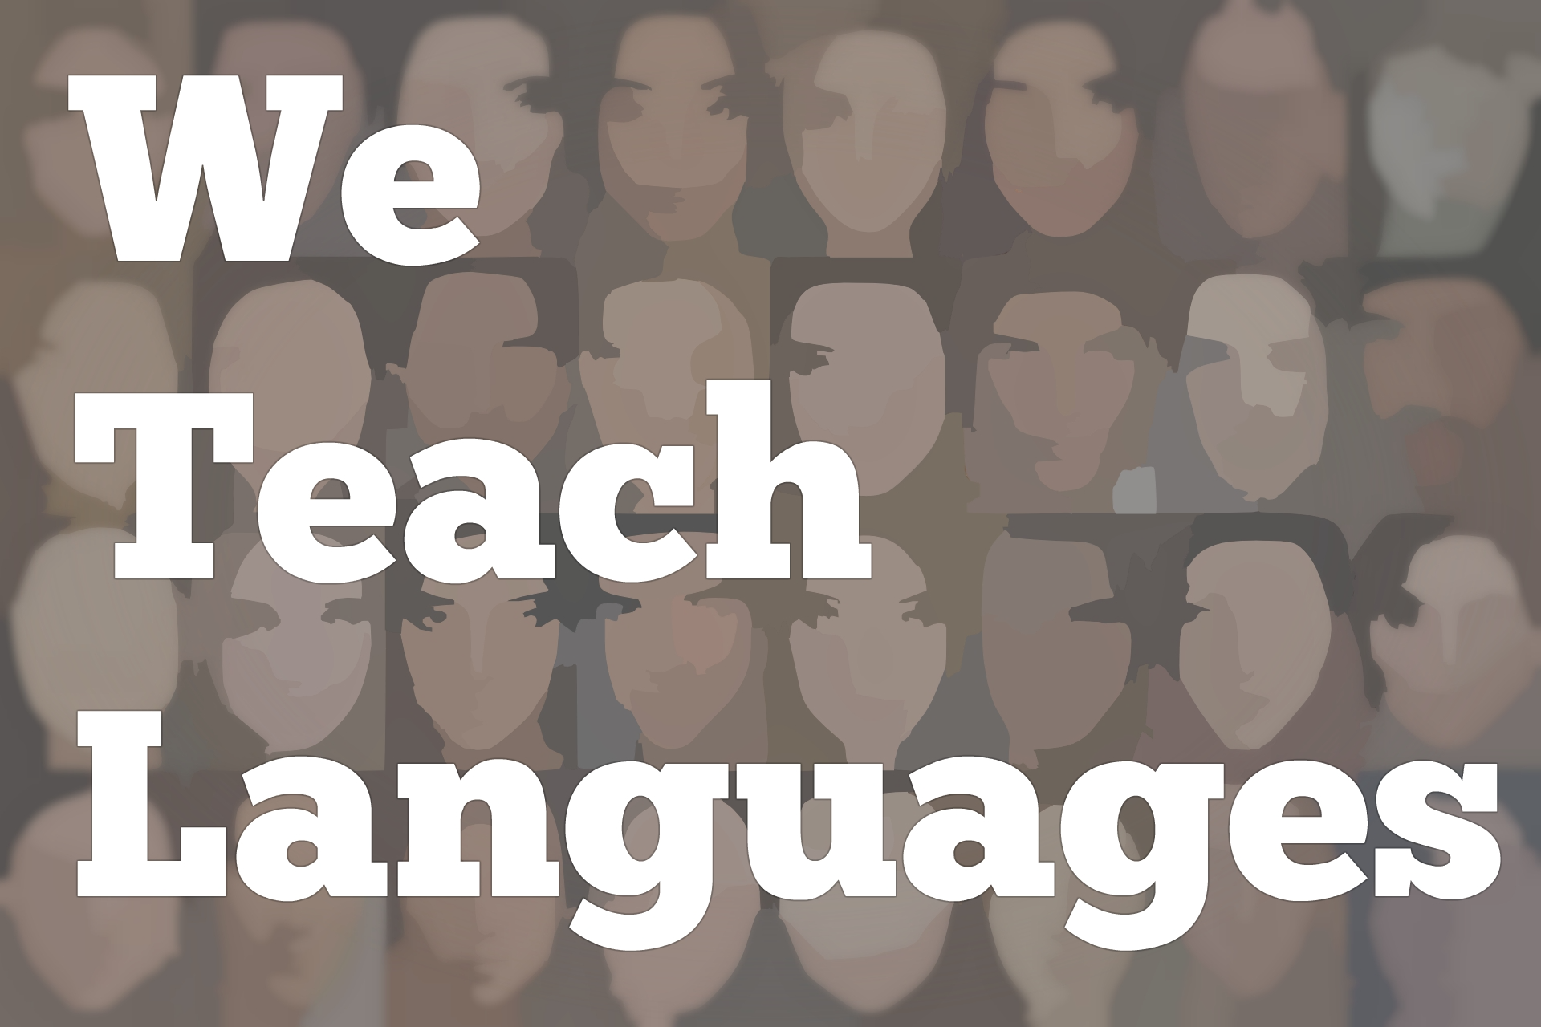
We Teach Languages Episode 140: Heritage Language Maintenance with Angelica Amezcua

Stacey Margarita Johnson: [0:00] This is "We Teach Languages," a podcast about language teaching from the diverse perspectives of teachers.
[0:07] [background music]
Stacey: [0:12] I'm Stacey Margarita Johnson and today, on episode 140, I get to speak with Angélica Amezcua about her research on Spanish language maintenance motivation in a heritage-learning classroom.
[0:29] Angélica, thank you so much for agreeing to speak with me today.
Angelica Amezcua: [0:34] No, thank you for the invitation.
Stacey: [0:37] The reason I extended this invitation and the reason I know about your work is because you recently published an article in Spanish and Portuguese Review. I think it has a lot of really clear applications for language teachers. We're going to spend our time together today talking about the research you did and what language teachers can learn from it.
[0:58] Before we get started on that though, would you mind telling us a little bit about what your context is, where you work, what you do, who you are?
Angélica: [1:06] Yes, of course. I'm a PhD candidate at Arizona State where my focus is in applying with specifically Heritage Language Pedagogy.
Stacey: [1:18] Excellent. How did you become interested in Heritage Language Pedagogy specifically?
Angélica: [1:22] As a Heritage Language speaker myself, I was always intrigue as to how do we find out what was happening? I came into United States when I was 11. By then, I realized that it seemed in order for me to learn my English, I need to lose my Spanish.
[1:39] There was no reinforcement in my literacy in Spanish. Then, that become more and more obvious when I went into University where I felt that yes, my English was stronger and I had developed certain literacy in English but in year, I felt that the Spanish that I came into United States stayed there. It was stuck.
[2:02] It was never developed. When I went into my BA, I started finding about linguistics. It was not until my masters that I started understanding that there's a social competent to linguistics, to Spanish.
[2:17] Now, I realized that there was this field, Heritage Language Pedagogy, and I identified with this population because I felt that as I was developing my English, my Spanish was not developed at the same grade, and because I was not given the opportunity to do so at the University.
[2:39] My only exposure was at home with my family or with those friends, but then they still like that. When I studied, I did my masters in Ethnic Studies, and then I realized that language is not a way, another form of discrimination to the Latinx community.
[2:58] My masters, I did in that, in how language is being used to continue oppressing the Latinx community.
[3:08] Because of that, I was like, "I'm going to do a PhD in Spanish and Heritage Language Pedagogy." I feel that development of literacies in Spanish for heritage language students is a right and it's a political act where anything around the university or the education, the only opportunity for them to develop certain skills in Spanish is on to high school.
[3:35] Sometimes they don't even give that chance or many times we are told that oh, we speak bad Spanish, we speak broken Spanish. In reality, we were never given the opportunity to further develop our literacies.
[3:48] For me, heritage language pedagogy, it started for my own personal experience but it developed into a political act as to how can we promote the maintenance in Spanish amongst students who unconsciously or they don't realize that the fact that they have been told that it's not...They don't develop certain skills in Spanish. It's not their fault.
[4:15] It's the society that we live in that are not giving them the opportunities. In a way, for me, having pride in Spanish became a tool of resistance. Through developing literacy skills, also is another form of resistance.
Stacey: [4:31] Angelica, that's awesome. I need a pause and think that through for a minute because that is beautiful. [laughs]
Angélica: [4:39] No, thank you for that. For me, when I started researching more about heritage language pedagogy, we were finding about, we were looking that "Yes, there's a positive outcome of these classes because students said that they feel more confident."
[4:57] I was intrigued in finding out what exactly is happening in these courses that is benefiting the students? That's how I came into this type of research and then with this framework, the fact that I live in California and I live in Arizona, in states that have low ethnolinguistic vitality.
[5:18] What this is is that there's no promotion and there's no resources to continue developing your skills. Instead the sobriety...
[5:25] [crosstalk]
Stacey: [5:25] Let me...I'm sorry. I just wanted to ask the term that you used.
Angélica: [5:30] Ethnolinguistic vitality, yes. In states that instead of valuing bilingualism, there's a devaluation in particular in California where a proposition, the impact that bi-language education, now we have another proposition that eliminated that and now we are able to implement more bilingualism.
[5:53] In Arizona, for instance, another proposition also hinder bi-language education so these two states really have low ethnolinguistic vitality. In this context, then what is the purpose of this heritage language classes and the heritage language pedagogy?
Stacey: [6:11] I'm not sure I completely understand what the term ethnolinguistic vitality means. Can you define that really briefly for me so I can understand how it relates to this anti-bilingualism policies that you talk about?
Angélica: [6:26] Ethnolinguistic vitality addresses the fact that what is the studies of the language within a society. In particular, these states because they have a big population or big demographics of speakers, Spanish speakers, for instance, but there's no support to be able to maintain the Spanish or develop different literacies.
[6:48] The fact that they have a lot of population and there's no resources, instead there's different [indecipherable] facts to the language use then that says that there's a low ethnolinguistic vitality of the language.
Stacey: [7:01] Got you. That is really interesting because we do think of California and Arizona as being places. I happen to have grown up in California so I think of it as being a place that has a lot of ethnic diversity and linguistic diversity.
[7:19] On the other hand, you have this social support and actual policies that are preventing people from maintaining their language, right?
Angélica: [7:28] Exactly. It's both education and governmental organizations that prevent this. There's already a population that speaks a language. Why not foment their abilities and promote their bilingualism for them to feel they can take pride of it and develop it. Instead they are discouraged or they're not given the opportunities to do so.
[7:53] How do we value what students bring already into the classroom? Then my focus really is with this concept in this society where we live at where there's no promotion of Spanish maintenance. Then how can we promote Spanish maintenance beyond the classroom? What could happen?
[8:14] What is happening in heritage language classes that could be used as a way to reinforce this value of their own language but also continue using their language beyond the semester or the academic year? Then I started to explore it, the curriculum of what was happening.
[8:32] Many times we feel that Spanish students come into the classes and they need to understand how to use preterite or perfect. They have to use grammatical structures or it depends on the curriculum. I wanted to see what was happening beyond this type of curriculum. What kind of activities really promote it? Spanish maintenance.
[9:00] I know that maintenance cannot be measured within one semester. In a way, what students learn in the classroom could contribute to Spanish maintenance because they could be motivated to continue using their Spanish beyond the classroom.
Stacey: [9:13] OK. With that in mind, what was the actual study that you conducted for this research? Who did you study and what did you do to get your data?
Angélica: [9:22] I interviewed students, 17 students that were enrolled in a Spanish heritage language classroom. The ones in a Chicana Chicano studies department. That's important to mention because it wasn't in a Spanish department.
[9:42] I interviewed them. I collected data from those interviews. This is students that range from different majors. They range from 18 to 35 years of age, and I allow them to self-identify. Many of them said that they were Latinos, Hispanics, Chicano students.
[10:06] I had two students from El Salvador. Once I collected those interviews, I analyzed the data and I was really impressed with the type of data that I gained from the students.
Stacey: [10:20] I would like to know what your findings were.
Angélica: [10:23] As I was interviewing them, I wanted to find out what was the most impactful things that they gained from that classroom. There's two things that they said that were really impact. The assignments for the first project that was called the personal history project, and I'm going to go in-depth as to what they was.
[10:41] The other second project was the community project. There's many research that has found that service learning is impactful for students. That community project involved that. Our student in order to do complete service learning in the community where they had to use their language as a resource to be able to help the community.
[11:00] That was one of the things that they stated that was impactful for them to participate in the class. In the personal history project, students said that assignments they have to complete which were four. One was many research study about learning why did they get the name, who gave it to them, and what did their name meant.
[11:23] The second one was interview that they have to complete with their family. Then also students need to do a family tree and the last one was they needed to write a poem that represented their bilingualism.
[11:42] Those are the two projects that the students kept mentioning. Mentioning that that was the most impactful assignments that they had in the classroom. Not necessarily grammar. Not necessarily spelling but these assignments that really connected them with the community outside of the classroom.
[12:01] With their language use outside of the classroom. There were three things that came from my study. First thing was the confidence, bonding, advocating and finding yourself, and then Spanish use beyond the classroom.
[12:17] Many studies have also found that maintenance goes hand in hand with linguistic confidence. That is pretty much to say that if students feel comfortable and confident about the language then it's going to be more likely to continue using their Spanish.
[12:33] What happen in this classroom? Students said that they recognize or they learned to value their way of speaking. Their way of speaking that many times was they consider as broken Spanish or not good Spanish. Students were mentioning that.
[12:53] That the teacher made them feel that their Spanish was valuable. That it was important for them to continue speaking Spanish. Many students continue saying that they feel more confident. That this course have built their confidence.
Stacey: [13:06] I think sometimes we take for granted like the power inherent in the teacher role. As we're in some ways granting authority to students to use their language.
[13:19] In my case, I don't often teach heritage speakers but I'm thinking about students who are just beginning to grapple with what it means to be someone who speaks another language telling them that the way they're speaking is good and useful, and communicates. I can understand that and I want to hear what they have to say is so powerful.
[13:40] I can imagine in heritage context where I'm also giving that external validation that the way they speak is good and correct, and they shouldn't feel ashamed of it would be that much more powerful.
Angélica: [13:53] Right. US Spanish is another dialect that needs to be valued as much as the other dialects that exists. So then as I think students' understanding that the way you're speaking is seen as valuable in the classroom, it's really prime for them to feel or be like have this reconnection that they are bilinguists. That they speak Spanish.
[14:14] Where many times they could think that "Oh, I'm not bilingual because I course switched," or "Not bilingual because I use cognates." No. That course switching or it's really what's happening naturally because of the combination of two languages. They should be able to recognize that.
[14:34] By the way, they speak is valuable. I think that that came a lot that students feel that after taking this class. They feel a lot more confident in using their Spanish. That goes into my other thing that it's how did this confidence help them.
[14:53] For instance, we find that Carolina, one of the participants said that after completing the tree, she found out who she was. Because many times we tend to forget that the students grow up in two different cultures. She feel that she was neither Mexican or she wasn't neither like an Anglo. She said that this mix of two culture is really what she is.
[15:19] She was able to visualize them by completing a family tree. That she belong here. That she didn't have to battle anymore figuring out who her identity is but rather her identity was both. That she celebrated Mexican celebrations at the same time, she celebrated US celebrations.
[15:42] I think that this as she interacted with her family by creating this family tree. She was able to embrace this bi-cultural identity.
Stacey: [15:54] That's fantastic.
Angélica: [15:55] That's another thing that came a lot about. This activity is that inter-connectivity between their language and their ethnic identity from these family trees, from finding out their name.
[16:08] The pronunciation of their name in Spanish has a different meaning than the pronunciation in English, and how many times it was like the struggle with their name pronunciation where they felt that they were different identity because...Does that make sense like the name was different?
Stacey: [16:27] Yes, I understand.
Angélica: [16:30] If we continue with that idea, I was mentioning the fact that the students have to do a service learning activity and there's this participant. Her name, I will say, is Carla. It was elementary class and then she realized, oh she had never realized that her bilingualism could be used as a resource.
[16:53] Then she find out through doing the service the value for bilingualism. Then she said after completing the service learning that she was required, she wanted to do more. She wanted to do more service and now, she wanted to extend it beyond a school. She wanted to go to immigration organizations to be able to use Spanish, to be able to help more people.
[17:17] What's going to happen as a result of this, Carla is going to continue using her Spanish. As a consequence, developing by helping others new vocabulary on her own. Maybe able to introduce this value into her Spanish.
Stacey: [17:30] One of the line in your paper which we're going to put a link to the paper obviously in the show notes so that people can go read it for themselves. It's really accessible.
[17:39] One of the lines that I connected with was you said the linguistic capital, students are building in this course is not only from the activities that foment their writing, reading and other skills but also from all these activities that allow them to explore more about their identity and their family, and have opportunities to engage with the Spanish-speaking community.
Angélica: [18:02] Exactly.
Stacey: [18:03] This removing the focus from the actual components of language and putting the focus on what we do with language actually helps students feel like their language was really useful and they want to use them more.
Angélica: [18:18] I'm going to mention one last one that I guess I love the data was impactful for me. I feel like an emotion connection with this work. There was another student and his name was Parco. He said that writing that poem...He writes poems in English.
[18:40] He had never explored the possibility of writing a poem in Spanish. By writing this poem in Spanish, he said that...At first, he's like, "I'm not going to be able to write in Spanish a poem. It's so difficult to do." He said, "OK." He started playing with it. He started incorporating sound into it.
[18:59] Then he soon realized that he enjoyed writing this poem and then from writing the poem, it led to him realizing that, "Oh, I write music in English. What if I try to write music in Spanish?" Then he discovered that ability by writing this poem and continued developing this gift.
Stacey: [19:21] The things that he was already doing personally for pleasure, for recreation to express himself.
Angélica: [19:29] In English.
Stacey: [19:30] In English. This course helped him realized that actually he hadn't explored all of that in this other language that he also has access to.
Angélica: [19:38] Exactly. I think it's because he never understood the value that his Spanish has.
Stacey: [19:45] Just to wrap up, for the language teachers who are listening, what are maybe one or two things you think they can take away from your research and start implementing in their own classrooms?
Angélica: [20:00] I think it's important to first realize why are students in our classes? If they are in high school, in elementary, it's really difficult to understand what are their goals, but what is the purpose? Why are they in classes?
[20:17] Many times, it's not necessary to learn what the preterite and imperfect is. Many times it's to be able to communicate with a grandma. Being able to communicate, being able to write a letter to a grandma because one of the participants here said that now she's started writing letters to her grandma in Spanish.
[20:35] How do we engage students not only by having them value their own Spanish but having them engaged with the Spanish in the settings, in the people they're already engaged with but further developing that and follow-up and reinforcing that.
[20:50] If we are able to do that in these Spanish classes, we can be able to combat this hindering Spanish maintenance in society. It could be done in one classroom by impacting these students. Not being afraid to incorporate activities like this, like writing a poem, interviewing a family member.
[21:11] Having students engaged with a community and using their Spanish as a resource. I think those are great ways to start.
Stacey: [21:20] Wow. Thank you so much for sharing your expertise with us. I hope lots of our listeners go and check out your article. Thanks for making the time to talk with me today.
Angélica: [21:30] No, thank you for this opportunity and I think if we all work together and strengthen the interconnection between language identity and developing different literacies in Spanish, we can able to combat all these.
[21:45] Thank you for this opportunity and please, go and read my article. If you have any comments, feel free to email me.
[21:57] [background music]
Stacey: [21:57] If you have questions or comments related to today's episode, we would love to hear from you. You can reach out to us multiple ways. All of them are available at our website, weteachlang.com/contact.
[22:09] You can also find us on Facebook and Twitter @weteachlang. We would like to say a very special thank you to the PEARLL Foreign Language Resource Center for partnering with us to provide transcripts and other professional development resources related to the episodes.
[22:27] You can learn more about PEARLL by going to pearll.nflc.umd.edu. Thanks so much for listening. Bye-bye.

Podcast transcripts are provided through a partnership with PEARLL (Professionals in Education Advancing Research and Language Learning), a Title VI Language Resource Center at the National Foreign Language Center at the University of Maryland. Find additional transcripts: www.pearll.nflc.umd.edu/podcast

Transcription by CastingWords

