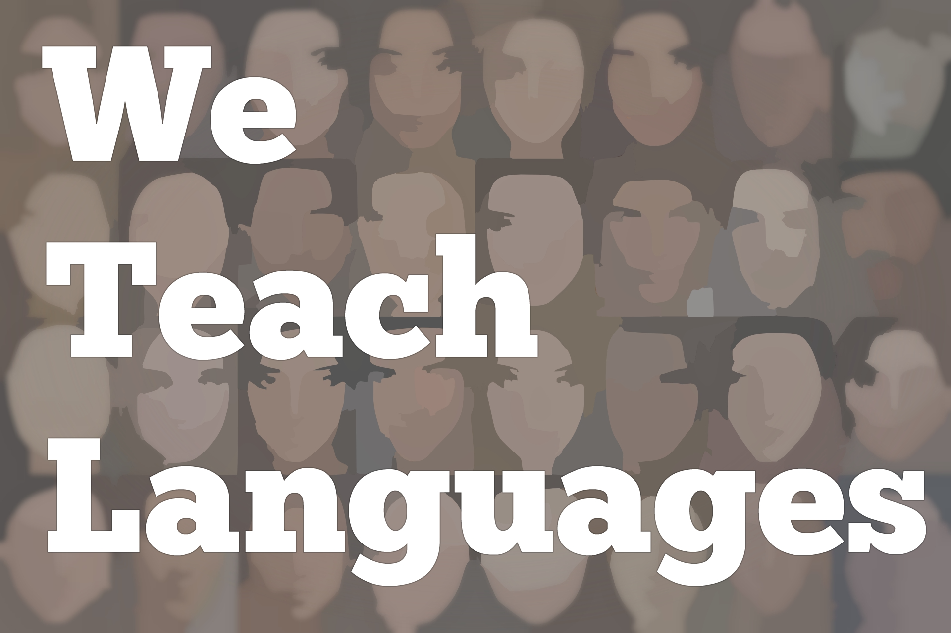
(Rerun) We Teach Languages Episode 41 (rerun): Vocabulary Lists with Kara Parker AC Quintero
Announcer: [00:00] This is "We Teach Languages," a podcast about language teaching from the diverse perspectives of real teachers.
[00:07] [music]
Stacey Margarita Johnson: [00:10] I'm Stacey Margarita Johnson, and today, on Episode 41, the topic is "Vocabulary Lists."
[00:18] Over the last almost a year now of doing the podcasts, I've talked to a lot of different teachers who said they've left some of their more traditional classroom practices behind to move towards a more communicative proficiency-oriented approach.
[00:34] That got me thinking, "What are some of the old standards of language teaching doing these days?" After seeing a very interesting exchange between some teachers on Twitter a few weeks ago, I started wondering, "What are people doing with vocabulary lists?" Most textbooks come with them but, if you've left the textbook behind, do you still need a vocabulary list?
[01:02] What purpose do they serve? If you do use one, how can you use it effectively instead of just using it as an endless glossary for students to refer to?
[01:12] The first place I went to look for more details about how to use a vocabulary list was to a past episode. It's actually our most-listened-to episode of all time. It's a two-parter with Joe Barcroft from last November, Episodes 28 and 29.
[01:31] In it, Joe specifically mentions that there's research that supports both incidental vocabulary learning, which is learning through reading or listening, picking up vocabulary through input, but there's also research to support the idea that you can acquire vocabulary more quickly with some intentional learning as well.
[01:51] In his interview, Joe went through his 10 principles for teaching vocabulary in an acquisition-focused classroom. We're going to listen to principle three, about intentional and incidental vocabulary learning.
[02:05] [music]
Joe Barcroft: [02:05] The third principle is to promote both intentional and incidental vocabulary learning. By intentional vocabulary learning we mean, when a learner consciously, intentionally, makes an effort to learn, let's say, a set of new target words.
[02:29] They might see a list of target words at the end of a textbook chapter and go home and attempt to learn those words, or they may do a series of activities where they know that it's their goal to attempt to learn those words.
[02:43] Incidental vocabulary learning is when you pick up new words when you're still exposed to them in the input, and again preferably multiple times, frequently and repeatedly, when you pick up words without intentionally attempting to do so.
[03:03] That's how, when we think back of how we acquired our vocabulary that we have in our first language, the vast majority of those words were acquired incidentally. We don't remember when we first acquired them.
[03:16] Often, it's the same case for the second language. We acquire these words over time. We may not remember or know exactly when we attempted to learn them. There may be cases where we remember studying a set of words. Having to take a quiz on those words, that would be intentional learning.
[03:36] The principle recommends including both. One of the reasons that I would recommend not relying solely on incidental vocabulary learning is because you can pick up a lot more when you include intentional learning as well. There are studies that indicate that. I won't go into those right now, but there are studies that indicate that.
[03:59] The other thing that I would say about intentional vocabulary learning is that even when you're intentionally trying to learn a new word, it's a meaning-oriented task or it's something that's meaning oriented in nature even when you're intentionally trying to learn a new word.
Stacey: [04:19] That was Joe Barcroft from Episode 28. I'm going to link to that episode in the show notes in case you want to go back and review it on the website.
[04:28] It's a really excellent episode for those of us who want to make sure that our students internalize words and have them as part of their mental representation of language instead of just memorizing words off a list that their brain is just going to dump as soon as the assessment is over.
[04:48] If you buy into the idea that people can acquire more words by combining intentional and incidental learning as opposed to just incidental on its own, then a vocabulary list might be useful for that.
[05:02] In fact, I am working on a research project with another colleague of mine, who's also a teacher who teaches first-year Spanish courses at the college level. One of the things we are working on is having students crowdsource a vocabulary list using online tools.
[05:21] In this model, and the model we use, we might have a Google doc or a Wiki, or some sort of a tool that students can collaboratively create a vocab list, where students will keep track of the words that have been the most useful or the most important in the input. Words that they didn't previously know that they came across in the input that they feel are important to know.
[05:43] That gives us two things, really. It gives students a place that they can go, not only to see the words they need to keep track of but to see the words that their classmates find important. If their classmates find a new term so important, it's pretty likely that the classmate is going to try and use that word in conversation or in a presentational activity.
[06:06] We want students to all have a collective space where they can keep track of words they might be using. The second thing is it gives us, as the instructors, a way that we can keep track of what our students say they need to know or want to know so that we can do things, like provide retrieval practice opportunities for them.
[06:26] Or, generate constructed readings as opposed to authentic text. Generate a constructed reading that includes a lot of those words that our students have said might be important to them. That's my thinking about vocabulary list.
[06:41] If we want to do intentional vocabulary learning, then there's a couple of reasons why both students and instructor might find it useful to have a shared space to collect vocabulary.
[06:53] If you're in a stable classroom as college instructors like me or not, but if you're in a stable classroom where you have your own room, having a word wall for a unit would be a great low tech way to create that space. If you have access to technology the way I do, then maybe having a Google Doc or a wiki document might be a more appropriate way to collect words.
[07:17] Whether high tech or low tech though, it seems to me that there's value in having some shared idea of what words are going to be important for expression in this unit.
[07:27] The next person I want to introduce to you is Kara Parker. She's a consultant and teacher trainer in Florida, who wrote a great blog post on her website, creativelanguageclass.com.
[07:42] I asked Kara if she would talk to us a little bit about whether she uses vocabulary list. If she does, how does she make that happen in a way that's both practical and useful for teacher and students?
[07:55] [music]
Stacey: [07:59] Kara, thank you so much for talking to us about vocab list today.
Kara Parker: [08:03] Thank you for having me. I'm excited to talk about something that I've definitely changed a lot over the years.
Stacey: [08:09] That sounds great. Tell us a little bit about what you think teachers should be doing with vocab list.
Kara: [08:15] I'm going to walk you through my process. When I first started getting into proficiency-based instruction, I was still doing the very traditional textbook. Starting off with, here's our vocab list. I felt that list was a thousand words that I always was saying. "Cross this one off." "Yeah, let's add this one, too."
[08:37] I found that, here, I had this very long list that, in the end, I was not necessarily seeing that whenever they were trying to do true communications. When they were talking about whatever the topic may have been, I wasn't seeing evidence of all of those words.
[08:53] As I got more into proficiency-based instruction, I realized the role of a vocabulary list is going to shift. It's not going to be what I think it should be. I'm still going to be able to control this but it's really going to be more student-made. I had some training about how the brain learns, that book by David Sousa.
[09:15] I was really intrigued by the part about the chunks. He talked about like, "You can handle seven chunks of information at a time." When I applied that back to my world, like in my classroom, I thought, "Does this mean students can handle seven chunks or phrases or words at a time? Can that be per lesson? Is that per week?"
[09:36] I had to do some soul-searching there to find out how that fit in with what I believe, and what I saw could actually happen in the classroom. That was my first stop, looking at it more as like chunks, and then assigning a purpose to it.
[09:53] No longer was it, I can talk about every food in the world. It's breakfast, lunch, dinner, and snacks, and get the target culture plus their own culture, and make sure it's all covered.
[10:04] It became more about, "What's our lesson for the day? What's the objective that they should be able to do at the end?" and let's just worry about what they need there.
[10:15] One part to that is, what are the function words or the function phrases that they really need? Everybody needs to have a few of these phrases, such as, let's just stick with food.
[10:26] If it's going to be, "I can talk about my breakfast," then they need to know breakfast, they need to know eat, but then there are all these other words, the detailed vocab that was separate. I found that there were some that were similar. Some of the students were eating some very unique things for breakfast.
[10:49] I could not predict everything that they may need. What I found is, if I can give them the function words, the most important, then during the lesson, I can provide different input and different authentic resources for them to then pull what words they need in order to complete the task.
[11:08] I found that my vocab list actually started being more of a reflection of, "What did you need to complete today's lesson?" instead of, "I'm gonna pre-teach all these words, and we'll get to them sometime in the lesson, and you'll use it later."
Stacey: [11:25] That makes a lot of sense. How do students keep track of their own list? Or, do they?
Kara: [11:33] Here's what I like to do. At the end of class, I would usually say, "Let's do a quick formative check. Let's see what you got for the day." I let them jot down on their notebooks. "These are the words I needed to be able to do today," is task. If it's describing something, maybe they need a few of those function phrases, which everyone had in common.
[11:53] Then they had others that were more specific to what they wanted. On our blog post about vocabulary list, we have two different options. The first one was one that Meghan developed. It talks about, they can organize their words and phrases however they want. It was more open-ended.
[12:12] Basically, she had one sheet that they started jotting down their notes throughout the unit. It might be at the end of day one, jot down some, day two, jot down some more. It was open-ended, and let them pick it. Option two, we have the example on the blog. It shows more how we did it in categories.
[12:35] Still the idea that students are putting what they want on there, but dividing it into categories for a few reasons. One is we were really working on getting novices to intermediate. The important part of being intermediate is that you can give a lot of details.
[12:53] This helped me whenever I was planning to see, "You know what? We don't have any people. We need to add some more people." Or, they're going to not be able to cover that as a detail when they're talking about it later. Also for students, there's research out there that shows if students are categorizing.
[13:11] It's a process to help them retain words. This helps eliminate the need to translate. Because if you look at it and you say, "These are all places. What was that Iglesia?" It acted as a trigger to help them remember what it meant.
Stacey: [13:29] That makes a lot of sense. I also think that there's something to it from an inductive grammar perspective by having students put words with similar grammatical properties in different categories. I see you have one that's descriptions.
[13:45] Just by seeing those words together, and then seeing how they all interact in different context in similar ways, students are subconsciously starting to make some connections about how do adjectives work in the language, without even realizing that's what's happening.
Kara: [13:59] Exactly.
Stacey: [14:00] All right. I'm going to put a link to this blog post in the show notes. Thanks so much for sharing your perspective with us today, Kara.
Kara: [14:10] Thank you so much for having me. I hope that helps everyone. Just look at vocab a little differently. It becomes more of what's needed for the task instead of pre-teaching everything upfront before we even let them get in, and see what they really needed to know.
Stacey: [14:28] If you want to ask Kara questions about her method, visit her blog post. Check out the show notes. You can go read the blog post for yourself. There's a lot of great ideas there.
[14:38] Kara's method is focused on the student generating a vocab list that works for them, which is in line with what my research partner and I are thinking about these days as far as classroom practice. How can we get students to generate a vocab list?
[15:02] Actually, sadly, I would say, traditionally, the vocabulary list is generated by the textbook. I was going to say [laughs] that, traditionally, the vocabulary list is generated by the teacher. There's some really compelling reasons for that as well.
[15:16] Here is AC Quintero to tell us a little bit about how she evaluates what new words are going to be important for her students to know before she starts a new unit, how she generates that word list, and what she does with it.
[15:32] [music]
Stacey: [15:32] AC, I know that you write comprehensible models for your students, and that you use a lot of input-based methods. I was wondering, how do you handle vocab lists? Do you use them? What do you use them for? Do you have any thoughts on that?
AC Quintero: [15:56] Yes, I do use vocabulary lists. What I generally do is when I'm planning the unit, the first thing I do is I curate all of the resources that I want to be using for the unit.
[16:08] I make sure that I have an article that students are going to complete some type of interpretive reading assessment on, and list out what the speaking expectations are going to be, what the writing expectations are going to be.
[16:21] Then, I usually preview the listening. From those four types of assessment, I usually draw the specific vocabulary that they're going to need. Sometimes they're special words. Words that are not necessarily most common words in Spanish, or some of them are going to be worse if they use pretty frequently.
[16:48] From that list, that's where I start making some type of accessible vocabulary list. Usually, I use Quizlet or some type of online resource so the students can have access to them.
Stacey: [17:01] That sounds great. You create a Quizlet for them so that they can review the vocab list on their own with Quizlet?
AC: [17:07] Right. Yes, I do. I'll create a Quizlet for them. The other thing that I failed to mention was that a lot of times, I have maybe one to three tiers of vocabulary. I like to think about my unit. I like to plan them in phases. I'll have a phase one, a phase two, and a phase three.
[17:28] Each phase will have some type of culminating activity. Let's say, if the vocabulary list is about 30 words, students will be responsible for knowing the first 10 words that are going to correlate to the first phase, for example.
[17:44] Using the Quizlet, just giving them a little bit more exposure to the vocabulary. I know a lot of people who are staunch supporters of the comprehensible input, which I am. I do support that model as well. I know that a lot of teachers feel very differently about having vocabulary lists.
[18:01] I feel like the more the merrier. Students can definitely acquire vocabulary through a lot of the reading activities that we do in class. Some of those reading activities, there definitely is a summative assessment reading, but then there are also smaller formative assessment readings, just readings that students are going to do that will enable them to practice vocabulary.
[18:21] That's not the sole goal of it, but that will enable them to practice their vocabulary or just have multiple exposure to those words. I do think that vocabulary lists are like an added value. I know that teachers have their different beliefs in terms of having a vocabulary list.
[18:38] In the past, a lot of the practice was having this extremely long and exhaustive vocabulary list. I think the shorter and the more meaningful the better, and just making sure that that vocabulary is something that students are going to be exposed to throughout the unit.
[18:54] Personally, my students, they like having vocabulary lists because in their other classes, they have vocabulary lists. It's nice to have that structure that they can go back to.
[19:05] I also feel like, thing about differentiation and you think about all the students being different in terms of how they learn, I don't want to assume that number one, the students are going to get most of their vocabulary nutrients, so to speak, through the reading. It really depends on how engaged students are with the reading.
[19:26] I feel like there are a lot of cognitive factors that underlie their ability to really acquire that vocabulary. That's one of the reasons why I like having a vocabulary list. I think it is important. It just gives students some type of target to work toward.
[19:42] Again, I'm not saying that that's all they do, but at least in terms of assessment, they have this physical or virtual list that they can point to. After being exposed to the words, or even sometimes students, they really enjoy doing Quizlet games, different things that motivate them. They feel like they've actually acquired the word. They can point to a word on the list and say, "I know that word."
[20:07] There's different levels of knowing a word, not just knowing the meaning of the word, but knowing how that word operates in different contexts and things like that. That's my primary reason for having a vocabulary list.
Stacey: [20:21] For those teachers that are using authentic resources, novels, and leveled-readers, and other kinds of resources that require students to know specific words in order for the resources to be comprehensible, I love AC's approach to selecting just the right resources for the unit, creating a list of what vocabulary might students need to know in order to get the most out of this unit.
[20:51] At the high school level especially, making sure that students also have access to that list and opportunities for intentional learning and retrieval practice around the list. I think that's really useful. Some of you might not use vocabulary lists at all and might be doing great without them. I would actually love to hear from you about why you don't use vocabulary lists.
[21:12] For those of you who do use vocabulary lists and wonder maybe if you practices align with what other people are doing, I would love to hear how your practice compares to mine, to Kara's, and to AC's. All of us are available on Twitter or on our various websites and blogs. [laughs] Or you can just leave a comment in the show notes for the episode. I would love to hear from you there as well.
[21:42] When you do visit the show notes, I also want to let you know that there's a few other resources that I've linked there. One is an academic book all about vocabulary lists by Nations, who's one of the big scholars in the field.
[21:55] Probably my favorite one is a three-part series on Amy Lenord's blog, where different #langchat contributors from Twitter all talk about how they use vocabulary lists. It's a really excellent blog series. I hope you check that out.
[22:13] I also wanted to let you guys know that in the month of March, we'll be doing a series of episodes all on a common theme of critical approaches to language teaching. We are coming up on the one-year anniversary of the birth of the podcast, which is really exciting.
[22:31] In the month of March, a special issue of the journal, "Dimension," on which I was the co-editor, will be coming out. It's actually debuting at the SCOLT conference in mid-March. Really excited about that.
[22:46] Just an honor on the special issue on the topic of critical pedagogy to celebrate the one-year anniversary of the podcast, and just because there's so many people doing great work on critical issues in language teaching, we're going to spend the entire month of March talking about critical pedagogy, social justice, and other critical issues.
[23:07] [background music]
Stacey: [23:07] If those are things that are important to you, I hope that you tune in and share the episodes with your friends and colleagues.
[23:13] As usual, I am really happy to hear from you. If you want to submit an episode to the podcast as a contributor, please reach out. You can reach me through our Google Voice number at 629-888-3398, at our website, which is weteachlang.com, by email, weteachlang@Gmail.com, or on Facebook or Twitter, @weteachlang. I look forward to hearing from you. Thanks for listening.
Podcast transcripts are provided through a partnership with PEARLL (Professionals in Education Advancing Research and Language Learning), a Title VI Language Resource Center at the National Foreign Language Center at the University of Maryland. Find additional transcripts: www.pearll.nflc.umd.edu/podcast

Transcription by CastingWords

