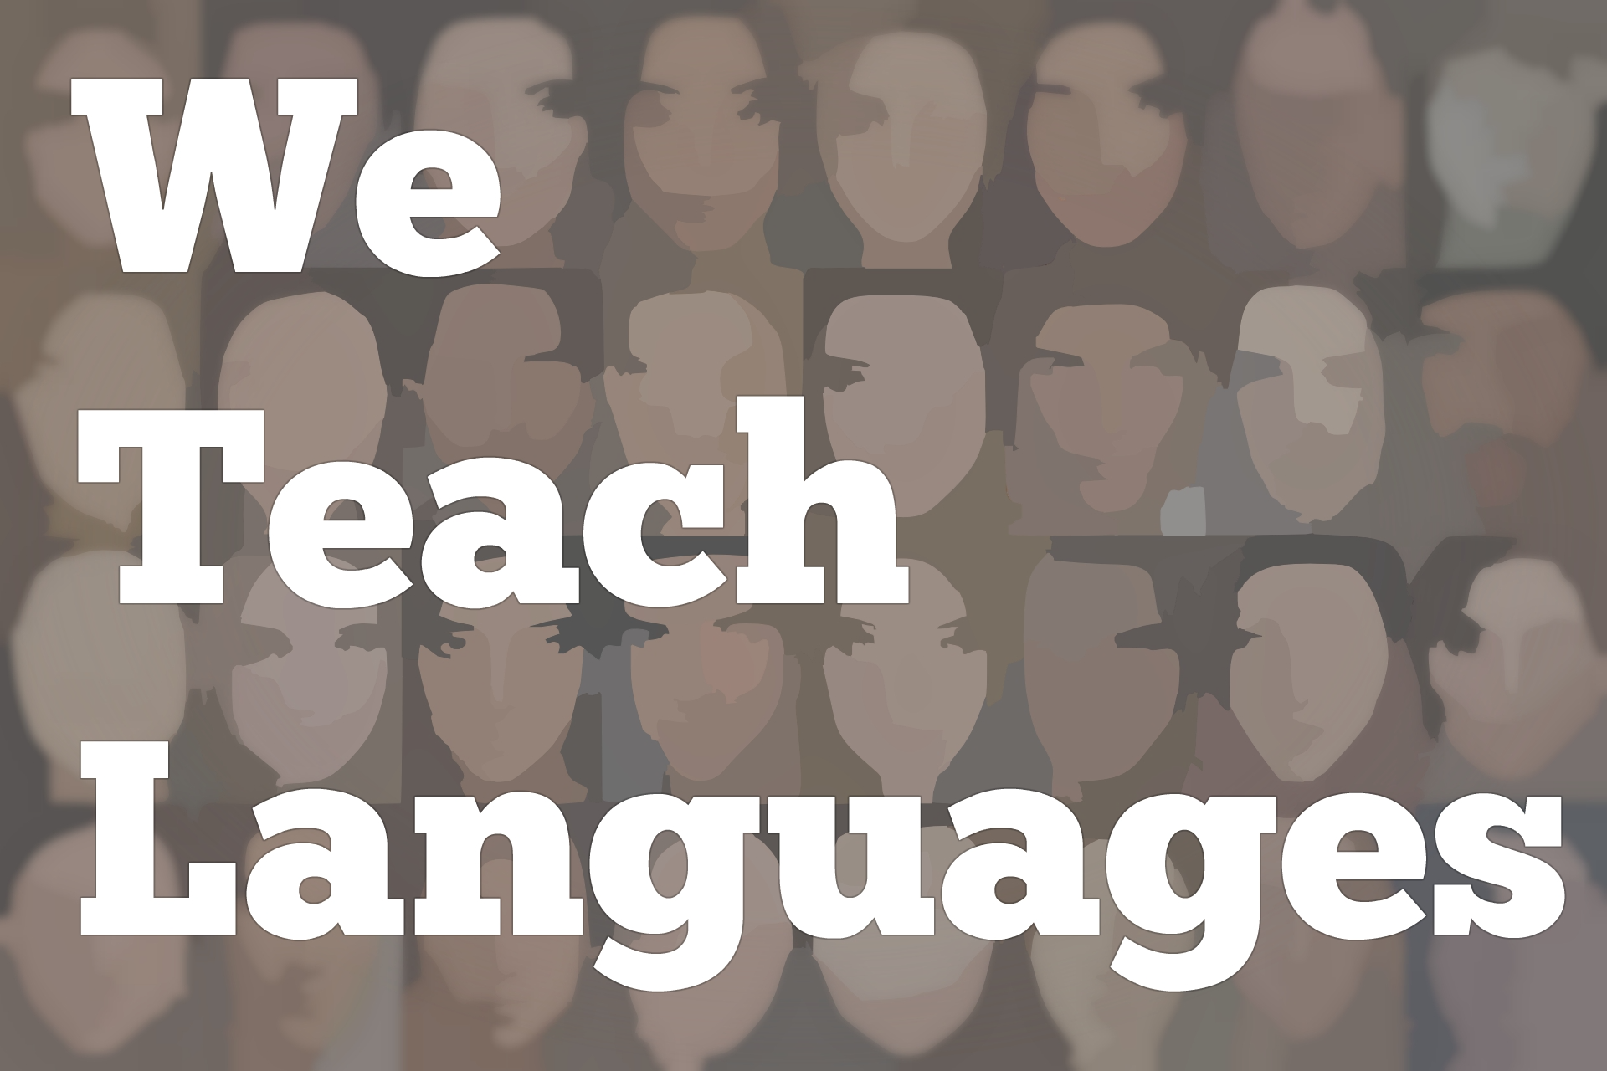
We Teach Languages Episode 9 (rerun): Performance Assessment in a Fully Online College Spanish Course with Claire Knowles

Stacey Johnson: [0:00] This is "We Teach Languages," a podcast about language teaching from the diverse perspectives of teachers.
[0:07] [background music]
Stacey: [0:07] I'm Stacey Margarita Johnson. Today, I'm very excited to have my friend and frequent collaborator, Claire Knowles, visiting the podcast all the way from England. Claire, how are you?
Claire Knowles: [0:24] I'm doing great, Stacey. How are you?
Stacey: [0:25] What's the weather like in England today?
Claire: [0:29] It is a balmy, 60 degrees, and partly cloudy. It is practically tropical over here.
Stacey: [0:36] [laughs] I'm really glad that you made time for us today. One of the things I was excited about was because you have such extensive experience with teaching language, both communicatively and fully online.
[0:51] That's a question that I know a lot of teachers have, is how to teach online well when languages have such specific activities that have to go along with them.
[0:59] Would you mind taking a minute to introduce yourself, what you do, and in what context for the listeners?
Claire: [1:05] Sure thing. I describe myself as a professional adjunct.
Stacey: [1:10] Tell us what an adjunct is because people who aren't in higher ed might not know that term.
Claire: [1:14] Right. I'm not a full-time faculty. I teach semester to semester in a variety of different colleges. I teach all online. Within the state of Tennessee, I teach all Tennessee eCampus, which is a collaborative universities, colleges, and technical institutes.
[1:35] We draw on students around the state and offer courses that they can take, such as the first two semesters of Spanish. I design and mentor the sectional faculty for Tennessee eCampus and design the courses.
[1:52] I also teach for Community College up in Pennsylvania, one in North Dakota, and also at the University of Memphis.
Stacey: [1:59] You stay really busy as a professional adjunct?
Claire: [2:03] Yes, I do, and I love it. It is very busy, but it's also incredibly flexible. I have two young children. Having the flexibility of online is really great. So busy, but for right now, I wouldn't have it any other way.
Stacey: [2:20] Excellent. Actually, I'll mention that proof of that is that you're calling in from England, but you just mentioned that you teach in Pennsylvania, North Dakota, Tennessee, these places.
[2:30] [laughter]
Stacey: [2:30] That's a lot of fun. I think one of the big questions that I was hoping that we could discuss is -- I know you teach communicatively.
[2:38] You focus on performance assessment, but you also teach in a fully asynchronous online environment. Would you explain to us what an asynchronous online environment is and talk a little bit about the kinds of things your students do in order to really use the language?
[2:56] Some of us might have the idea that online teaching is watching videos and doing quizzes, but I know your classes aren't like that. I'd love for you to chat about that a little.
Claire: [3:04] Sure. Asynchronous. Some places have the requirement that they must be asynchronous. That means that there is not the requirement to be online at a specific time.
[3:15] Whilst you have to be on regularly as a student, you can organize your study and logging on into the course at a time that suits you. Some colleges just encourage that because in pretty much all cases, there's a diverse student body with diverse needs.
[3:33] They may work night shift or have family. It's important to be able to offer that to students.
[3:41] In the language learning environment, which stresses communicative approach, communication, language, and interaction, it does create somewhat a little hurdle that you have to figure out how to get over.
[3:55] You can't expect students to connect with other students at the same time when you have them coming from all different states and with different backgrounds.
[4:06] There's lots of different ways that I try and replicate that communicative approach within the classroom, predominantly in discussion boards, using different methods of being able to record and use the language, listen to the language, interact with the language. As much as possible, replicate that kind of communication.
Stacey: [4:29] It also occurs to me that in my first year class, I do not emphasize true interpersonal communication, spontaneous exchange of information, because that's just difficult for a novice learner to do.
[4:45] Our interpersonal communication forays are more about using rehearsed performance language, and building confidence about being able to talk, not actually [laughs] exchanging new information through interpersonal conversation.
[5:00] I imagine that if you're teaching the lower levels, that's the thing that you could arrange through technology, so how would that work?
Claire: [5:09] One thing that you mentioned about, they don't have that spontaneity. In the online learning environments, it's very difficult to have that spontaneity.
[5:22] It's ideal for beginning students because what I do is allow them to revise quite a lot in order to improve their communication skills so that they have a speaking assignments or written assignments in which they are not just producing language.
[5:46] There is that opportunity to revise over that you wouldn't necessarily get in the face-to-face learning environment because you're going from one student to another student to another student.
[5:57] What we're doing in the online environment, we perhaps scaffold exercises up from quite basic to more complex. I'm getting constant feedback, which again is much easier online learning environment because I can give a lot more feedback to students and encourage them to revise and to go back.
[6:20] That is what we focus on in the online learning environment because we can do really well. They have lots of opportunities to record and re-record. It does give them that muscle memory that you need for language so that when they go out, they are able to recognize and remember some of the constructions in the sentence structures and things like that.
Stacey: [6:46] I think that's really interesting. While you were talking about how that works, I was also remembering a few weeks ago in the Twitter #langchat, weekly chat. The group was talking about using videos in the classroom.
[7:00] Several people that I follow mentioned that they like students to record videos in the classroom, but it's so time consuming. Just having students actually talk in class is something you can get through pretty quickly.
[7:16] When you have them create videos despite the benefit that they can then go back and re-watch the videos, or create portfolios where they can see how far they've come over the course of the semester through video, the process of learning the technology, getting the videos constructed, then organizing them and presenting them can just be a little bit daunting.
[7:35] It sounds like the online environment is a place where you've taken advantage of what's good in online to do the things that work best for recording student work through video, where you might be losing some of that more fast-paced, spontaneous language production that we would see in a more traditional classroom. Does that sound right?
Claire: [7:58] That's exactly right. Also, using the different facilities within the online environment. We have spaces like the discussion board where they can listen to each other, make comment, and have that sense of community, "Hey, you. That was really great. I really enjoyed listening to that."
[8:15] Also, have what is like the safe space, a Dropbox where I'm the only one that's listening and can give them really in-depth feedback also.
[8:24] There's multiple ways that they can express themselves and get feedback in different arenas. I think it's very helpful.
Stacey: [8:32] I know that you can't tell us about any particular cases, but what is student feedback in these college courses that are fully online and asynchronous? What is that feedback typically like? What do students have to say about the course?
Claire: [8:47] I request feedback constantly. At the end of each chapter, I want students to be reflecting not only on language and culture, but on the learning process.
[8:57] After each module or chapter, what's going well, what's not going well, what surprised them, what did they find ease? Initially at the start, it is a lot more work. It is a lot more work and it's more challenging.
[9:11] A lot of students think Google Translate or some kind of online translation tool is going to make it a cinch. My dissertation research topic is online translation. That is a big surprise at the beginning.
[9:26] By the time they get to the end of the course, they have adapted to the course load, and what's expected of them, I think they appreciate the opportunity to have all these opportunities throughout the course to reflect, to revise, to look at topics in an in-depth way.
[9:46] A lot of the feedback I get is it was a lot of work, but the feedback was great. I feel like I progressed. We looked at topics in culture, which is another one of my...things that really excites me about learning a language is that making those connections to the language, to culture, and to students lived the experiences.
[10:11] It is the feedback where students feel that the course in so many respects has made a difference. Another thing is, I talk about small but significant stories of language learning, which is easy to share in the online learning environment. It's like posting in Facebook or on Twitter.
[10:32] I went to the store and there was a little boy. He was lost. He was not an English speaking. I was able to talk to him. We found his mom.
[10:40] I didn't even see a huge deal and to get feedback from...but little things like that that you can share, that you would perhaps not necessarily share in a face-to-face learning environment.
[10:53] Students are comfortable doing that. They're familiar with that kind of social media, just posting things that happen. There's lots of ways to benefit from that environment.
Stacey: [11:03] That's fantastic. You don't force your students to do everything in the target language online?
Claire: [11:09] I do not. When we scaffold and we start with a topic, let's say education...They've got the vocabulary. We're using the grammar. They'll talk about that topic, what they do on a daily basis, let's say, what classes they're taking.
"[11:23] Ritmost" has lots of real world examples where they're listening to real students talk about their lives. We scaffold up, scaffold up.
Stacey: [11:35] I'm totally on board with that. I know the textbook that you use. I've used it in the past also. It's a fantastic textbook. One of the great things about Ritmost is it provides a lot of comprehensible input up front.
[11:47] You have native speakers or sometimes near native speakers talking about their real lives and sharing stories with students using comprehensible language. There's a ton of reading. Students are slowly scaffolded to production.
[12:05] However, parallel to that building up their language ability, I want them to be able to deeply and critically reflect on culture, identity, and big questions, so doing a little bit of that in parallel in English to make sure that they're using their higher-order thinking the whole time.
[12:27] I personally think that's a great idea. I know that there are instructors who go a different direction. The big issue might be proportion, like how much of your class are you spending doing this deeper thinking in English because too much and suddenly, it's a social studies class instead of a language class. Generally, it's a great idea.
Claire: [12:48] Exactly. If you were to look at a...it would be like a Venn diagram of what's going on in the class. Everything is overlapping. Everything is interlaced.
[13:02] Use something that they listened to in Spanish, if somebody reacted to something that it was a listening portion. They talked about their educational experience, the university in Mexico. They can draw on that while doing that English...
Stacey: [13:17] Yeah, I'm all about that. The language requirement is about helping students develop skills so that in the future, they'll be able to communicate effectively. Communication is about showing respect, being able to decenter your own perspective, and take up other people's perspectives.
[13:34] It's about language skills. It's about intercultural competence. It's just a multifaceted thing. I love your eclectic approach to what you do in the language classroom. Focused on language, but incorporating other skills as well. I think it's really effective.
Claire: [13:50] It's about giving students these skills. Why do we make our students take these? There are important things for them to learn. I think moving beyond, they have to know this grammar and pass this test, which I don't give tests.
[14:06] I don't think they're effective. I don't think they measure learning. I don't think they show either comprehension well or student's ability to produce language at all.
Stacey: [14:16] You do a complete performance assessments?
Claire: [14:19] I do. Yeah. It's effective because we started small by learning the vocabulary, these grammar sentence structures. We use discussion board a lot to ask questions.
[14:32] It is written, and I respond and do that so that they are building towards this proficiency assessment, which is a written assessment, a listening assessment. They do an oral assessment. It's just bringing everything together.
Stacey: [14:49] That's awesome. One last question for you. If there's someone listening who is going to be teaching an online course for the first time, what advice would you gift to them?
Claire: [15:01] It can feel overwhelming because you have to create everything to be ready from day one. Oftentimes, when we go in the classroom, we can focus on, "Right, we'll have ready," or, "I'm going to do this week, perhaps in two weeks' time."
[15:18] It's not going to be the best course you've ever done the first time you do it.
[15:23] One of the great things about teaching online is that at the end of each semester, you can say to yourself, "What was the one thing students got stuck on? What was the one area they kept asking questions about? What can I do to improve student learning?"
[15:39] You look at those three areas. You make three changes. You teach it again. At the end of that semester, you ask yourself the same questions.
[15:46] I've been doing this for a decade. At the end of the semester, there's always and it could be a very small thing. The way I've worded some instructions that I know I can...This is the area that I got 27 emails, all with the same question.
[16:02] That's the one thing I need to improve. You just keep improving on. Don't try and replicate what you do in the classroom. You have to do that to some degree. They need to be assessed on the different aspects of language learning.
[16:16] Students have to log on pretty much every day to learn a language in the online learning environment, so you have to adapt what you give them.
[16:24] Be open to what other people are doing. Even if it's not your subjects, if they do online workshops or...Community College in Pennsylvania, they are constantly offering the Virtual Campus workshops.
[16:39] It's great to see what other faculty are doing. I learned lots of things, ways to chunk assignments that I've never thought of doing before. Go to those things, especially, being the online learning environment, it's really easy to go to those kinds of workshops. Be open to those as well.
Stacey: [16:55] I'm just going to repeat what I heard you say. The first one was, remember that at the end every semester, you get to improve the course. The first time might not be perfect, but you get more chances to improve.
[17:08] The second one was to remember that the online environment isn't going to look exactly the same as your face-to-face environment and that's OK. You can capitalize on what works best.
[17:20] The third one is to take advantages of opportunities to seek out training and mentorship from the online learning folks on your campus or maybe from other sources.
Claire: [17:30] That's it. Yeah, absolutely.
Stacey: [17:32] It's good advice. Thank you so much for being on the show today.
Claire: [17:36] Thanks for inviting me. It's been a lot of fun. Bye.
[17:40] [background music]
Stacey: [17:37] If you have questions or comments related to today's episode, we would love to hear from you.
[17:46] You can reach out to us multiple ways. All of them are available at our website, weteachlang.com/contact. You can also find us on Facebook and Twitter @weteachlang.
[18:00] We would like to say a very special thank you to the PEARLL Foreign Language Resource Center for partnering with us to provide transcripts and other professional development resources related to the episodes.
[18:13] You can learn more about Perl by going to pearll.nflc.umd.edu.
[18:28] Thanks so much for listening. Bye-bye.

Podcast transcripts are provided through a partnership with PEARLL (Professionals in Education Advancing Research and Language Learning), a Title VI Language Resource Center at the National Foreign Language Center at the University of Maryland. Find additional transcripts: www.pearll.nflc.umd.edu/podcast

Transcription by CastingWords

