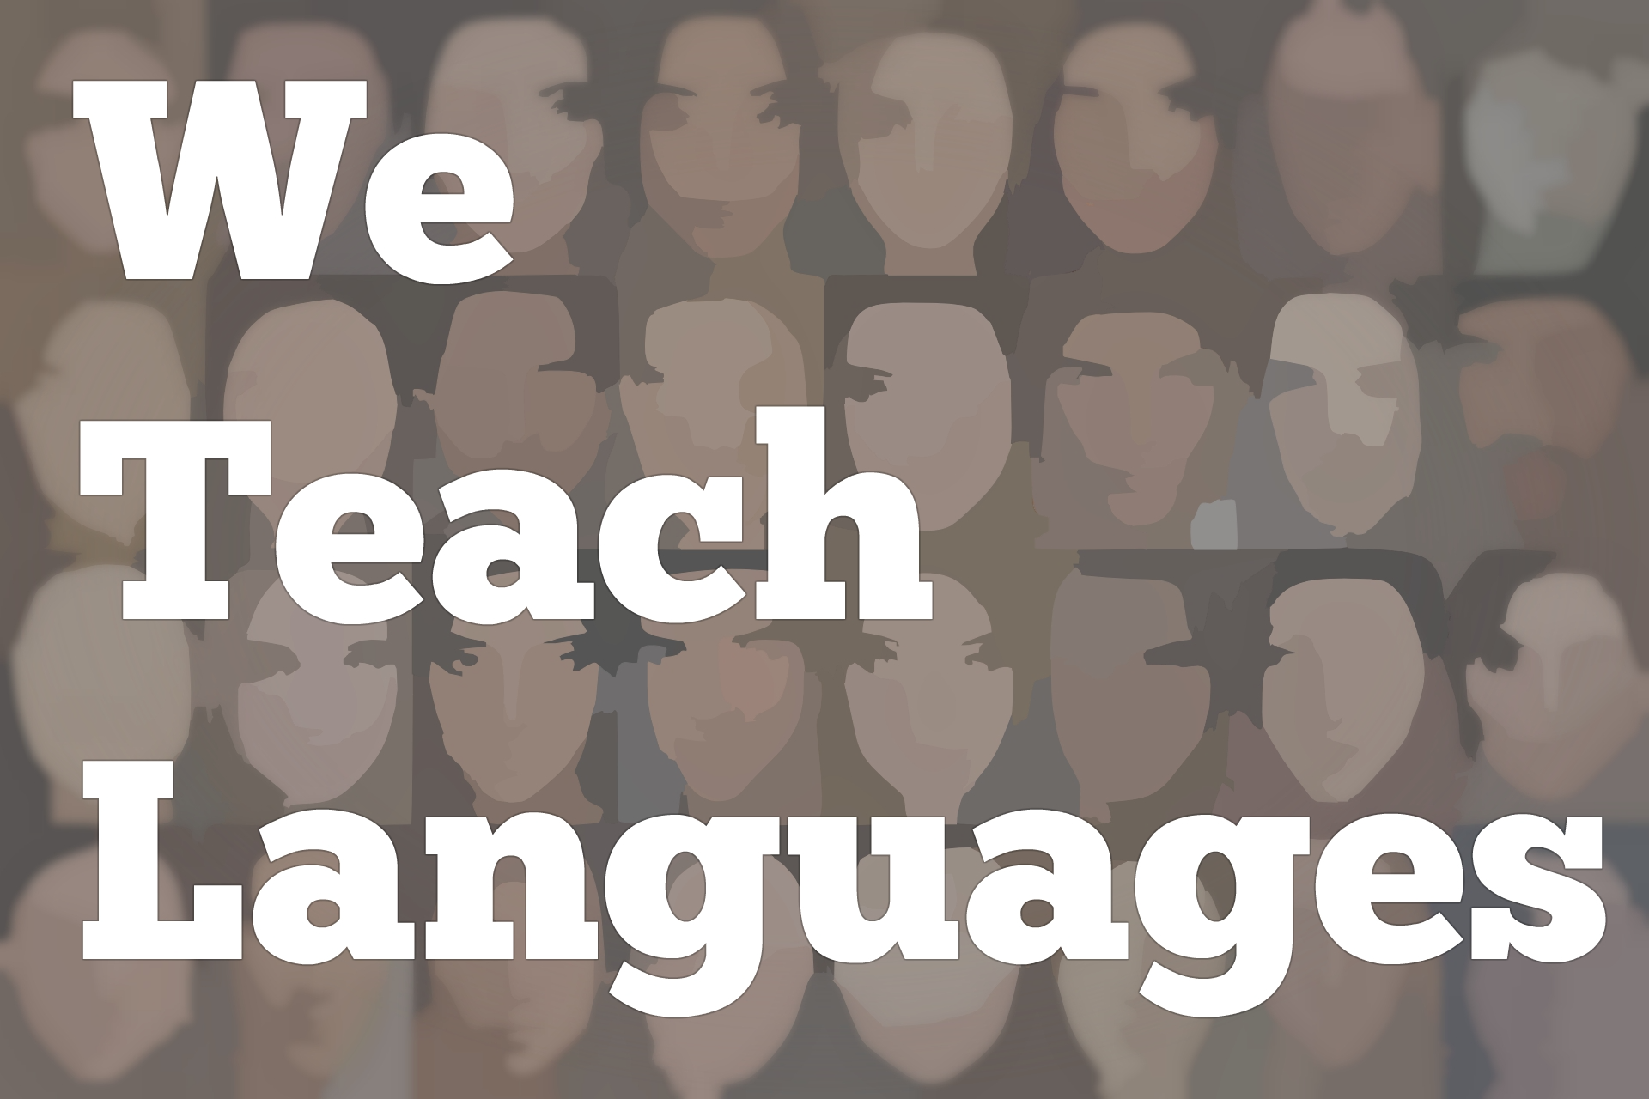
We Teach Languages Episode 100:
Celebrating 100 Episodes!

Maris Hawkins: [0:00] This is "We Teach Languages," a podcast about language teaching from the diverse perspective of teachers.
[0:05] [music]
Maris: [0:11] I am Maris Hawkins. Today, we have reached a hundred episodes of the podcast. We will be talking to some listeners about their takeaways and favorite episodes.
[0:21] To give you some background, Stacey Margarita Johnson started the podcast with an introductory episode. Since then, over 150 people had been able to participate in this podcast via newsletters and interviews.
[0:35] I personally started listening to We Teach Languages in episode 13, when I heard Stacey interview Noah Geisel, and I was hooked. I found myself nodding along as Noah talked about how our language classrooms are changing, how we focus on culture. All of a sudden, I found myself binge listening to the We Teach Languages podcast and all of the episodes.
[0:57] Through this podcast, Stacey has always encouraged teachers to interview other teachers and to become involved. While she featured some of her own students, interviewing initially, this became even more of a reality in episode 20 when Caleb Howard interviewed Noemi Rodriguez after Stacey had interviewed Caleb in episode 19.
[1:17] Since then, 27 interviews have included a teacher other than Stacey conducting the interview. To me, this in particular, is what makes We Teach Languages so special, that everyone's voice is heard and that every teacher's voice deserves to be heard.
[1:33] More importantly for me, We Teach Languages has brought forth a variety of voices that I wouldn't have connected with before. It seems that many times, I haven't always connected with college professors to talk about what they're doing in their courses. Some of these episodes have given me wonderful ideas to use in my own classes.
[1:52] I particularly loved episode 92, when Elena was talking about portfolios, episodes 88 and 89, talking about Google Translate, and episode 42, when Daniel talked about choosing critical content and trusting that acquisition was taking place. If you haven't had a chance to listen to these episodes, I highly encourage you to do so.
[2:16] Now, I want to turn the episode over to some of our listeners, talking about their favorite takeaways. We will start with Sam Kinison. Sam, where are you and what do you teach?
[2:29] [music]
Sam Kinison: [2:30] I am in Central Iowa. I currently am teaching grade 6, 7, and 8th grade Spanish, including heritage and novice lows.
Maris: [2:42] How long have you listened to the podcast?
Sam: [2:45] I've just started getting into podcasts in general around winter break time. I found this podcast about three weeks ago.
Maris: [2:56] What have you liked the most about the We Teach Languages podcast or just podcasts as professional development in general?
Sam: [3:05] With the We Teach Languages podcast, I like how the notes after the sessions are actually complete. I can do a quick scan and prepare myself to listen with intent.
[3:19] My other thing that I enjoy is that there is such a variety of information that there's always something new to think about, something to reflect on, and most likely, something that I'm going to take to my classroom the next day.
Maris: [3:33] I agree. Sometimes, I've seen the topics in general. I've thought, "I don't know how much that will apply to me." Then I end up listening. Sometimes, I take away 10 different ideas when initially, I didn't know how much I would get from each episode.
Sam: [3:49] That's the best part.
Maris: [3:51] Then are there any episodes in particular that have resonated with you?
Sam: [3:56] For me, episodes 83 and 84, when you were talking with Maria and Chris about heritage programming. That's a subject that's near and dear to my heart because I'm in a district where I have the highest Latino population, and we have no guidance.
[4:13] Really understanding how to serve my students, incorporating best practices, and listening to other people's wonderful takes on how to serve students is always super helpful.
Maris: [4:25] I agree. The other thing that's nice is to feel that you are not alone in this journey, because there's other people out there who are going through the same thing that you are as well.
Sam: [4:39] When Kara and Megan, in their episode, talked about working with other teachers who might not be super excited about what's going on, especially talking about proficiency, I think it was inspiring to remember that.
[4:52] It is about community and uplifting each other. We're here to support each other. Let's work together and meet each other where we are. It's so important.
[5:01] [music]
Melanie Thomas: [5:04] Hello. This is Melanie Thomas. On Twitter, I am senoramthomas. I teach outside of [inaudible] New York, and I teach high school Spanish. This year, I made a transition to also teaching an additional class in the middle school.
[5:19] I've been listening to We Teach Lang since the near beginning. I can't recall exactly when, except that I was walking and I was looking for a podcast and I fell upon We Teach Lang. Have been hooked ever since. Now, I'm a regular listener. I love the variety of episodes that Stacey and the crew has for us.
[5:38] I studied a lot about second language acquisition when I was getting my master's degree. I felt very conflicted when I stepped into the classroom, because what was being done in the classroom did not support what I had learned about SLA.
[5:49] For 20 years, I've been trying to teach in a communicative way but have only recently found great confidence in doing so as the lang chat community and other stakeholders, such as Axiom, have supported making shifts to performance-based assessments and to teaching almost entirely in the target language.
[6:07] I've listened to the many episodes on the podcast. I just find myself nodding my head right along. I'm very grateful that other teachers have the same beliefs and values about language teaching.
[6:16] There have been episodes with Paul Sandrock, Rich Madel, Lisa Shepard, which have shared great insight to performance assessments. IPAs have been a game-changer in my department. In doing so, we've had to make sure that we comprehensify our classrooms.
[6:32] In episodes, Martina Bex, Kara Jacobs, Megan Smith, and Kara Parker shared some amazing ideas. For me, the biggest inspiration was when I listened to episode 45, the episode about thematic units and social justice with Anneke and Jennifer.
[6:50] I've been exclusively teaching upper high school for many, many years. As I said, this is my first year teaching a middle school class. I knew that stepping into the classroom could be done in the target language. I just didn't know how Anneke and Jennifer proved that we can be teaching novice level, and at the same time, be cognitively challenging.
[7:11] I also found Heather Sherrow's episode really inspiring. Heather's episode showed how we could look at the personal identification unit through the lens of identifying stereotypes, looking at how people are individuals and celebrating those differences. She used authentic resources as she did so.
[7:32] These two episodes are ones that met my personal needs in my own journey. I love that Stacey offers a variety of episodes to meet different needs. She has people talking about online courses, about heritage language courses, about indigenous language classes. I'm grateful for the 30 minutes that she gives me once a week. Thanks, Stacey and crew.
[7:51] [music]
Claire Knowles: [7:54] Hi. My name is Claire Knowles. I teach Spanish a couple of places, Tennessee e-campus, ATC, DSU. I was calling with my favorite episode. My favorite episode is the indigenous languages episode.
[8:12] I'm interested in how culture connects with language and how my students, even if they don't go on to study language beyond the first year or two that their degree requires it, that they can gain an understanding of other people, other perspectives, their history and culture.
[8:41] I love this idea of preserving languages, although they are only spoken by relatively a small number of people, but how this grounds people to place in history and tradition.
[9:00] It was interesting. After I listened to this podcast, about a week or two later, a colleague shared a video about the Wiki Languages project, which is also doing a similar thing of trying to preserve different languages, minority languages, and less commonly spoken languages. They had a great video about the [inaudible] language, which is spoken in Louisiana. It was very serendipitous. That was my favorite podcast episode.
[9:38] [music]
Rebecca Blouwolff: [9:40] Hi, this is Rebecca Blouwolff. I just wanted to leave a little note of appreciation. I absolutely adore listening to We Teach Languages. There are definitely some key phrases that have stuck in my head. I'm thinking back to the man who told us to trust the process. That is a big one that comes to me when I'm teaching with my students at times.
[10:03] I also think We Teach Languages empowers teachers to think about the conversations that we want to hear and, in some cases, create for the show. For me, it's been a wonderful opportunity to think about some of these big figures in our field that I would enjoy speaking with and then taking that risk of going out and interviewing them.
[10:23] I so enjoy listening to the show and also very grateful for the opportunity to interview some of my world language heroes on it. Thank you.
[10:31] [music]
Inga Pattersons-Uniga: [10:34] Hi. My name is Inga Pattersons-Uniga. I teach in North Caldwell, New Jersey. It's my 22nd year teaching. I teach Spanish. I absolutely love your podcast. It's probably my second year tuning in. I still haven't heard all the episodes, but I do have to say, some of my favorites are the one on vocabulary acquisition, episode 28 and 29. It was a two-part episode.
[11:03] I also loved your most recent one on the OPI. The episodes on authentic resources were very, very helpful to me as well. Comprehensifying authentic resources, the novice descriptions unit episode, the one on social justice.
[11:22] I found all of your podcasts very educational. I would just say, keep them coming because they're truly a wonderful resource for language teachers. Thanks so much.
[11:33] [music]
Maris: [11:36] Thank you so much to everyone who has called in and participated in this hundredth episode. Adding more voices to our community is one of my favorite things to do and why I'm always willing to interview more people.
[11:49] I encourage more people to call into the show with their takeaways so we can continue to add more people's voices to the podcast each week. You can do that by calling the Google Voice number, which is on our website.
[12:03] Getting the feedback from everyone, it is obvious that what makes this podcast so special is that each listener can find an episode that resonates with them. Each episode that resonates with them is unique. It makes all teachers feel supported and lessons in their classrooms, wherever they are.
[12:20] This week in the newsletter, we will highlight some more of people's favorite episodes via Twitter. I encourage you to listen to many of them if you haven't gotten a chance.
[12:31] I know, I plan on relistening to some of my favorites because I always learn more the second time I review anything. As I've grown as a teacher, it's going to be interesting for me to go back and listen to what other people say. I might be able to work their thoughts and their ideas into my teaching in a new and different way.
[12:52] From the newsletter, some recurring favorites from Twitter include Steve Smith's interview for episode 58 and Dorie's interview with LJ Randolph on episode 82.
[13:05] One thing as we've been coming through people's favorite episodes that we've noticed is that many people's favorites are when two teachers interview each other and submit their recording for the podcast. We want to continue to encourage teachers to record their own episodes for the podcast. All you need is about 30 minutes to sit down with a colleague to record.
[13:28] As Rebecca said, you can reach out to some teachers that you've always wanted to talk to and discuss any of your favorite topics with them and any questions that you've had yourself as a teacher. It's really easy. Stacey is amazing to work with. She edits everything, puts together the notes. Voila, an episode is made.
[13:49] However, we all know that it isn't that easy. I wanted to end episode 100 with a huge shout-out to Stacey. She works tirelessly each week to produce this podcast. She is happy to share the spotlight, but each time I look at the collection of voices from the podcast, I am amazed.
[14:07] It covers a wide range of teachers from beginning teachers to teachers who have taught more than 20 and 30 years, including people who've retired. It also includes elementary voices, middle school voices, high school voices, and college professor voices.
[14:26] Thank you so much to Stacey for everything that you do to make We Teach Languages successful. Congratulations on the milestone of reaching a hundred episodes.
[14:39] You can reach out to us on social media, or on Twitter, or Facebook at We Teach Lang or on our website, weteachlang.com.
[14:48] [background music]
Maris: [14:48] We want to especially thank the PEARLL Foreign Language Resource Center, who's partnered with the podcast to provide transcripts and other resources for the episodes. You can learn more about PEARLL and see everything they have to offer by going to PEARLL, P-E-A-R-L-L.nflc.umd.edu. Thank you so much for listening. Bye-bye.

Podcast transcripts are provided through a partnership with PEARLL (Professionals in Education Advancing Research and Language Learning), a Title VI Language Resource Center at the National Foreign Language Center at the University of Maryland. Find additional transcripts: www.pearll.nflc.umd.edu/podcast

Transcription by CastingWords

