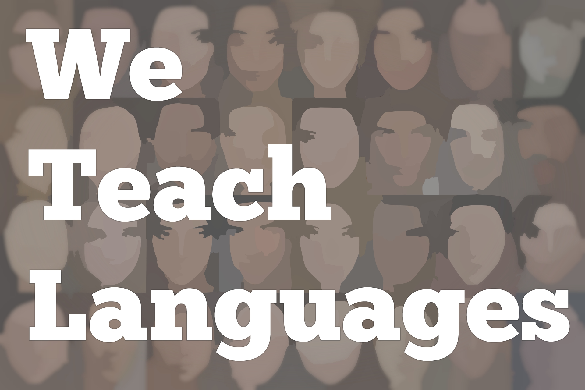
We Teach Languages Episode 102: The Complexity of Language, Acquisition, Teaching, and Textbooks with Michael Leeser

Stacey Margarita Johnson: [0:00] This is "We Teach Languages," a podcast about language teaching from the diverse perspectives of teachers.
[0:09] [background music]
Stacey: [0:12] I'm Stacey Johnson. Today on episode 102, I get to speak with Michael Leeser, professor, researcher, and textbook author, about how he views language and language teaching, how he approaches his teaching methods course, and quite a few other things. There's a lot packed into this 20-minute episode.
[0:36] To get started, I asked Professor Leeser how he approaches teaching second-language acquisition and language teaching to graduate-teaching assistants at his institution who might be new to the field.
[0:51] [background music]
Professor Michael Leeser: [0:53] I've been heavily influenced in the last couple of years, more so in the past year by Ray Jackendoff's work. His book, "Foundations of Language," takes readers on a tour of the enormous complexity of a simple sentence.
[1:09] He talks about the levels of phonological structure first -- the different sounds that make up that sentence -- and that those individual sounds are a combination of distinctive features.
[1:26] These distinctive features group together, and then these words have a syntactic structure -- noun phrases, verb phrases. All of this also has to map on or be linked to meaning in some way. Yet, all of this happens without us being aware of it, but there are all of these levels of complexity that we're completely unaware of.
[1:49] One of the things I try and do when I teach my course on language teaching is I assume they have no background in linguistics and take them through the levels of structural complexity of sound structure and meaning of a very simple sentence to get them to show that it's amazing that we're able to produce, that we're able to express ideas.
[2:16] That this sound coming out of my mouth can get you to think certain thoughts and to respond in certain ways is something that we don't stop and think about in enormous complexity.
Stacey: [2:31] I do think about this all the time, and I'm still staggered even listening to you say it now. Every time it occurs to me, how crazy it is that this random collection of sounds coming out of my mouth is communicating anything. I know how it works. I don't get it though. [laughs]
Professor Leeser: [2:48] A lot of us take for granted these things. When the in-service teachers I work with stop and think and I get them to see the fact that your language learners are able to do anything given the very limited time that they have in the classroom is rather stunning. In spite of what we do, they're still able to make a lot of progress.
Stacey: [3:16] That's the key, isn't it?
Professor Leeser: [3:18] Yes.
Stacey: [3:18] In spite of all things we do to them.
[3:22] [laughter]
Professor Leeser: [3:22] My whole approach in teaching that course is to get them to think a little more deeply about language itself. What do we mean by language? What are the different levels of structure? How are these things acquired? How do children acquire it? How do second-language learners acquire these things?
[3:40] How can we take those insights and think about the language classroom, what we do in the language classroom, what we can reasonably expect, and how what we do can work along with natural processes in learning and acquisition?
Stacey: [3:58] I latched onto that idea of what can we expect, because my own expectations as a teacher in large part were conditioned by the expectations that were placed on me as a learner, expectations which were unreasonable to start with.
[4:15] When you have a teacher who's in that place where they expect things that aren't realistic because that's what was expected of them, what are the things you do in your classes or in your program to get people to the other side?
Professor Leeser: [4:26] One of the things I do is -- and I do this during our orientation usually -- I have somebody come in who speaks a language that I know none of them have ever heard of before.
[4:40] This orientation, I do not only for incoming teaching assistants and instructors of Spanish but also French, Italian, German, Slavic, Arabic, Chinese, Japanese. We do, in our Spanish program, have a couple of Basque speakers.
[4:58] I bring in a Basque speaker to do a very simple mini immersion where they come in and they speak only in Basque. I know that because Basque is unrelated to any other language that they have zero background. I'm not going to have somebody come in and speak Portuguese, because all the romance speakers will...
Stacey: [5:16] They can pick it out.
Professor Leeser: [5:17] Exactly. Basque, that's not going to happen. I have them go through this experience of very simple where this person comes in and says their name, where they're from, uses a lot of visuals, introduces him or herself. Finds out names of different students, talks with them, and tries to construct something to show them how to introduce themselves.
[5:46] At the end of this 30 minutes, they're talking to each other in Basque and asking them [laughs] very basic questions. That is a huge eye-opener. We do a debriefing session after that. I said, "Did you actually know that you used these different cases or these different..." Basque is an ergative language, so it works this way.
Stacey: [6:09] I don't know what an ergative language is.
[6:12] [laughter]
Professor Leeser: [6:12] That's OK. Because so many of them have this idea that they have to teach the grammar or this prescriptive pedagogical grammar, I said, "You've just used it without knowing anything about it." Any language teacher has seen this.
[6:30] To give an example, in English, third person "S," we'll add "S" onto the end of the word. If you think about it, that's not true. There's three different sounds that could be added. There's a voiced alveolar fricative, an unvoiced alveolar fricative.
Stacey: [6:47] Students don't like it when you tell them to use an alveolar fricative. [laughs]
Professor Leeser: [6:54] Also, preceded by a schwa. There's three different endings. The example that I give with the students in Basque is a good wake-up for them to see that, "OK," when I tell them the different discrete grammar points that they were using without being aware of it.
[7:12] It's in a second language, in a different language for them. You don't have to explain all the so-called rules before using them. That language is learned by exposure to language and being immersed in it and experiencing it, interacting...
Stacey: [7:31] Making meaning.
Prof. Leeser: [7:32] making meaning. It's interpretation, expression of meaning. Structure plays an important part of conveying meaning, but a lot of the structure that is taught isn't what is used to communicate.
[7:51] Every time a native speaker of Spanish is teaching Spanish, of course, they always think, "Oh. Well, the way they're describing [Spanish] is not really true." I said, "I know," [laughs] or special distinctions -- preterite, imperfect.
[8:08] These are all shorthand tricks that fail to capture the enormous complexity language. If we focus on how language learners can interpret meaning and express meaning in different ways, that helps get them to see things a little bit differently.
[8:28] I know that, unfortunately, in a lot of universities in the United States, graduate students, whether it's Spanish, French, or whatever language, they end up with one course on language teaching. Somehow, they're expected to be experts in that area. Yet, no one would say that while you've taken one course in literature, you're an expert in...
[8:50] [laughter]
Professor Leeser: [8:50] literary and cultural studies.
Stacey: [8:50] I have a master's degree in literature, and I'm pretty sure no one would call me an expert in that.
[8:59] [laughter]
Professor Leeser: [8:59] There's a misconception that you can teach this methods course or take this methods course and you're good to go. I see it as a starting point.
Stacey: [9:12] In some ways, it represents the devaluing of this applied field within a larger university context but also a lack of understanding of how complex language is and how complex language teaching is.
Professor Leeser: [9:28] I focused there on the formal structure of the phonology-syntax semantics meaning, but there's also pragmatics and social use of language which lays several more layers to complexity and something that I continue to find exciting.
[9:49] I want to share that excitement with these teachers that are getting into that. They have never taken linguistics before or never had a class on second-language acquisition to get them to see that something they've been taking for granted and using their entire lives is wonderfully amazing and complex.
[10:09] People come to language learning and language teaching with very concrete ideas, because, A, they've all been language learners, and they've been in language classrooms.
[10:19] Some of them have quite a bit of experience language teaching. It's hard to change their minds if they already think they know how it happens, and many of them think they know how they learned.
Stacey: [10:30] That's the other crazy thing about language teaching is we can completely misinterpret how our own learning is taking place. Then feel very sure of ourselves that we were there, we experienced it, we know what happened.
Professor Leeser: [10:44] I try and push them to draw on their own experiences. Even though, of course, our experiences can deceive us.
[10:52] [laughter]
Professor Leeser: [10:54] I share my experience in growing up, taking German classes. I could conjugate any verb. I knew all of the adjective endings, the case endings, and so on. I had this impressive knowledge about German, but the first time I went to Germany, I could barely say anything.
Stacey: [11:19] Such a common story.
Professor Leeser: [11:22] Many language learners, especially those that began their experience in classrooms, have similar stories. To get them to draw on that and say, "You probably learned about this injunctive."
[11:35] Did there ever come a moment when you were abroad or interacting with Spanish speakers where all of a sudden, you're like, "Oh, I just realized there was a subjunctive." [laughs] used there.
[11:47] To get them to see that those are examples of what we might acknowledge about language is very different from this internalized complex, abstract, linguistic system that language users all have.
Stacey: [12:03] I'm going to change gears a little bit to draw on that conversation. I know that you are a co-author on a well-known textbook, "Sol y viento." Right?
Professor Leeser: [12:15] Mm-hmm.
Stacey: [12:16] Would you remind me who your co-authors are on that textbook?
Professor Leeser: [12:19] Bill VanPatten and Gregory Keating.
Stacey: [12:22] I'm not a huge textbook fan, because I have been forced to use so many terrible ones over the years. I'm interested in knowing what kinds of things does your textbook do that might be influenced by your position, the conversation that we just had about what language is. What I expect to see in your textbook that might not be in traditional textbooks.
Professor Leeser: [12:44] First, a little something about textbooks in general. I also view textbooks as tools. I want teachers eventually to make informed decisions to understand why they're doing what they're doing and to know what their options are. When we were writing both Sol y viento and "Asi lo veo"...
Stacey: [13:07] Asi lo veo is the film-based one. Right?
Professor Leeser: [13:09] Yes.
Stacey: [13:10] That's the one I interviewed Bill for in the podcast, "Leading Lines," which I will totally link, because it's a really great interview.
Professor Leeser: [13:18] We know that in textbooks, for example, there's way more there. We never expect that an instructor's going to use everything that's there. It's about giving them options. It's about giving them choices.
[13:32] What's great about both Sol y viento and Asi lo veo is that they are film-based. Sol y viento follows a fictional story. Asi lo veo is more of a series of interviews with speakers of different backgrounds in Mexico City.
[13:51] Something that I feel very strongly about this that I want students to not only be able to express their own, like what they did over the weekend, or what their hobbies and pastimes are but to be able to engage with Spanish speakers.
[14:09] To be able to think about, talk about, and write about what Spanish speakers are talking about, their ideas about different topics. That's part of Asi lo veo. Or in the first-year book, Sol y viento, they're watching a film that is geared towards language learners.
[14:28] They're writing about content so that Spanish is not or any language is used not to talk about themselves and their own interests. They can engage in critical thinking about, "So how will we describe this character? What are their motivations? What did they do?" Why did they do this? What do you think will happen?"
[14:48] Trying to get them to learn those types of skills, because those skills, they will use later on down the road. In Asi lo veo, to try and understand different points of view that even though all of these speakers are from Mexico City, they have very different perspectives on things.
[15:10] Who do they agree with? Who do they disagree with? How will they summarize someone's argument for why they think that way? That's something that is not always part of other kinds of textbooks.
Stacey: [15:23] I would agree wholeheartedly. One of the things that's often missing in textbook representations of cultures and of communities is a lack of diversity within those communities.
[15:34] We're talking a little bit earlier about critical pedagogy and social justice. One of the first steps is understanding that diversity exists on an individual and on a community level within the target community.
Professor Leeser: [15:50] That's something I like about Asi lo veo. When it first came out, we got reactions from different instructors that said, "Well, it's too Mexico-centric. It's all about Mexico."
[16:03] I said, "Well, again, a textbook is a tool, so instructors have options to bring in other things, but what we wanted to do is to get our students to see that there is no Mexican point of view, just like there is no Latino or Latinx point of view or American point of view."
Stacey: [16:23] I have a very strong reaction to people who prefer breadth over depth. I understand that Mexico is not the only country, but it is the one that most Americans are going to have contact with. Most United States-ers are going to have contact with. It's important for them to understand the depth of the people in that culture. Right?
Professor Leeser: [16:43] Exactly.
Stacey: [16:43] I'm OK with that.
Professor Leeser: [16:44] We look at a couple of people, but there is some very interesting contrasts for students to begin to see that that there is no one point of view. That's one of the reasons why we named the text, Asi lo veo.
Stacey: [16:58] It's a good name.
Professor Leeser: [16:59] This is how I see it, rather than Asi lo ven. That's how they see it, because there is no one way that they all see it or that we all see things. There are issues they have in common, but Mexico is not a homogeneous country -- Mexico City.
Stacey: [17:16] Any particular apartment building in Mexico City is not homogeneous.
Professor Leeser: [17:20] Just like any city in the United States is not homogeneous.
Stacey: [17:26] There's only two people in this office right now, and I'm guessing we don't agree on a lot of things. I haven't come across those things yet, but I'm guessing they're there. [laughs]
Professor Leeser: [17:33] I'm sure. That's OK. That's what makes life interesting.
Stacey: [17:38] I agree. I like the variety.
Professor Leeser: [17:42] So do I.
Stacey: [17:43] I have another question for you. There's a lot of conversation among language teachers who are trying to grapple with SLA literature. It can be hard to break into.
[17:53] One of the questions that I see in language teacher communities online is grappling with what's the role of input and what's the role of output. I'm wondering, what's your take as someone with your depth of knowledge and experience?
Professor Leeser: [18:08] First, it depends what we're looking at. I view language learning at a very basic level as involving, at least, the accumulation of form-meaning connections. The language acquisition process means establishing new connections between phonological and syntactic form and meaning, as well as strengthening those connections. That's one level.
[18:36] An outcome of that is then being able to use that in listening, reading, writing, speaking in communicative skill. When we're talking about the roles of input and output, are we talking about skill development?
[18:54] Are we talking about establishment of form-meaning associations? Do I view it for communicative skill development? Of course, people have to speak. Of course, they have to write.
Stacey: [19:05] In order to learn how to speak and to write, you have to speak and write. That makes a lot of sense to me. [laughs]
Professor Leeser: [19:12] At the level of acquisition, it's hard for me to see how speaking would establish a new connection between form and meaning. I see input as playing a fundamental role there.
[19:25] However, I see output playing a role in terms of strengthening those associations. Any time we're accessing a particular form to express meaning, activation levels of associations are being raised, so those connections are being strengthened.
[19:43] I see that input is absolutely vital for establishing form-meaning relationships and strengthening them, but they can also be strengthened through speaking and writing. It's important to see what do people mean by acquisition, first of all.
[20:00] Are they talking about skill development? Are they talking about some sort of implicit mental representation or initial form-meaning mappings? What exactly do they mean by that? Then how do they see the different roles of input and output in those different areas?
[20:19] I guess my view is establishing initial connections input. Strengthening those can be done through input but also through output.
[20:26] [background music]
Stacey: [20:28] Thank you so much for being on the podcast.
Professor Leeser: [20:30] Thank you, Stacey. It's a pleasure.
Announcer: [20:32] You can reach out to us on Twitter and Facebook, @weteachlang, or on our website, weteachlang.com. We want to especially thank the PEARLL Foreign Language Resource Center who has partnered with the podcast to provide transcripts and other resources for the episodes.
[20:54] You can learn more about PEARLL and see everything they have to offer by going to pearll.nflc.umd.edu. Thanks so much for listening. Bye-bye.

Podcast transcripts are provided through a partnership with PEARLL (Professionals in Education Advancing Research and Language Learning), a Title VI Language Resource Center at the National Foreign Language Center at the University of Maryland. Find additional transcripts: www.pearll.nflc.umd.edu/podcast

Transcription by CastingWords

