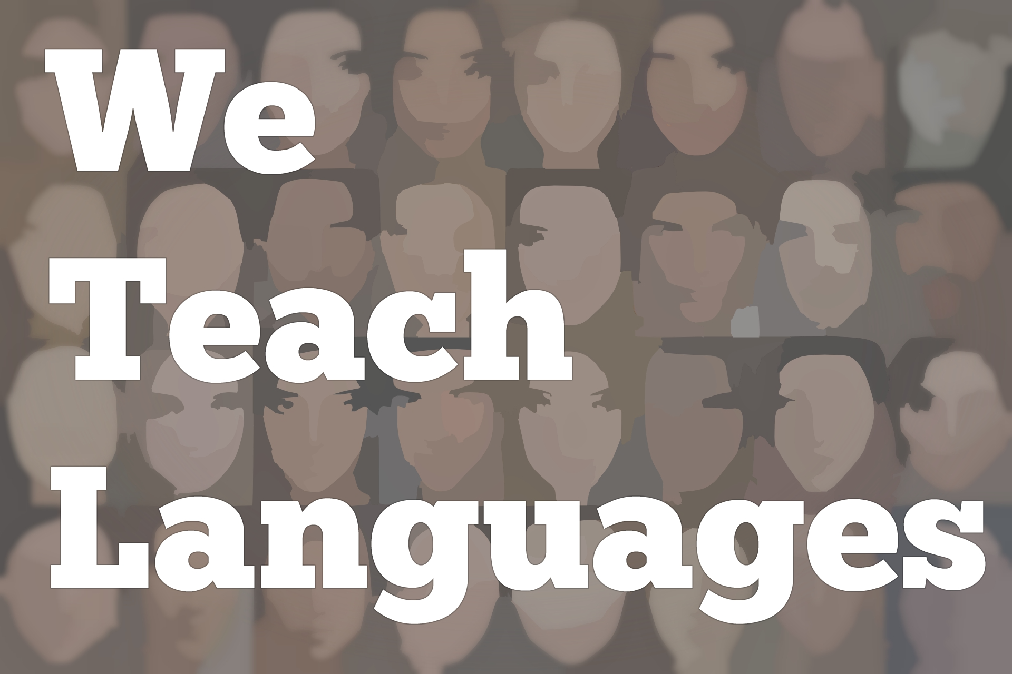
We Teach Languages Episode 103: Tech Tools for the Language Classroom with Heidi Trude
Stacey Margarita Johnson: [00:00] This is "We Teach Languages," a podcast about language teaching from the diverse perspectives of teachers.
[00:07] [music]
Stacey: [00:12] I'm Stacy Margarita Johnson. Today on episode 103, Maris Hawkins interviews Heidi Trude about all of the tech tools for the language classroom.
[00:25] [music]
Maris Hawkins: [00:28] My name is Maris Hawkins. I teach Spanish in a school in Potomac, Maryland.
Heidi Trude: [00:36] Hey, I'm Heidi Trude. I'm a French teacher in Front Royal, Virginia. I teach all levels of French at a public high school, Skyline Line High School and I am the 2018 SCOLT teacher of the year.
Maris: [00:49] We have followed each other on Twitter for a while.
Heidi: [00:52] Of course.
Maris: [00:52] We finally got to meet at GWATFL in the fall. That was really exciting.
Heidi: [00:57] That was so fun.
Maris: [00:58] I know that one of the things that we connect with a lot is using technology in our classes. What are some of your favorite technology tools?
Heidi: [01:09] Some of my favorite technology tools, I'll break these down into categories. By looking at tech tools, if I'm looking at them for formative assessment, I have several favorites. My ultimate favorite for formative assessment for my students is Gimkit, which I know you love as well, Maris.
[01:27] The kids are addicted to it. I'm addicted to it. If you haven't tried it, I would say it is a game-changer for just doing quick formative assessment of vocabulary. The kids like it. They like the competitive atmosphere of it. I also now like using the Seasons aspect.
[01:44] Now, I have my different class periods are competing against each other. It puts it all in a whole new perspective. I like the feature too with KitCollab where the kids can submit their own questions. We make it together right before a test, which I did that today with my third-block class.
[02:01] I was like, "OK, we're going to take a few minutes. Everyone puts in a question. We're going then to play it for just a few, and then you're going to go and take your test." They're like, "This was so helpful. It helped me review better." I was like, "Yeah. The cool part is you're the ones writing the questions. You guys are taking ownership of the game, not me."
Maris: [02:18] One thing that I like a lot about Gimkit, I always talk about this the fact the Josh is a high school student, the creator. On top of that, I feel like he's always changing things, changing it up because he realizes that as a student, he gets sick of the same things. That's when he came out with the KitCollab, Seasons, and all that.
Heidi: [02:40] I also learned when he did a Google Hangout with my class. He's a French student. I can't say enough good about Gimkit and how responsive they are compared to other tech tools. That's probably one of my favorites.
[02:52] I also like Quizlet Live. It's different than doing Gimkit. I like it more when we put them into teams. You're forced to talk. You have to talk with your neighbors. Some kids don't have those social skills sometimes where they know, "OK, we have to work as a team. We're not playing against each other right now."
[03:12] I like that one if I want to mix it up after a while, change them up for a little bit, and then, "OK, you can go back and you can do Gimkit another day."
[03:19] I like Quizizz. If I want to give them a little more individual time or I want to assign it as homework, I like using the Quizizz feature with that one for doing homework assignments. If I'm out for a day , that one's a great one for a sub.
Maris: [03:33] I love Quizizz, too, because like you said, if you're not there, it's easy to set up. You said the questions go with the pace of the student. Gimkit does as well, but some of the other tools like Kahoot!, I feel like sometimes you have to wait for everyone to answer, whereas Quizizz, it goes a lot faster.
Heidi: [03:51] I feel like with Kahoot!, some of the students, they need more time than what I give them in Kahoot!. They just need that processing time where I'm like, "OK, if I give you the Quizizz, you can take your time with it. You can move through."
[04:06] Some of them have told me their feedback is, "I know the material, but I'm pressured if I see a clock." I'm like, "OK, I'll take the clock feature off of Quizizz You just don't get those bonus points for answering quicker." They also feel that they can be more successful.
[04:23] That was a review for my formative assessment that I really like. Probably where I like to use tech the most is in the creating realm. My favorites there, I love using Flipgrid. Flipgrid is phenomenal. If you have not caught onto the Flipgrid fever yet, it's a great tool for speaking practices. We use it pretty much all the time in my class.
[04:47] If I'm going to give them a speaking assessment, I give them a prompt or, "Here's a reading. Now, I want you to share your thought." We have a recording corner in my room, they just go there, or if they want a little more privacy, they just take their Chromebooks, they go out in the hallway.
[05:02] I've had kids who have gone and they wanted to sit in a comfy chair. The principal told them to go sit at his desk and record. I'm like, "I don't care where you go and record. I just want to hear your voice and hear you using the language."
Maris: [05:15] That's awesome.
Heidi: [05:16] Another way that I use it is we have a partner school in France. With the time difference, it's hard for us to communicate with our partner school live a lot since they're six hours ahead of us, so we use Flipgrid. We go back and forth. My kids will pose questions or my partner-teacher and I pose a general question. The French students and my students will respond back and forth.
[05:40] We're getting culture in there. We're getting target language use. My students are getting to hear native speakers. The French students, sometimes we switch. My students will speak in English because the French students in France are working on their English. They want to hear American students speaking English.
[05:56] We'll do a switch where my kids speak English, the French kids speak French. It's just so much fun. We've done all kinds of topics. It's all through Flipgrid.
[06:06] The cool thing with Flipgrid is you can also App Smash. If you're not familiar with the term "App Smashing," it's where we combine multiple tools together. We've mixed Adobe Spark, and then we made our project in Adobe Spark.
[06:21] You make Adobe Spark videos. They download their video, and then they share it in Flipgrid. Then everyone can watch it and comment on that same video. It used to be in class, I'd be like, "OK, we're doing presentation day. Let's get up and let's everyone to do their presentations."
[06:37] Now, when I put them on the Flipgrid, I can say, "OK, your presentation is due this day. You go and you're now going to have to watch them. I want you to comment or ask a question on five people's presentations, or two people's presentations," whatever it is depending on the class number.
[06:54] It gives them more time, that we can do other activities in class instead of taking the whole class period to watch 30-some presentations. I love it because now we can involve our partner school with the presentations and be like, "Here. You make the presentation. We'll ask you questions."
[07:10] Then they go back and forth. That wouldn't be possible without technology. I love Flipgrid for that reason.
Maris: [07:17] Exactly. I should say I was thinking about this when you were talking about it. Gimkit is a paid subscription.
Heidi: [07:24] True.
Maris: [07:25] Then Quizlet Live, Quizizz, Flipgrid, Adobe Spark, they're all free.
Heidi: [07:30] Yes. I forgot to mention that, too. It's free. Flipgrid is one that I love.
[07:36] Of course, I was just talking about Adobe Spark, which I use. There's three components to Spark. You have Spark Video, which you can make videos. The cool thing is the students can record their voice right into it. They can put text, pictures, images. They can also do little short videos into it.
[07:54] I've had my students mix Snapchat and mix Adobe Spark together. It gets really fun. We did a project where they were describing a day in their life to show our partner school. They would do little snap stories. They could throw those right into Adobe Spark without a problem. It's a pretty cool way to do that. You get their audio. You get their little video with their crazy filters.
[08:18] That works nicely with Spark Video. Then you could do Spark Post, which you can use that for making posters and graphics. If you want them to do an infographic, they can make it, and it's not a problem, or you have Pages, which you can think of Pages is like a newsletter-type format. It's like a scrolling newsletter or a web page.
[08:41] I use it if they want to write a story, and I'm not going to have them do any audio or video component to it. They can write it there. They insert their pictures. It's great. It scrolls.
[08:51] I use it more with the upper levels. It's not as neat if you were to make a story with a level-one class. They're going to have less text than, say, the fours and the fives. The fours and fives, they go to town with Spark Pages. If I want my level-ones and the two's creating a story, I like to use Book Creator.
[09:13] Book Creator has a free version. It also has a paid version. I do have a paid subscription just because with your free version, you're limited to 40 books. You can fit a couple classes, and then, well, they make their book and then you don't have any more room.
[09:32] I've gone ahead and just paid because I found after we tried it on the free version, I was like, "Wow. These kids love this." Like Adobe Spark, they can also record their voice in it. The kids like that. They can add their own drawings. They can draw right on the computer if they want to do it that way.
[09:49] Some of them draw their pictures by hand. Then they use their phone and snap a photo of it, or use their Chromebook, snap the photo, and send it to themselves. You can put your own hand-drawn images and you can add images right from within Book Creator, which is really cool.
[10:05] They can add videos in there. They could even add their Flipgrid. It syncs with Flipgrid. You can put your Flipgrid video right in there if you wanted to. It's a very user-friendly with a lot of tools. You can smash different tools with it to make it work.
[10:19] I say that one's probably my favorite for creating stories with because it's just so versatile. They come out looking professionally done. I've found the kids don't need a lot of training with it. They figure it out. They're like, "Oh, I do this, this, this." They are like, "Bam. OK. I got it. I'm doing it."
Maris: [10:39] That's one thing about technology. It's always making sure that it's pretty intuitive for the students because even when you're doing these projects, you don't want the technology to make it take much longer than it normally would without it.
Heidi: [10:57] Exactly. I don't want the tech to be the focus of our lesson. Either it's I want my concept to be that focus and not the tech tool itself driving the lessons. It allows us to share it out.
[11:07] The cool thing with Book Creator, it has a shareable link that I can activate, and then the students can share their book with their parents. They can share it with their grandma who might live across the country. We can share it with our school in France by making it this link that opens up to anyone can read their book on the web.
[11:26] The students can choose to download it as an e-book. They could read it on an e-reader without a problem, which it's cool. Or you can use the print option if you have a color printer. You can print them out and have them bound like real nice books, like real books.
[11:38] It's very versatile to students. I like it on the teacher side because it organizes all of mine. It literally looks like a book shelf. It's where it stores all the kids' work. I'm like, "It's so cute."
[11:50] I have everybody's work lined up like little books on the shelf. They see it when I pull it up. I'm like, "Look. Here's everyone's books. Everyone's there." Then theirs lines up on little bookshelves on their account side. They think it's cool though.
"[12:05] Look, I've made this many books." I'm like, "That's cool." Or they like it, too, because they can do comic books.
Maris: [12:12] I would think, too, when the students have all of their books lined up on their shelf, then at the end of the year, to go back and look at where was I at the beginning of the year. Now, it's something that's really...
Heidi: [12:26] It's really cool. It's great to see how they're progressing, to see their proficiency. They see that, "Well, at the start of the year when I made this book, I was only doing this, but now I'm doing this many pages. It's expanded."
[12:40] The cool thing, too, with Book Creator on my side of it, I could take all their books. I can combine them into one library that they could then share out. "Here's what I have done in my language classes." Book Creator allows you to create those shareable whole group libraries.
[12:57] I could take their work. OK, I take Suzie's books, I put them all in one link. Now, she has all of her work she's ever done that she could share out like a Google Drive, almost, but within Book creator. The kids have that portfolio.
[13:10] Also, I forgot to share about that with Flipgrid now. They have the new MyFlipgrid. Anyone can access if you've ever recorded any of Flipgrid anywhere. You can access all your recordings in one spot. You have that record of your progress.
"[13:27] Well, this was my first video I ever made in French 1, now I'm in French 5. Wow. Look how much I've changed over the years and how far I've gone with the language."
[13:38] That's a great tool. The different types of creators are listening to what teachers want and focusing on that portfolio and seeing your whole progress of growth, which I think is fabulous looking at the digital portfolio model.
Maris: [13:53] I would say that was one thing I ended up doing last year at the end of the year with Flipgrid and Adobe Spark was I downloaded some of their Flipgrid videos. I also had various pictures from our class. I put them all into an Adobe Spark video. Then at the end of the year, we watched them all.
[14:15] The nice thing about Flipgrid is it's so easy to download and then upload into Spark. You can make sure that you have everyone represented equally.
Heidi: [14:26] I love that idea. That's one that I would totally use with our partner school. We've done videos before where we highlight what we do. I'd never thought to do download our Flipgrid and put them into a Spark like that when we try to tell people about them. That's a great idea. Love it.
Maris: [14:42] Thanks. You can download the Flipgrid pictures, too, because you've got all of their work.
Heidi: [14:48] Eith all their crazy stickers and drawings. The kids were finding the different flags. They're like, "Look. There's all kind of stuff." I'm like, "Hey, maybe, there'll be world language words stemming from the other languages." I'm hoping because they have that on Twitter.
[15:03] The other week where they were asking for world language teachers to share phase words or different words that you would like to see come up as a sticker. I'm hoping, maybe, that means they're going to make them soon. I love how they're so responsive, too.
Maris: [15:18] They actually came to my school on their tour last year. They talked to our entrepreneur class. They said the same thing. They said that their number one priority is helping teachers interacting with teachers and supporting teachers. They are really great.
Heidi: [15:37] They're great. I'd love to see them come to actual...I've put that bug in their ear. Maybe, we could try to get some of these other companies to come and see what language educators actually do to cater some of their products to us because now Flipgrid, they have an integration doc, which I was part of their team that helped to create it.
[15:59] They have a doc on their blog, a Google Doc that gives you ideas for using Flipgrid in the world language classroom. If you don't have ideas or you're looking for topics, they have this doc that will give you ideas. They asked several world language teachers to work with the Flipgrid team and create this Google Doc.
Maris: [16:19] We talked about Gimkit, Quizlet Live, Quizizz, Flipgrid, Adobe Spark and Book Creator. Is there any other tech tool that you're using now?
Heidi: [16:29] Let's see. If we want to go to a whole another realm of tech and take it outside of the classroom, one thing we're doing a lot of this year in my classroom is dealing with virtual reality.
[16:41] That's another fun realm if you have Google Cardboard viewers where you can take your learning and look at culture. We do a lot of virtual field trips in here, in my classroom using Google Expeditions.
[16:54] The problem that we've encountered here is WiFi can be an issue. Also, another problem that can be tricky when doing these is making sure all the students have a device. That's eventually on my list, is to write a grant so I can have devices that I could provide all the students.
[17:13] I do have a class that have viewers. That helps, but for them, a lot of them have never left Front Royal. They're like, "Wait a minute. We're actually going to see Paris? We're going to experience inside a museum?" I'm like, "Yeah. You're going to put on this viewer. I'm going to direct us around, and we're going to go on a trip."
[17:31] The way I explained to them is it was like when I was in school when I would watch "The Magic School Bus." I'm like, "OK, we're going on a field trip with Ms. Frizzle. Now, you're going on a field trip with me, but you're going to be virtual." They liked that when it works.
[17:44] What we've also started doing is we've started creating our own that we use with our partner school where we're doing a lot of reused Google Cardboard camera. I asked the students to do it at home because I'm like, "Hey. The WiFi is going to work. At home, it won't be a problem."
[18:00] They go and they take 360 photos in and around town. They describe them in target language and then we share those on Google Doc with our partner school. They download them. They watch them in Cardboard. They watch it using Cardboard camera app in the 360.
[18:17] They're starting to get little virtual tours of our town. A fun way to do it where the kids are in charge of the creation versus me pulling out content that's already been curated from someone else. I put them in charge here.
"[18:32] You are the tour guide. You're the tour director. Take them somewhere in town. Explain what this place is. Take the photo. Tell them what it is, why it's important, and then you share it with me. I share it over to France. France shares back to us places from their town, why it's important." We've got a glimpse. It works.
[18:52] That's one that we're playing with more on our own. It seems that's been easier doing it that way, then trying the Expeditions and all the headaches with the Google Expeditions we've been having.
Maris: [19:03] This is great. Is there anything else you want to add?
Heidi: [19:07] No. This has been fabulous. If you all have questions, feel free to reach out to me on Twitter. My handle is @htrude07. I love talking tech, language, and integrating those two together. Feel free. Just reach out.
[19:22] Give it a try. Just try one of the tools. Don't feel like you have to try everything that I've mentioned or that Maris has mentioned. Just find one tool or one strategy that might work for your class and go with it. Once you feel comfortable, branch onto something else.
[19:37] I always tell everyone just use baby steps. You'll find the kids will help you along the way. You'll find what works, what doesn't work. You make changes. Give it a try. You'll be amazed with how much language your students will produce for you.
Maris: [19:52] Thank you so much for joining us. I will put a lot of these in the show notes as well, so people can check everything out.
Heidi: [20:00] Awesome. Thank you.
[20:02] [background music]
Stacey: [20:03] We would love to hear your feedback on this episode. You can reach out to us on social media. We're on Facebook and Twitter @weteachlang, or you can find us on our website, weteachlang.com.
[20:17] [background music]
[20:18] I especially want to thank the Pearll Language Resource Center for providing transcripts and professional development resources related to this episode. You can learn more about PEARLL and see everything they have to offer language teachers by going to their website, pearll.nflc.umd.edu.
[20:46] Thanks so much for listening. Bye-bye.
Podcast transcripts are provided through a partnership with PEARLL (Professionals in Education Advancing Research and Language Learning), a Title VI Language Resource Center at the National Foreign Language Center at the University of Maryland. Find additional transcripts: www.pearll.nflc.umd.edu/podcast
Transcription by CastingWords

