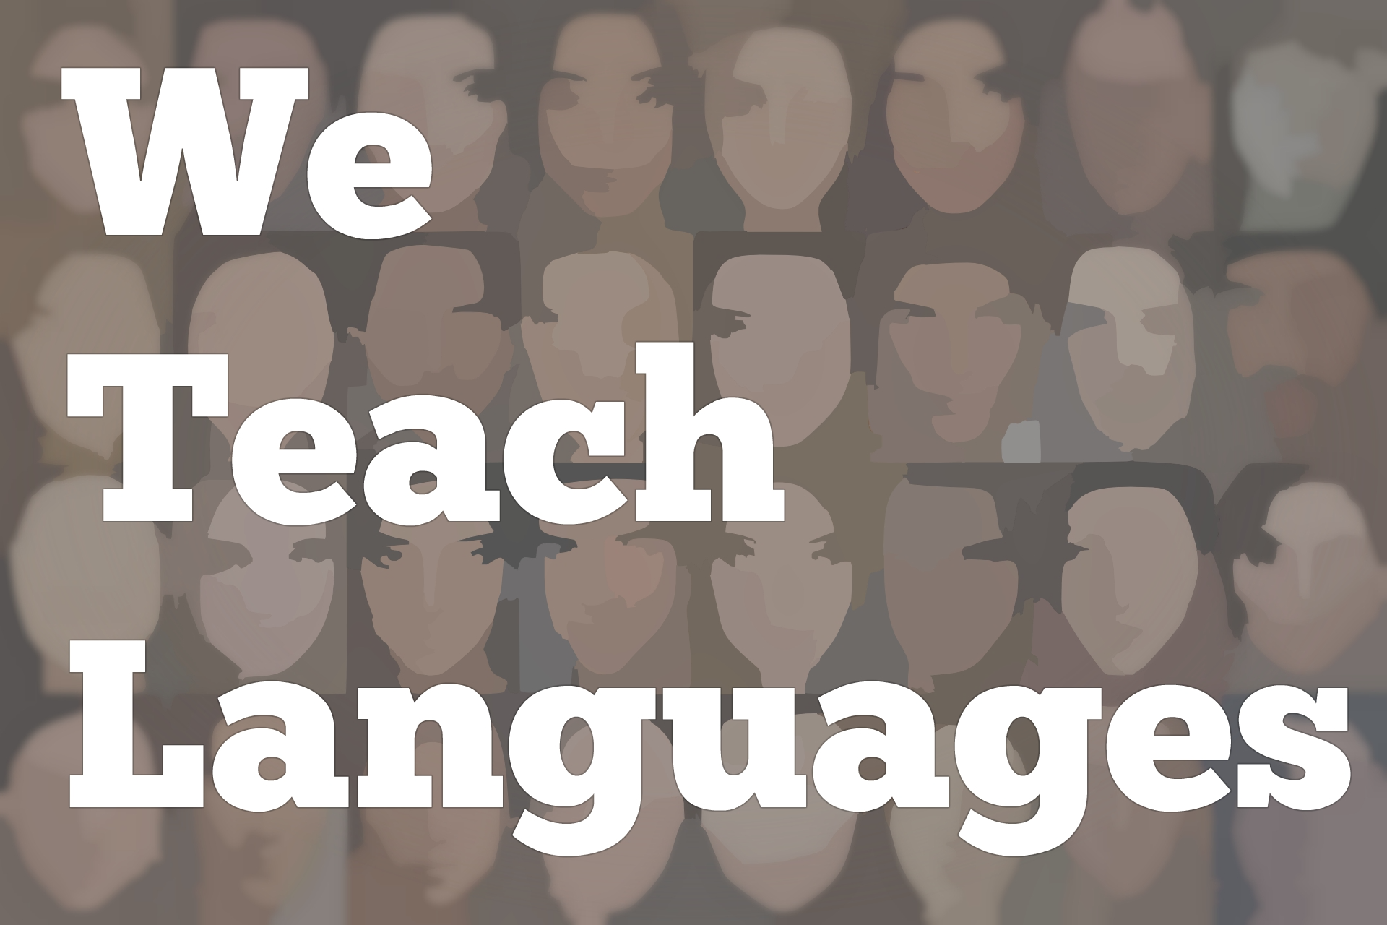
We Teach Languages Episode 106: Prioritizing and Interpreting Texts with Virginia Scott
Stacey Margarita Johnson: [0:00] This is "We Teach Languages," a podcast about language teaching from the diverse perspectives of teachers.
[0:06] [music]
Stacey: [0:07] I'm Stacey Margarita Johnson. Today, on episode 106, Anne-Sophie Dubosson interviews Virginia Scott about her work as an applied linguist and as a professor in a literature-focused language program.
[0:29] Before we jump into that interview, however, I wanted to open up the topic of how we get our students to engage in more in the target language than just superficial conversations. That is of particular interest in college language programs focused on literature study as an end goal, but it's also relevant to other kinds of language study.
[0:55] For example, if your secondary language program is successful, you might have a large number of students looking towards AP credit. What does it mean to teach in a way that leads to success on the AP exam? What does it mean when students can really look at a text and make interdisciplinary and personal connections with the text?
[1:17] Back in November, I actually got to meet Ryan Rockaitis at ACTFL. You might remember him from episode 98. When I met Ryan at ACTFL, he and I got to sit down and talk a little bit about what it takes to succeed in an AP class.
[1:35] [music]
Ryan Rockaitis: [1:35] With the AP course, so much of it is based on authentic materials, and students are really required to develop their ideas. There are so many parts of the AP curriculum where you're just giving students the opportunity to reflect on their own culture, how that connects to the cultures of the Spanish-speaking communities, in my case, or whatever the target culture is.
[1:58] My advice would be not to be overwhelmed, just to pick out the pieces that are most exciting, most relevant to your students, and develop those deeper thinking skills, which is what's going to help them be successful in that course or any other course.
[2:17] [music]
Stacey: [2:17] As Ryan described, higher levels of language study often require students to think deeply about texts and be able to make connections. That was also a theme in episode 101 with Professor Michael Leeser.
[2:34] You might recall that Michael talked a bit about exactly how the textbooks he wrote work to foster critical thinking.
[2:42] [music]
Professor Michael Leeser: [2:45] Something that I feel very strongly about is that I want students to not only be able to express what they did over the weekend, or what their hobbies and pastimes are, but to be able to engage with Spanish speakers, and to able to think about, talk about, and write about what Spanish speakers are talking about, their ideas about different topics. That's part of "Así lo veo."
[3:14] In the first-year book, "Sol y viento," they're watching a film that is geared towards language learners. They're writing about content so that Spanish is not -- or any languages used -- not just to talk about themselves and their own interests.
[3:29] They can actually engage in critical thinking about, "How will we describe this character? What are their motivations? What did they do? Why did they do this? What do you think will happen?" trying to get them to learn those types of skills, because those skills they will use later on down the road.
[3:49] [music]
Stacey: [3:53] With all that in mind, let's turn to Anne-Sophie's interview with Virginia Scott, in which they talk about prioritizing texts and teaching textual interpretation.
[4:06] [music]
Anne-Sophie Dubosson: [4:10] My name is Anne-Sophie Dubosson, and I am a PhD student in the French Department at Vanderbilt University. I have the chance today to have with me Dr. Virginia Scott, who is Professor of French & Applied Linguistics as well as Professor in Education at Vanderbilt.
[4:28] She has been awarded several prizes for excellence in undergraduate teaching and then Chevalier dans L'Ordre des Palmes Academiques in 2004. Virginia?
Professor Virginia Scott: [4:39] Yes.
Anne-Sophie: [4:40] Thank you for being here with me today.
Professor Scott: [4:43] My pleasure.
Anne-Sophie: [4:43] I have the chance to take a class with you this year. I have been very impressed on the take you have on teaching literature for undergraduate and graduate students. Could you tell me more, first, on how you see the evolution of teaching literature for the next coming years?
Professor Scott: [5:03] As long as I have been in this career, I have believed that literature lies at the heart of what we do. Being at Vanderbilt for me has been good, because our programs in French, Spanish, German, and Portuguese for graduate students are in literature, and so we're shaping teachers of the future.
[5:22] While also saying that, I think of text as being more than a traditional canonic literary text. I think of texts as being film, music, interviews, journalistic, and everything that is something students can access. For me text is central, and then literary texts.
[5:44] Students, if you say to them the word, literature, what is the first thing that comes to mind? It's nearly never positive. Students are afraid of literature, , especially if you show them a novel that's more than 50 pages, they get very frightened. How do we get students to think about literature in a different way?
[6:07] I've been working on that for a long time. My first publication was with my colleague, Holly Tucker, "Second Language Acquisition and the Literature Classroom," and we really enjoyed that work.
[6:18] When ACTFL came out with its new understanding of communication as having three modes, the interpretive mode, the presentational mode, and the interpersonal mode, the interpretive mode for me was the most interesting thing. What does that mean?
[6:35] What we really want to do is teach our students how to interpret text. Text they hear, text they see, text they read. All of the work I have done has been on what does that mean to interpret in the first level, in the fourth level, what does it mean to interpret text?
[6:52] My own approach has been that students don't know how to interpret texts. I like to take a task-based approach to literary text, which is a task is not have your students read 30 pages. A task is not answer these five questions about what you've read. It's not what the students know, but how they know.
[7:15] Even if they only can read a third of it, let's say, or even less than that and don't understand all the words, how do they get into something and then having students ask questions is more interesting than having the teacher ask questions. Again, I would say it's not what they know, but how they know.
Anne-Sophie: [7:36] Could you, maybe, explain more about this task-based approach?
Professor Scott: [7:41] Yeah. That's tricky. Because my own orientation is linguistic, I give my students tasks that are linguistic tasks. As an example, when I've had students read "Madame Bovary" by Flaubert, it is a 19th century novel that is long. It's a novel that I love.
[8:02] If you know it well, you know that Flaubert uses metaphors and similes or comparisons throughout. There's not a page in the novel that doesn't have a metaphor or a simile. For example, the main character, Emma Bovary, saw her life as a long, dark corridor with the door at the end shut tight.
[8:27] I have the students -- every time they come to class -- they have to have identified a metaphor in the section that we're reading, the page that it was on, all the words in the metaphor that they particularly like. Look them up, look up the synonyms, look up the antonyms, and come to class prepared to talk about your metaphor.
[8:47] Every student usually picks a different one in class. Then the students can talk about their metaphors, and that leads us to talking about the entire passage that they read. It also is a way for students to have something to say in class. That's a task, looking for metaphors.
[9:04] My tasks are almost always linguistic. Look in the text and find such and such. If a text like a Marguerite Duras -- all of my examples are from French. I'm sorry, but that's all I've done -- Marguerite Duras who writes very skeletal prose...It's really a subject, verb, object in the indicative.
[9:24] There are not many adjectives. There's not much embellishment. Each reader has to imagine what's going on. I ask the students to take sentences and add adjectives, adverbs, relative pronouns, dependent clauses, and flesh it out.
[9:41] Then we come to class, and we see that your interpretation of the sentence is radically different from this student's interpretation of the sentence. Duras' style then becomes apparent that your interpretive work as a reader is enormous.
Anne-Sophie: [9:59] You've been working on the digital project, "La Princesse de Clèves," on a task-based approach. I would be very interested to understand the process and how you came to that.
Professor Scott: [10:14] The Princesse de Clèves is a 17th century novel that is very difficult for students to access linguistically and even thematically. There is another text that also was a 17th century text, a map, an allegorical map, called the "Carte de Tendre."
[10:31] I was talking to some friends who do digital and mapping, and I said, "I wonder if you could turn an allegorical map into an actual digital map that the students could negotiate, could walk, could interact with, could go from place to place and, maybe, write when they were in these different places."
[10:49] A colleague of mine said, "Sure, of course." He digitized the map for me, superimposed it right in the middle of Paris, right on the Louvre. The students could actually do the allegorical map, but they could also walk out and around Paris, which was amazing. I can't do that myself. You have to do those things with colleagues.
[11:09] Then the students in the class were supposed to read the Princesse de Clèves and imagine that they were on this allegorical map. They were supposed to imagine where they might be in a particular place in the text, write in a blog that went along with the digitized map where they thought they were and why they were there, and have them do a trajectory.
[11:31] In class, they compared where they were. A student would say, "I am in the Town of Tenderness," and someone would say, "Oh, no, no. But no, you should be in the Town of Obedience," because this allegorical map has these very strange love-related places that a person could go.
[11:47] They can go down the River of Inclination which has to do with lust. The students not only saw this allegorical map and read this text. Mostly, the idea is that they can come to class and say something that was fun. Iit does bring you to talking about the actual text.
Anne-Sophie: [12:09] I was wondering like you have mentioned an article that just published last year on the Princesse de Clèves in part of the multiliteracy's framework in your approach. What does it consist of?
Professor Scott: [12:21] That article describes what I did in that class with the Princesse de Clèves. I was working with graduate students. It's co-published with a graduate student, Cara Wilson. Your question is multiliteracies.
[12:35] For me, the essence of the multiliteracy approach is that we prioritize text. Text, you don't prioritize talking about yourself, what you're wearing, what your mother's name is and how old you are, which is so much of what communicative language teaching has done. It's very self-referential.
[12:52] If you prioritize text, then students are always having to look out rather than look in. They're looking out obviously to the target culture texts through Internet. For me, that's part of multiliteracies. We have an opportunity now to use all kinds of resources for learning.
[13:14] Again, I'm going back to this interpretive mode that, for me, if you prioritize text, and you prioritize the interpretive mode, and not just the interpersonal mode, then you're creating students who are able to negotiate meaning and are sensitive to another culture.
[13:34] To go back to this, ultimately, if we're wanting to create the multicultural citizen of the world, you're not ever going to have a student...No student is going to say, "Oh, my gosh. I took French at Vanderbilt, and we learned the plus-que-parfait, and I'm so excited about that."
[13:54] A student might say, "Oh, I took a French course at Vanderbilt, and we read some really random 17th century texts. There was a digital map. We got to roam around the map and roam around Paris, and talk about that while reading the novel."
[14:07] They will remember that. They might look up and see what else they would be interested in.
[14:13] The final question, always, after you've done something is, "What more do you want to know?" You say to the students, "We've read the Princesse de Clèves. We've looked at this allegorical map. What more do you want to know?"
[14:24] What the students tell you is part of their grade. What more do they want to research about the 17th century? What more do they want to know about digital technologies?
[14:33] It doesn't matter what it is that they say, but in a multiliteracy framework, we've presented them with text that should lead them deeper into exploring. It's a discovery model of learning, rather than a static model.
Anne-Sophie: [14:49] If you had any advice to give, what would it be for a young teacher, young professor, who starts in this career?
Professor Scott: [15:02] The only advice is to remember that your students are not you. You are a specialist. You love literature. You love language. You are very particular. You're not an engineer, and your students are not like you.
[15:16] Most of them don't care a lot about literary text. They don't care a lot about learning French or any other language. They're there for reasons that are...
[15:25] You may have 1 out of 20, but most of them aren't there for that. It isn't until they're in upper level that they're highly motivated for the subject you love. Remember that, and give them something that's memorable.
[15:40] One of the mistakes that novice teachers often make is they try to do too much. If you've just finished a dissertation on, let's say, 20th century women writers, and you teach a course on 20th century women writers, you may have six novels. It's better to do less, to do more with less than to do less with more. Do you follow what I'm saying?
Anne-Sophie: [16:05] Yeah.
Professor Scott: [16:06] Yeah, so that would be my advice. Do less, do it better. Remember, they're not you.
Anne-Sophie: [16:13] Merci beaucoup, Virginia.
Professor Scott: [16:14] Thank you for coming. I'm very glad you came.
[16:16] [music]
Stacey: [16:19] I hope you've enjoyed hearing from Professor Scott. I really can't get enough of her. [laughs] If your interest is piqued, you might check out her articles mentioned in the episode, which I have also linked in the show notes.
[16:34] I'll also mention, even though it didn't come up in the episode, her most recent book, called, "Double Talk," is a great read. Although on a slightly different topic, it addresses monolingualism in the classroom. I'll link that in the show notes as well. I highly recommend it.
[16:55] Before I sign off, I wanted to mention some of my personal experiences with Professor Scott. First of all, I'll mention that I knew of Professor Scott long before I met her.
[17:07] I have been teaching courses at various colleges in the language teaching methodology space since about 2006, which happens to be just a couple of years after the video series was produced called, "Teaching Foreign Languages K-12 Workshop."
[17:27] If you haven't already watched [laughs] that series, it's just a remarkable set of videos produced in part by ACTFL. I will link to the website in the show notes so you can learn more about that as well.
[17:39] However, I mention them because in the first episode called, "Meaningful Interpretation," Virginia Scott is part of the roundtable discussion on what is a text and what does it mean to interpret a text. I've been pretty much assigning that video to my students for a decade.
[18:01] When I came to my on-campus interview at Vanderbilt University in 2015 and got to meet Virginia face-to-face for the first time, I had actually known her through those videos [laughs] and introduced her to most of my method students through those videos. That was a real treat for me.
[18:22] It got even better when I got the job, and have realized over the last four years that she has been an advocate for me. She's been a mentor to me. She's a tireless advocate for languages, language teaching, good pedagogy, in general, on campus and in the profession.
[18:43] She's just been a tremendous colleague and mentor. I am so grateful to her which, I think, is a sentiment that all of her colleagues and students in the Department of French and Italian would echo.
[18:56] Part of the reason I'm excited to share this interview with you all now is because Professor Scott is retiring from Vanderbilt this year. This episode gives me a chance to publicly give her a bit of a tribute.
[19:12] Thank you, Virginia, for everything you've done for me and for your department, for Vanderbilt, and for the profession.
[19:21] [background music]
[19:21] We would love to hear your feedback on this episode. You can find us on Twitter or Facebook @weteachlang, or you can leave a comment on the episode page on our website.
[19:33] We would like to say a special thank you to the PEARLL Foreign Language Resource Center for partnering with us to provide transcripts and other professional development resources related to the episodes. You can learn more about PEARLL by going to pearll.nflc.umd.edu.
[19:51] Thanks so much for listening. Bye-bye.
Podcast transcripts are provided through a partnership with PEARLL (Professionals in Education Advancing Research and Language Learning), a Title VI Language Resource Center at the National Foreign Language Center at the University of Maryland. Find additional transcripts: www.pearll.nflc.umd.edu/podcast

Transcription by CastingWords

