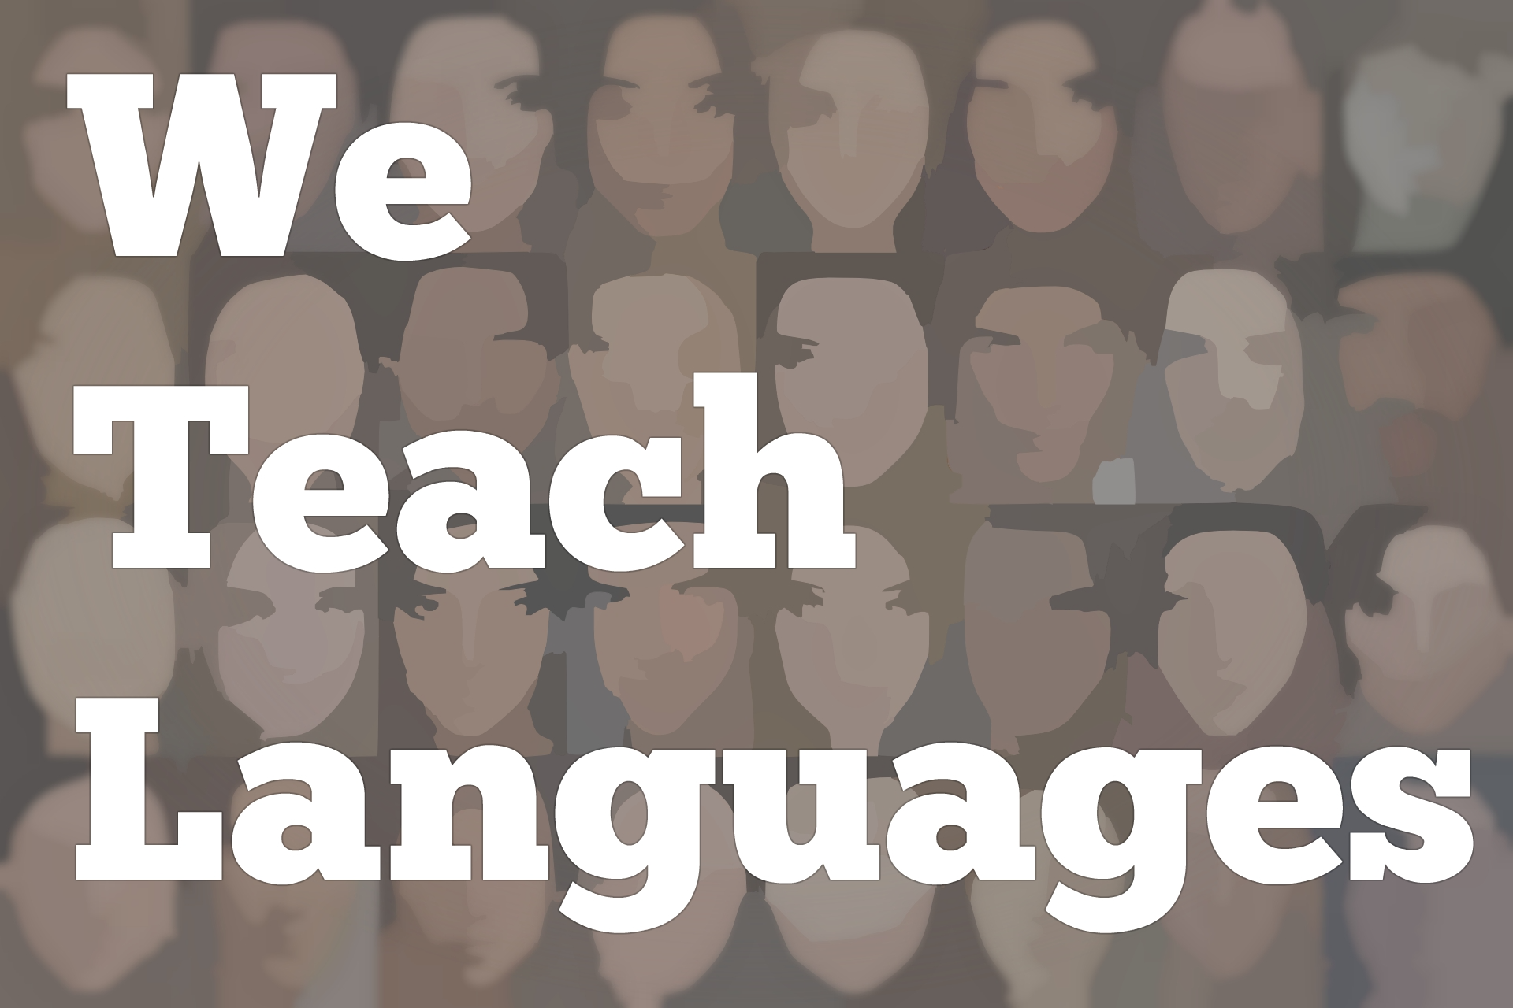
We Teach Languages Episode 115: Who should be talking in the language classroom?
[00:00] [background music]
Stacey Johnson: [00:00] This is We Teach Languages, a podcast about language teaching from the diverse perspectives of teachers. Hi, I am Stacey Johnson. Today, on episode 115, I'm taking the mic in my own hands.
[00:18] I'm going to explore a question that came up recently that's really closely related to a few of the things we've heard on recent episodes and on not so recent episodes. I thought I'd take this opportunity to look at the question of who should be talking in the language classroom?
[00:40] For instance, you might be in a district or in a setting where a supervisor, a chair, or an admin of some sort occasionally comes in to watch you teach and give you some sort of a formal or informal evaluation of your teaching.
[00:59] Interestingly enough, what works in language classrooms isn't always what is scored positively on those admin evaluation forms. I'm interested in the question of who should be talking in the language classroom. However, the more I dug into that question, the more I kept coming up with the answer, "It depends."
[01:25] It depends on lots of factors of the teacher, how they're teaching, what materials they're using, and how engaging it is. It depends on the students and their proficiency level, and what they're working on, and whether the tasks are well-designed.
[01:43] Also, sometimes no one should be talking. That's another question [laughs] that we're going to look at. Instead of starting with a very big, rather controversial question that basically is always going to be answered, "It depends."
[02:00] I thought it would be interesting to break that question down into several related questions, like a constellation of smaller questions and take each of those one by one and see if there's any interesting points of view that we can find.
[02:16] The first sort of sub-category of the question of who should be talking that I think is important to deal with is, one, should students be talking or should the teacher be talking? That might be what most of us think of when we think of this question.
[02:34] Interestingly enough, if you asked students, who should be talking in the classroom? You will get some paradoxical information. One, we know that students really do prefer a very strong knowledgeable faculty member or a teacher, however, preferences for learning are socially constructed like everything else.
[02:56] Possibly because of their socially constructed preferences for learning, students do often say that they want someone who explains things clearly, presents information in clear logical sequences, and gives interesting lectures.
[03:17] Students also [laughs] report that learning a language means learning to speak that language. This is from two studies I did, one I published in 2010 and one in 2015.
[03:32] Sort of an unintended finding of these studies, something I learned that I did not expect to, was that students did not consider learning to listen or write or become culturally competent or change their perspective about the world.
[03:49] Students didn't consider any of those things learning. When students thought about what it means to learn a language, they thought about speaking that language. They often had very unrealistic expectations about how much they would actually learn to speak by the end of the semester.
[04:08] They came in with preconceived ideas [laughs] about what the instructor should be doing in class. They also came in with unrealistic expectations about how much they would learn to speak while in the class, as we know second language acquisition is a predictably slow process to quote Daniel Woolsey from episode 42.
[04:35] On the other hand, if you ask language instructors and language education researchers, you'll also get some mixed responses about who should be talking based on their orientation, their philosophical orientation, and the lens that they bring to reading research and practicing language teaching.
[04:57] In a communicative classroom, really talking about maybe the last 40 years or so of language education, and we're not necessarily talking about any one person's conception of communicative language teaching, but we're talking about communicative language teaching as it has been deployed worldwide.
[05:21] In a communicative classroom, the idea is that students should really be talking as much as possible. This is part of a larger trend in education towards student-centered instruction that happened not only in second language acquisition, but also in other subjects.
[05:41] I'll start by saying that part of my job at my university is working at the Center for Teaching, where I get to have great conversations about teaching with faculty from all over campus.
[05:55] At the Center for Teaching, we often talk about how a traditional lecture format, where the faculty member has all the knowledge and imparts said knowledge through a lecture, often accompanied by dense PowerPoint slides. Does that sound familiar [laughs] ?
[06:09] That format just isn't really supported by evidence that it's the best way for students to learn. It's not necessarily the best way to acquire knowledge, if that's the point of the exercise, but it's also not the best way to develop skill or wrestle with challenging open-ended questions, which I think is a little more obvious.
[06:31] Sometimes, you hear people say things like, "Instead of the sage on the stage, the teacher should be the guide on the side," or you might hear folks describing the role of the teacher as going from lecturer to coach.
[06:45] These are both useful ways to think about how we might move more responsibility onto learners, but I would argue that they are not enough. There's a growing awareness.
[06:59] Once again, I'm talking about in the broader educational context, not just in language learning, but in all aspects of education, that binary approaches like "Teachers talk less, students talk more," are just too reductionist.
[07:14] It's not enough to say students should talk more unless students have a strong knowledge base, useful structures, and clear guidelines for what kinds of things to say. It's also not fair to say teachers should always talk less.
[07:28] In some classrooms, the problem isn't that the teacher is talking, but rather what the teacher is saying and how that teacher talk is being leveraged to improve learning outcomes.
[07:40] In L2 classrooms, we've seen a similar, go from sage on the stage to guide on the side [laughs] shift in many classrooms with the communicative approach over the last 30 or 40 years, with great intentions and a lot of really useful research.
[07:59] People who employed the sort of broad understanding of the communicative approach want to stop lecturing at students about verb forms and sticky grammatical points and spend more time letting students actually use those structures to communicate, first in scaffolded and then in open-ended contexts.
[08:24] Many language teachers made the same shift as other educators. Culturally, as a whole, the profession definitely made the shift [laughs] that teachers should be talking less and students should be talking more.
[08:37] What's interesting I think in language learning, and it definitely parallels what's happening in education more broadly is that language teachers are starting to take a hard look at when and how to get students talking.
[08:52] As a discipline, I think we're becoming more aware of the role of input. In fact, for some teachers, the pendulum has swung so far to the other side that they would say that teacher-delivered input is the only important kind of talk in a classroom and that student should not be required or expected to talk at all.
[09:15] Of course, there's a lot of nuance in there and there are more moderate views as well that center students receiving input via teacher talk while also employing some communicative strategies to get students talking after they've built up their reserves with input, so to speak.
[09:35] Very recently, in episode 112, Gianfranco Conti shared the importance of teacher talk using the analogy of teacher as nurturer.
[09:46] [music]
Gianfranco Conti: [09:48] Because if you become the nurturer, then you're the provider of input and by right, you should be because you are an expert, but also you need to find ways for students to do the most natural thing, which is interpersonal listening because most listening doesn't happen in a vacuum or listening to a source.
[10:06] It is between two people.
Stacey: [10:09] I think that's a really concise and compelling explanation [laughs] . If you haven't listened to episodes 111 and 112 with Gianfranco Conti, you really missed out. They're tremendous. Go back and have a listen to those. I think he will change your mind about some of the ways that we teach listening in the classroom.
[10:33] All of this [laughs] conversation about whether teachers should be talking or students should be talking seems to land us at the position of really teachers should be nurturing, especially at the lower levels when students are building capacity.
[10:51] Teachers should be nurturing student listening skills through interpersonal talk that focuses on teacher-delivered input.
[11:02] However, [laughs] to throw a wrench in that, my next question is, "If we can agree that teacher talk is very important in a language classroom, should it be the teacher doing all the talking or is it important for students to hear multiple proficient language users or native speakers?"
[11:19] Gianfranco Conti was pretty clear that it is not important for students to hear that. Back in episode 28, Joe Barcroft told us something that on the surface seems very different. Let's have a listen.
[11:33] [music]
Joe Barcroft: [11:35] But there is some, there is a growing body of research on different types of enhancement that you can use to facilitate the acquisition of target vocabulary. One area that I would point out that I think is quite interesting is in the spoken mode.
[11:52] If you're dealing with presenting target words in spoken language, if you use what we call different types of acoustic variability, that can be facilitative. Actually, it can increase L2 vocabulary learning substantially. What do I mean by acoustic variability?
[12:15] Input manipulation by including multiple talkers you can use to facilitate vocabulary learning. We've done that with multiple talkers. We also find that you also get positive effects for multiple speaking styles. This would be one individual using different voice types as they present the target words, for example.
Stacey: [12:38] I don't think this is an either/or situation. One of the things I love about second language acquisition research is that often there are findings that seem to be contradictory at the surface, but when we dig a little bit, we discover that there's really a place for both of them in our classrooms.
[12:58] At the earliest levels, when we are building capacity, when we are building confidence, when we are establishing language foundation, the teacher as nurturer model is probably the only one we need.
[13:12] However, as students advance in proficiency and need to acquire larger vocabulary, maybe a more academic vocabulary, they need to learn to describe things outside of their immediate conversational experience, one strategy that we have at our disposal is hearing similar things said by multiple speakers.
[13:37] Moving on, my third question, when our students do talk, assuming you have a classroom where students do talk, some of the time or most of the time, which student should talk? This is a really interesting question that came up in my interview with Steve Smith.
[13:59] I'm going to put a link to this in the show notes. In fact, all the episodes I mention are all going to be linked here.
[14:05] In my episode with Steve Smith back in June of 2018, one of the things he talked about is cold calling students, asking a question or engaging in some sort of a conversational device and then waiting, giving students a chance to think of what the answer might be, and then calling on a student to answer.
[14:33] Now, for a lot of us, calling on students to answer a question seems a lot like putting them on the spot, like maybe it would cause anxiety.
[14:45] However, one of the things that often, just shockingly often happens when we don't intentionally call on students in a systematic way is that a few high flyers or sit in the front enthusiastic [laughs] students or students who have ethnic, racial, and gender identities that belong to the dominant group, these students just tend to get called on more.
[15:16] As teachers, I think we need to take equity really seriously. The idea that when I am left to my own devices as a teacher, I may not be as equitable as I want to be in calling in students, over time has led me to really believe in the power of cold calling.
[15:39] Now, what I've done in my class this semester that has been just really pleasant and successful from my perspective although we'll see when I get a chance to get some feedback from students about how things are going, I will report back, but I have told students that I have all of their names on a three by five card.
[16:00] I will just go through the stack calling on students throughout the class period. My goal is to get through the stack of cards a couple of times every class, but if I call in a student to answer a question or to engage in conversation and that student does not want to or cannot answer me, all they have to say is, "Bustle."
[16:20] That's it. That's Spanish for "I pass." The idea is that sometimes we just are having a bad day and we don't want to talk or sometimes our brain just can't recall how to respond [laughs] , and that's OK, not wanting to or not being able to engage with my question is fine in my classroom.
[16:43] There is no shame. Hopefully, I am striking a balance between calling on students equitably and giving them the opportunity to gracefully bow out of situations they don't want to be [laughs] involved in.
[17:00] Another question that I was thinking about is, when the idea of teacher talk and student talk really relates very closely to a question that comes up regularly in all the discussion boards, message boards, Facebook groups, and on Twitter, which is "Should we be speaking students first language or second language?"
[17:21] When I was trained as an instructor, really under a communicative model, we were instructed to speak 100 percent target language all the time, no exceptions. We could not write any English on the board.
[17:38] We could not use any English in our tests or in [laughs] our quizzes, definitely not spoken English during class time. We were supposed to insist that students not use any English either. That was when I was a graduate student TA instructor and leading class for the first time. I think the pendulum...
[18:02] Once again, we have another pendulum swinging back and forth [laughs] , but I think the pendulum has really swung away from that target language or bust mentality that I was taught with 20 years ago.
[18:17] Now, the idea is that, yes, students need to spend a lot of time in the target language. ACTFL gives 90 percent as a guideline. Obviously, this would be something that I can't...It's mind-boggling to even imagine how you would research, what the appropriate percentage is because, once again, with these kinds of things, the answer is always, "It depends."
[18:41] As a guideline, try to do 90 plus percent of your class in Spanish.
[18:49] In my mind, this 90 percent is a nice number because it gives me enough target language that we're really advancing students' proficiency, but it also gives me some space to focus on students' emotional needs, to clarify what things mean using students' first language without feeling like I have cheated [laughs] or without making students feel like they're cheating.
[19:16] It also helps me really address issues of identity and self and reflective practice in the classroom in ways that might be a little bit more advanced than our language level, especially considering that I do teach novice learners.
[19:35] When we're asking who should be talking in the classroom, I think asking what language should they be speaking [laughs] is another very closely related question. I will also throw in here, let's imagine the teacher/nurturer is speaking, that they're speaking 90 plus percent in the target language.
[19:57] Of course, there's room here for us to include other proficient speakers for students to talk, for students to talk to each other [laughs] , for us to occasionally use the L1 for different purposes, but let's assume we're in a classroom where a competent teacher/nurturer is providing input 90 percent plus in the target language.
[20:17] Question I think is really important to ask is, "But can students understand you when you talk?" Often, we talk about providing input. I think a really huge percentage [laughs] of teachers that I know aren't just talking about input, they're talking about comprehensible input.
[20:42] If I speak with my novices using words they can understand that they haven't learned, talking about things that they can comprehend and just have them sort of surrounded by target language, that doesn't actually necessarily lead to language acquisition.
[21:04] Way back in episode 19, that was [laughs] in the summer of 2017 I think, maybe just around two years ago, I interviewed Caleb Howard about staying in the target language in class. He used the analogy of using a lot of target language from day one that students cannot understand as throwing them in the ocean to learn how to swim.
[21:34] Every once in a while, he would use visuals or hand gestures, and that was like throwing a life preserver out to the students drowning in the target language. It was rescuing them from a situation that they should not have been in in the first place.
[21:50] When he started revising his approach to the target language, he started ensuring from day one that he was providing target language in small comprehensible doses, that he was using a lot of repetition, checking in with students, making sure everyone was on board with what he was saying and what was happening, and that no one ever felt like they were drowning.
[22:12] Another thing that really struck me from Caleb's interview is he talked about his strategic use of silence in the classroom. Rather than flooding students with the language, he strategically would use silence and allow students just to focus on his actions, his demeanor, before he added words to that.
[22:35] That is very similar to a recent episode, episode 113, with Justin Slocum Bailey, where he talked about the incredible power that silence can have in our language classroom.
[22:50] [music]
Justin Slocum Bailey: [22:51] Silence is the most underused vocal skill of teachers, not just language teachers, teachers in general, probably one of the most underused skills of humans [laughs] .
[23:05] Silence is so powerful, especially of context in a world with so much noise. Some of the noise is actual audio noise. Some of it is just the general distractions that we have. We get so few opportunities for silence that, if we can punctuate our speech and our lessons with genuine silence, it's a huge contrast to people's normal lives.
[23:29] Like we discussed, anytime you generate a sudden contrast, it grabbed attention. Silence can actually be an amazing attention grabber. It can also be a way of, right after you say something, giving people time to process what you just said.
Stacey: [23:45] Just to recap all the questions [laughs] that we've talked about in this episode, I would say, first, who should be talking, the teachers or the students?
[23:56] Second, if it is the teacher talking, is it only the teacher or is it an interpersonal exchange or maybe are there other proficient language users that we're bringing in to help with vocabulary acquisition? I would ask that, if it's the students who are doing the talking, which students are talking?
[24:20] Are we, as teachers, accidentally allowing some students to dominate the conversation and not using equitable practices that ensure that everyone's engaged? Also, are we speaking the target language or a student's native language? What percentage of each are we using? Why do we choose to use one over another?
[24:47] Those are really interesting questions to think about. I think different teachers might come to different conclusions about what works best for them. Finally, are we always talking? Is there any room for silence in our classroom, either to make our language more comprehensible or to help students focus on what's important or to build suspense.
[25:12] If you have any other questions that you think are important to consider around this whole conversation of who should be talking in the language classroom, I would love to hear from you.
[25:25] [background music]
Stacey: [25:25] You can reach out to us multiple ways, all of them are on our website, weteachlang.com/contact. You can also find us on Facebook and Twitter.
[25:36] We would like to say a special thank you to the PEARLL Foreign Language Resource Center for partnering with us to provide transcripts and other professional development resources related to the episodes. You can learn more about PEARLL by going to pearll.nflc.umd.edu. Thanks so much for listening, bye.

Podcast transcripts are provided through a partnership with PEARLL (Professionals in Education Advancing Research and Language Learning), a Title VI Language Resource Center at the National Foreign Language Center at the University of Maryland. Find additional transcripts: www.pearll.nflc.umd.edu/podcast

Transcription by CastingWords

