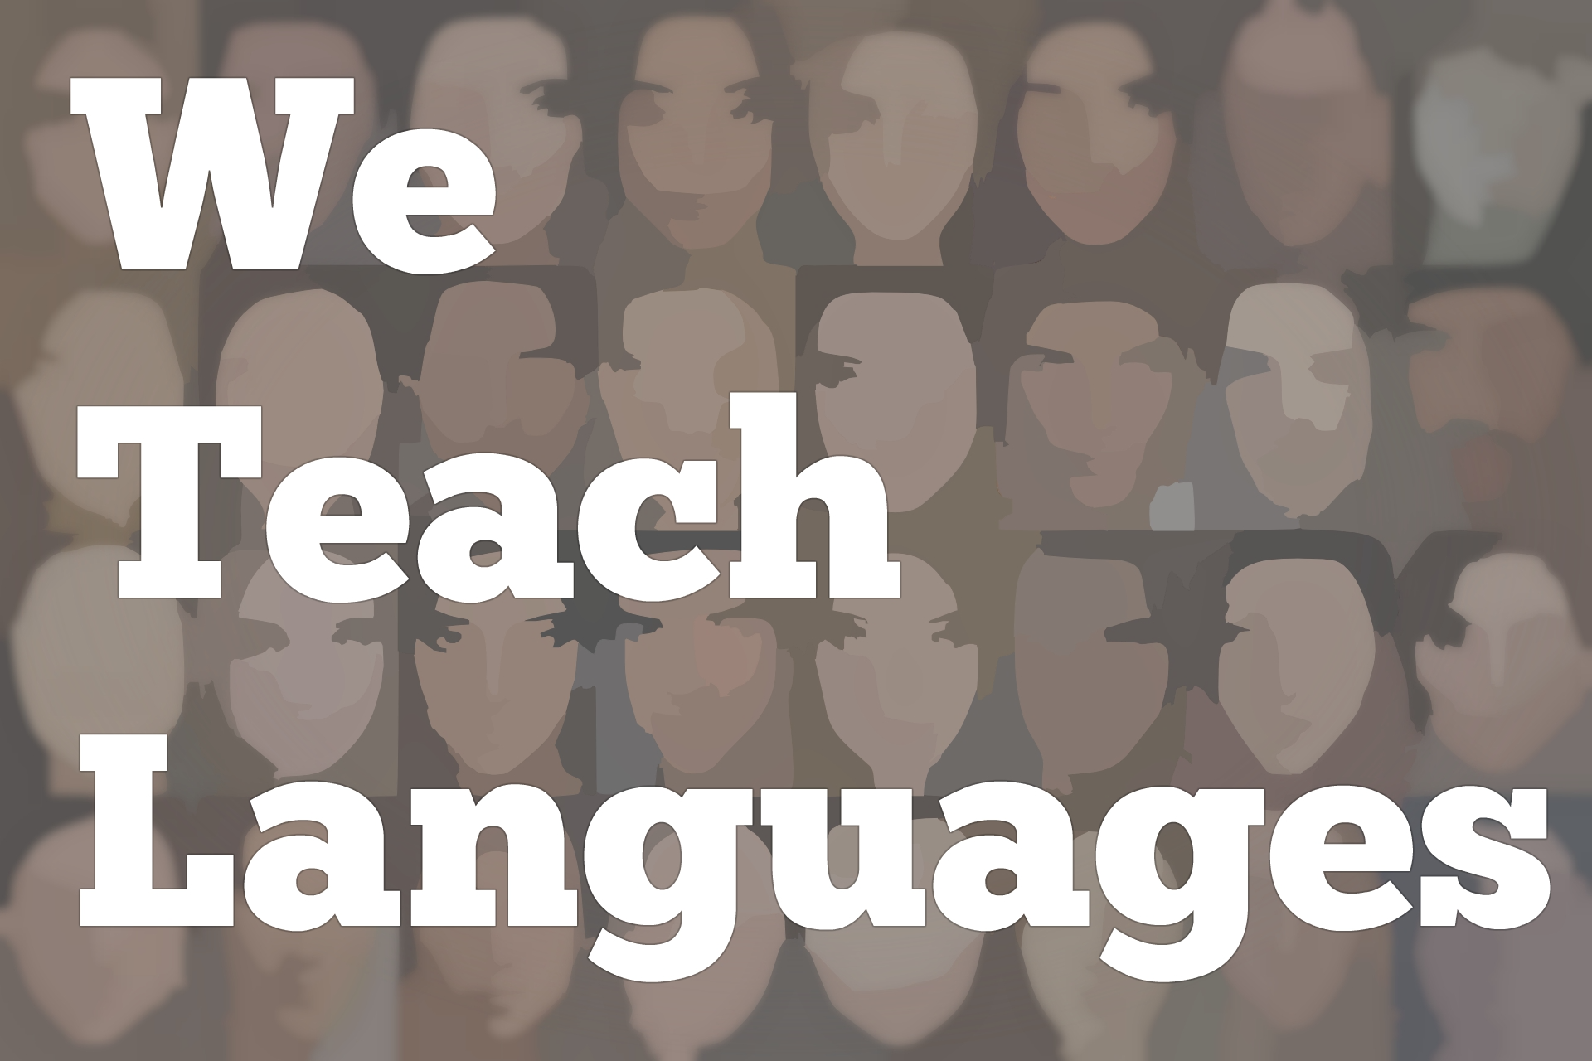
We Teach Languages Episode 130: 2019 Year End Wrap Up
Stacey Margarita Johnson: [0:00] This is "We Teach Languages," a podcast about language teaching from the diverse perspectives of teachers.
[0:08] [background music]
Stacey: [0:12] This is Stacey Johnson, and today on Episode 130, I am going to do our 2019 year-end review episode.
[0:24] To prepare for this episode today, I went back and listened to the 2017 and 2018 year-end review episodes. It was so good to hear, how in previous years I really reflected on what went right and what could have gone better, and set goals for the podcast and thought about how this project would grow over time.
[0:52] I am not going to bore you with all of the details, have link to those two episodes in the show notes if you want to go through and hear about things that were on my mind in past years.
[1:06] I did want to recap that, in 2017, one of the things that I set as a goal for the podcast was that we would include more international guests and more diverse guests. In 2018, I was able to go back and talk a little bit about how we did that.
[1:29] In 2018, I set as a goal that we would have more contributors doing episodes that I would be continued to do the editing and production work, but that I would be taking the lead less, doing fewer interviews, and that more contributors would be stepping in to do that front and center work.
[1:50] In this 2019 wrap-up, I want to talk a little bit about how that went. Yeah, it went great. [laughs] We had 44 episodes in 2019, not counting this one. Of those 44 episodes, 24 of them had interviewers that were not me, which is awesome. That's more than half of our episodes being led by teachers.
[2:24] There were 14 contributors in all. I am just going to list them really quickly. Caroline Schlegel, Claire Knowles, Rebecca Blouwolff, Maris Hawkins, Meghan McGinley, Ellen Toubman, Tomas Sauer, Anne-Sophie Dubosson, Janina Hanson, Melanie Forehand, Carolyn Siegel, Margaret Kelly, Jiaqian Chen, and Shannon Mason.
[2:51] In the show notes, I have all of those contributors and their episodes' linked up. If you want to go hear some of our amazing volunteer- and contributor-led episodes from 2019, that should be easy to find.
[3:08] We also had folks from a few new countries involved in the podcasts, since that was one of my goals for last year. We did not have as many international guests as we did last year when I was specifically focusing on it as a goal. We did have two countries we had not previously had represented on the podcast. That was really fun to see as well.
[3:32] Now another thing that I wanted to mention is that our listenership has grown quite a bit. I have mentioned this before, but I don't keep any data on how many people are actually listening to the podcasts. I only have data on how many people are clicking on the show notes on our website.
[3:53] It's hard for me to know exactly how many listeners we have. That's one of the reasons why I avoid giving real numbers for things like that. When I click on the website, one trend that I can see is that between 2017 and 2018, the number of people clicking on our website more than quadrupled, and then from 2018 to 2019, it doubled again.
[4:22] I am not sure how many of you there are listening, but I know that tons of thousands of people are clicking on the website every year and that the number just keeps going up and up, which is really exciting.
[4:38] I can't help to think how cool it would be if a percentage of the people who are listening were also contributing in different ways, [laughs] but growth over time. We'll see even more contributors next year.
[4:52] This is going to be a pretty short episode. I have put a lot of thought into what goals I might have for the podcast in the upcoming year, but I don't have enough of my thoughts together to be able to make an announcement in this episode. I am going to lay it out for everyone really quickly.
[5:18] I imagine that over time, over the year 2020, the podcast will begin to develop more of its online resources to support teachers. In addition to the show notes with all of the links, I am imagining how can we systematize some of the information available on the website to make it more useful for teachers, more useful for professional development.
[5:44] In order to do that work well and put effort into developing the web resources, I am going to have to find the time by limiting my time another places.
[5:58] For now, my goal for the next year of the podcast is to do less podcasting. I am hoping we'll have substantially fewer episodes in 2020. We will come back with a new episode the second week of January.
[6:16] I am not sure we'll always stick to a completely weekly schedule in 2020. My hope is that we'll have significantly fewer than the 44 episodes we had this year. I also hope that we will have a more organized and systematized web resource available for teachers that makes good use of all of these episodes that we've collected.
[6:42] At some point, when you have well over 100 episodes of just gold from teachers, it's not such a matter of continuing to amass more resources. At this point, I feel an obligation to make sure that we're making good use of all these resources and that the episodes aren't being lost in the archives. Does that make sense?
[7:10] Stay tuned. We will definitely still have episodes coming out. Probably most Fridays, you will see an episode of We Teach Languages, but just at a slower pace than we have in the past three years, and hopefully developing those web resources even more.
[7:30] If you are interested in being involved with the podcast as a contributor or any number of different things, we could definitely use more volunteers. Please feel free to get in touch. I will get back with you as soon as I possibly can to talk about how you might become a contributor.
[7:52] [background music]
Stacey: [7:53] I also want to take this opportunity to say just thank you so much to the wonderful, kind, supportive community of language teachers who have embraced the We Teach Languages podcasts. Thank you so much for being my teachers and encouragers, and thank you for keeping this little operation going.
[8:18] I can't wait to see what 2020 has in store. I think it's going to be our best year yet. Thanks for listening. Bye-bye.

Podcast transcripts are provided through a partnership with PEARLL (Professionals in Education Advancing Research and Language Learning), a Title VI Language Resource Center at the National Foreign Language Center at the University of Maryland. Find additional transcripts: www.pearll.nflc.umd.edu/podcast

Transcription by CastingWords

