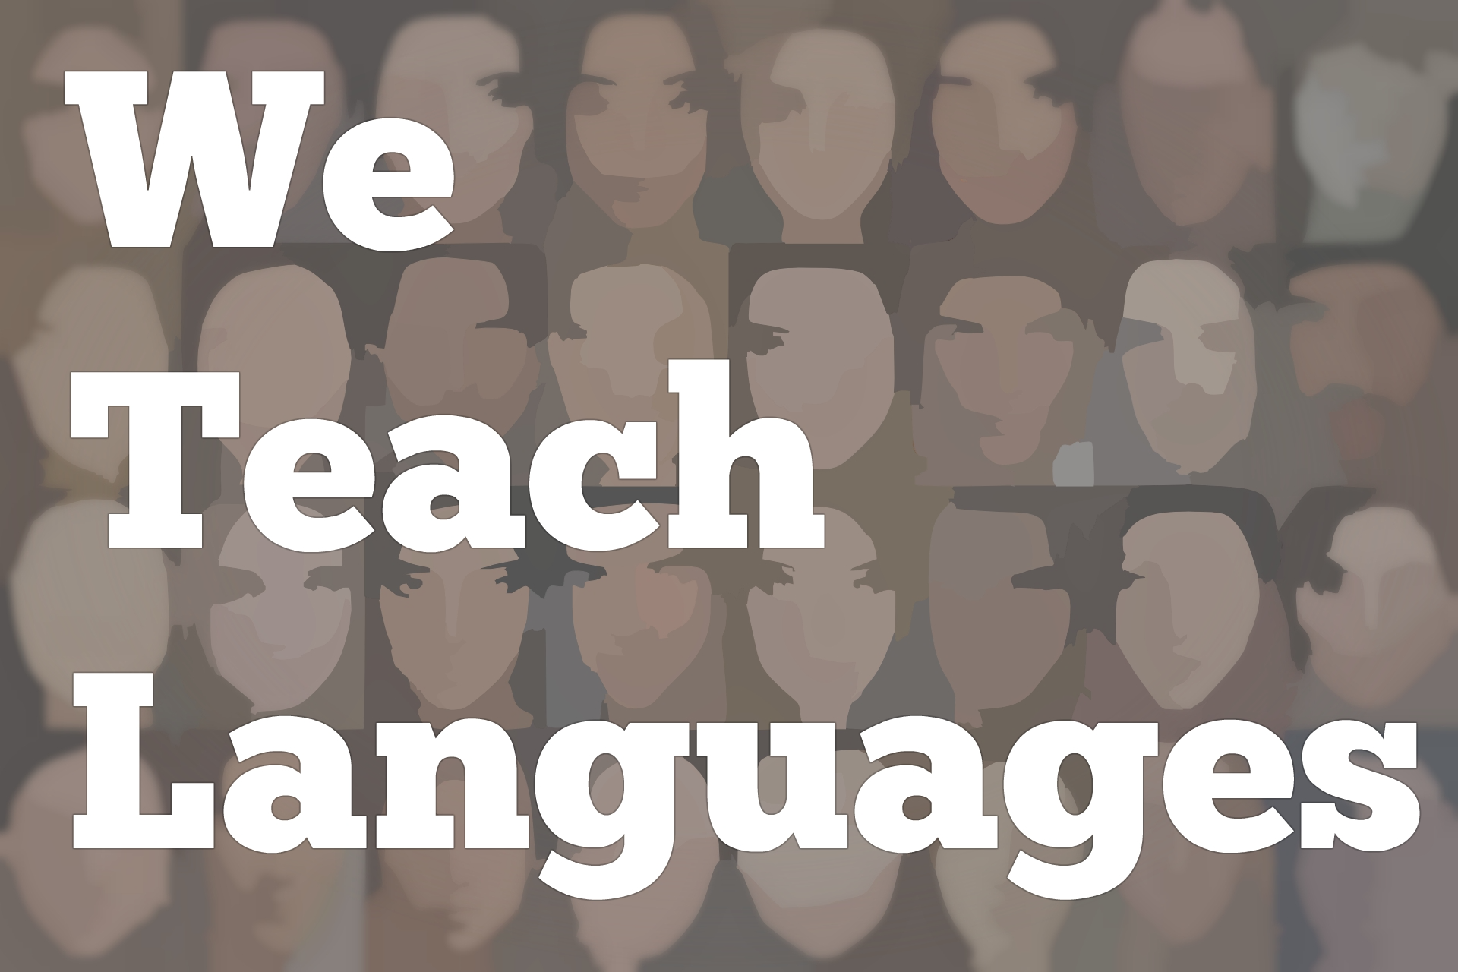
We Teach Languages Episode 131: Evolving Teaching and Writing Comprehensible Novels with Inga Paterson-Zuniga
Stacey Johnson: [0:00] This is "We Teach Languages," a podcast about language teaching from the diverse perspectives of teachers.
[0:06] [music]
Stacey: [0:06] I am Stacey Johnson, and today, on episode 131, and our first episode of 2020, Maris Hawkins interviews Inga Paterson-Zuniga about the novels she authors for language learners and some of the ways that her language teaching has changed over the years.
[0:34] [music]
Inga Paterson-Zuniga: [0:40] My name is Inga Paterson-Zuniga. I have been teaching Spanish for 22.5 years here in Northern New Jersey. I teach middle school, grade seven and eight. Mostly, I have been teaching middle school since I started teaching.I did teach some elementary for a time, and high school, but my niche is definitely middle school.
Maris Hawkins: [1:05] Wonderful. I'm curious about how you originally were introduced to TPRS, or comprehensible input?
Inga: [1:14] Back in the late '90s, believe it or not, I stumbled upon a video of Blaine Ray and his approach to TPRS, and found it fascinating. I was teaching elementary school at the time. I started playing with TPRS in my classroom and attending workshops. I became a follower of the methodology, so much so that Blaine actually invited me to start presenting workshops on TPRS.
[1:47] I was doing that for quite some time, back in the mid-2000s. It's evolved, my practices have evolved quite a bit since then, constantly evolving with the times. I'm trying to find ways to better connect with my students. I want to be able to better serve them all.
[2:07] We always have students who struggle with language acquisition due to a variety of factors. When a student's having difficulty connecting with their teacher, it's often because they cannot see themselves in their teacher, right?
Maris: [2:20] Yeah.
Inga: [2:20] One of the things that I've really been working on, especially as of late, over the past couple of years, is trying to become more equitable. We know that 80 percent, I say, 80 percent of teachers in the US are white. Here I am, a blond-haired, blue-eyed Spanish teacher named Inga, and most of us do not represent the demographics of our students. Even if we do, we don't represent the demographics of the world they'll inherit.
[2:55] I've been doing a lot of soul-searching, I've evolved. Back in the '90s, it was mainly about storytelling and working on constructing stories with my students. We still do that in our classroom, but trying through the lens of equity and being culturally responsive. I try to learn more about my kids, and find out what makes them tick, and then have that be the springboard into our class discussions and storytelling.
Maris: [3:26] I think that's so important. I've been reading a lot of the same things, too, just on Twitter, where people are talking about what teachers look like versus what our students look like. I think that that is important.
[3:40] Another thing that we had talked about is that you also write novels, TPRS, comprehensible novels, which I find fascinating. As a child, I envisioned myself as an author. [laughs] How did you get started with those novels?
Inga: [4:01] The very first one, it came to me on a whim. I worked for several years with a friend of mine in a district here in central New Jersey. She was inspired to write, because we didn't have anything that was the right fit for, as far as teaching through CI. We wanted to make sure that we gave them a compelling context.
[4:32] She decided to take vocabulary and structures and create a novel out of it, but based on her experiences in Spain. I'm going to put in a plug for her, Magaly Rodriguez. She's a friend of mine, and she wrote, "Berto y Sus Buenas Ideas." It grew out of her need to try to find a way through storytelling, to take the curricular goals and turn it into a story.
[4:57] She inspired me, and I said, "You know what, I have so many stories to tell." I lived for several years in Mexico. Actually, I live and breathe Mexico in my everyday life. My husband is from Mexico. We speak Spanish at home with my son, and I spend my summers in Mexico.
[5:17] I told stories to my students about going to the bathroom, the public restroom. Something as simple as a visit to the public restroom is a totally different experience abroad, and so I was inspired one day.
[5:31] My kids, they always loved that story about having to pay to use a public restroom. I thought, "What am I doing? Why am I just sitting here and telling these stories?" and I'm like, hmm, this is something that I need to share at a bigger scale. I said, "You know what, I'm just gonna write."
[5:45] One night, I sat down and wrote the story of "Cinco Pesos," which was my first novel, and it was inspired by that story of me trying to find money. A lot of it was based on my own true experiences, not having any money to use the restroom, and trying to find a coin. It's actually pretty hilarious if you think of it. That was the first one.
[6:10] Then, I was inspired by my brother-in-law in Mexico, who is always late to the party.The second one was titled "Ahorita," which is the concept of Ahorita time in Mexico, and how everyone is going to be there, Ahorita, which mean right now. It really actually means anything but Ahorita.
Maris: [6:34] Exactly.
Inga: [6:37] Americans have a real hard time. We're foreigners who come to Mexico. We have a hard time grappling with that concept. I thought it was another story that needed to be told.
[6:47] Then, my third one I published this past fall, was based on a true story in central-southern Mexico, in Guerrero, a discovery that I don't want to get too detailed with, because it'll ruin the punchline. That one, it's culturally complex. There is a lot to it, a lot of history. That was a fascinating story to write. I'm all over the map with what drives me to write, but we need more materials on our shelves. We can always use more readers. That's what got me started.
Maris: [7:29] I agree. I thnk that other languages are starting to also increase their novels that they have that are comprehensible. In particular, that's one way, as Spanish teachers, that we are lucky that there's so many novels out there. We can always use more, because the Spanish-speaking world is so vast and so complex, that we always need more that we can include, and that also can hook our students into reading.
Inga: [8:02] That's my hope. I try to put a lot of imagery in the novels, too, because I feel that my novices are drawn to the images. I try to balance my images to words on the page, because I feel like, sometimes when they're very text-heavy, it turns them off and they're drawn to the...They really like the graphic novels.
[8:28] I do a lot of my own photography when I'm down in Mexico. Basically, all of my books are all my own photography. That's a lot of fun too.
Maris: [8:40] How do you feel writing these novels, that you've changed your ideas and focus, as your teaching has evolved as well?
Inga: [8:49] Yes. My first novel, "Cinco Pesos", it was definitely more English-centric. There was a lot of culture in there, but I'm trying to go into the mindset of a person who's living and breathing Mexican culture, and not from the mindset of an American.
[9:13] I'm working on one now, about a woman named Juanita, and I know her personally. It's a fictional novel, but I'm trying to interview her one-on-one, and get what's going through her head as she's going through the situations in this book. I'm trying to get it from that angle more.
Maris: [9:38] That's interesting, because I do write a lot. I don't make whole novels, but I do try to make comprehensible units.
[9:48] I do the news with Martina Bex. Again, it's trying to read as much as you can, or talk to as many people as you can, especially as some of these bigger news stories have happened for us, for example, the protest in Chile. It's talking to people who are from Chile and getting their background, because it is valuable to get those voices out there.
[10:19] To be able to produce something that you want to share with other students, and having the ability to do that, but also to be able to bring in other perspectives, other than just the American viewpoint into that, is valuable. Asking other people for their thoughts and taking feedback from others is especially important.
Inga: [10:43] That's so true. That's so important.
Maris: [10:48] Another thing that we're trying to do as well, is also look at voices that are not always represented. I started taking Spanish in 1996. I'm trying to think at what point I had a shift in thinking.
[11:10] I don't feel like it was until, maybe I was actually teaching Spanish, that I realized that a lot of indigenous cultures existed. That just wasn't what we talked about. To me, Mayans were people who lived way before Christopher Columbus came.
[11:29] That's one thing that I'm trying to do now, is push to my students the fact that a lot of these indigenous cultures still exist throughout South America and throughout Central America, and Mexico, just so they're aware. So it's not what I experienced, that all of sudden I realized how important indigenous cultures are, and that they still exist.
Inga: [11:51] Yes, they're still very much alive. They tend to be among the marginalized. We've got to bring attention to the richness of their culture.
Maris: [12:03] Exactly. That starting to shift can start to validate also what's going on in the United States as well.
Inga: [12:12] Yes, it's very timely.
Maris: [12:15] This is wonderful. Do you have anything else that you want to add, or any other things that you've been thinking about, as you have evolved as a teacher and as your [inaudible] ?
Inga: [12:25] Yes. [laughs] Of course, there's definitely. I have so much to add, but I'm going to try to focus on a couple things.
[12:37] An area I've been working every year to improve is my approach to grading. If you ask me, I feel that grading is one of the most damaging practices that could have ever been instituted in our schools. I really have a hard time with dealing with an industrialized system of arbitrary letters and numbers.
[12:58] Kids get very good at playing school. They love to ask the question, "Is this for a grade?" They don't ask, "How will this help me learn?" We talk about that frequently. I feel that it's important to focus on remediation for the kids that need it.
[13:20] If I have, let's say, I use can-do statements in my class. When I'm going through a particular topic, we have can-do statements to fall back on. Let's say, I'll ask my kids to achieve 8 out of 10, for example, some arbitrary number, and to try to aspire to 8 out of 10 can-dos.
[13:43] At a novice level, novice-mid, that would mean listing words and phrases. Some kids might even be able to produce some sentences. It all depends on where they are on their proficiency journey, but we talk about always constantly striving to the next level-up.
[14:02] Let's say there's a student who particularly struggles to get these thoughts out, and they're only accomplishing maybe two or three of the eight can-dos. Then it's time to remediate. I'll meet with them one-on-one to discuss learning strategies, and come up with a more reasonable personal goal.
[14:20] Let's say, I'll ask that kid, "Do you think five can-dos would be reasonable?" We work toward that goal, and I'll have them come in to try again, maybe a couple of times, until they're able to really grapple with it. Then, we'll up the goal one by one, and eventually, they rise to the occasion.
[14:37] We'll do that with timed rights, we'll do that with any type of assessment, and always giving them an opportunity to try again. That's important, because...I don't know if you've heard the statement, "Children are like popcorn."
Maris: [14:53] I know, I have.
Inga: [14:54] [laughs] I don't remember who said this, and I wish I did. I just keep going back to this, children are like popcorn. They don't all pop at the same time, but they eventually all do pop. I always have this in the back of my mind.
Maris: [15:12] No, that's good.
Inga: [15:13] Isn't that great?
Maris: [15:14] Yeah.
Inga: [15:15] You've got to approach it with that lens, because there's such a heterogeneous mix of levels in our classes. When I'm teaching, I'll always give them the same quality of input, but my expectations of output would vary from student to student, based on where they are, how they're doing on their progress, from their point A to their point B.
Maris: [15:39] I agree. One thing that I've reflected on a lot that you mentioned too, is the fact that some of this stuff is arbitrary. For me, sometimes testing dates are arbitrary, like [inaudible] are in trimesters, and so there's at some point where I need to get grades in. I take the formative assessments that I've been giving. I try to reach a point where I feel like most of the kids will be successful.
[16:09] There are always students who need extra time, like you said. They haven't popped yet, and so I'll do the same thing. I'll let them retake any assessment throughout the trimester. I wish I could extend it throughout the year.
[16:26] If you can do that much better on the assessment at the end of the trimester that I ask for a mid-trimester, I don't care when it is, especially if I'm asking you to do this as an assessment, it's something that I've valued. If you can do it at the end grade, I'm not going to...and at least for me, if they get a 100, then that 100 goes in. I don't make it, "Oh, well, you can only get up to an 80."
[16:52] No, if you've performed at a 100 or 90 or whatever it is, that's the grade that I'll put in the grade book, because like you said it, some kids it's going to take longer. That also allows them to try again and take more risk. At least for me, I've found, rarely do students want to redo assessments. For me, I haven't found that kids come in with the attitude, "I can just redo this."
[17:20] No, because at least for me, it was during a study hall or something like that. It wasn't something that they were like, "Eh, I'm just gonna blow this off." I found that that has worked for me a lot with my grading.
Inga: [17:37] I totally agree there. It has not been an issue for me either.
Maris: [17:42] Then, have you found that your assessments have also shifted as you have adopted this policy?
Inga: [17:50] Yes. Yes, yes, yes. I've been trying to focus more on ACTFL proficiency goals, to have them demonstrate what they can do rather than what they can't do. That's been a seismic shift for me.
Maris: [18:09] I agree, and I think the other thing, as I've done something similar, that I've seen, and it goes back to what you were talking about a little earlier about novice mid and list, I think as teachers become aware of what is actually appropriate at the novice level, I think that also allows students to feel more successful.
[18:34] I know for me, before I really looked at that, I was asking for them to do stuff that wasn't realistic to what their proficiency level was. Learning those proficiency levels really opened up my eyes to what I should be asking them to do.
Inga: [18:52] Oh yes. Yes, definitely. I hear you there. It's something we have to constantly go back to, I feel like. I'm still learning, as far what are the characteristics of a novice mid, and what do they really need to be able to achieve novice high in a sustained way? There's a lot of learning going on when it comes to understanding proficiency benchmarks.
Maris: [19:22] Exactly, and to me, that kind of makes it exciting. The going back and rethinking something and reworking it for the following year and making it work for my students and my levels is energizing.
Inga: [19:38] I just think it's definitely a work in progress. I think if there's anything that we, as language teachers, need to do is we need to advocate, because we're up against a lot in our system.
[19:51] I think that there's a lack of awareness of the value that languages have in supporting 21st-century goals, skills for their future careers. We really, really have to work on advocating.
[20:08] I know that a lot of districts across the country have set up equity committees to work through systemic issues, and I think that's a great way to get more of an awareness out there, to build awareness district-wide.
[20:25] I think we're really under serving students by perpetuating this Anglocentric view of the world. That's something that I think we need to really look at, like our curricular goals. How can we make systemic change happen through our curricular goals, and at least within our classrooms?
[20:47] If we support the social studies curriculum, or the science curriculum, and make it real, that that would definitely go a long way in building more of an understanding of the value.
Maris: [21:01] I agree. I think that it's so important. I think, because many of the times some of the older language practices, that this new shift is allowing our students to become more engaged. But you're right, it's also reaching beyond that, to the district, to make sure that they also recognize the importance of what language can do, and language classes can do.
Inga: [21:34] Yes, yes. Amen to that.
[21:36] [laughter]
Maris: [21:36] Thank you so much for taking the time to talk. We'll make sure that we can link a lot of the resources that we talked about here under the show notes as well.
Inga: [21:50] Wonderful. It was such, such a wonderful opportunity. I feel so fortunate to be able to share.
[21:56] [music]
Stacey: [21:56] If you have questions or comments related to today's episode, we would love to hear from you. You can reach out to us multiple ways. All of them are available at our website, weteachlang.com/contact. You can also find us on Facebook and Twitter @weteachlang.
[22:18] We would like to say a very special thank you to the PEARLL Foreign Language Resource Center for partnering with us to provide transcripts and other professional development resources related to the episodes. You can learn more about PEARLL by going to pearll.nflc.umd.edu.
[22:39] Thanks so much for listening. Bye, bye.
Podcast transcripts are provided through a partnership with PEARLL (Professionals in Education Advancing Research and Language Learning), a Title VI Language Resource Center at the National Foreign Language Center at the University of Maryland. Find additional transcripts: www.pearll.nflc.umd.edu/podcast
Transcription by CastingWords

