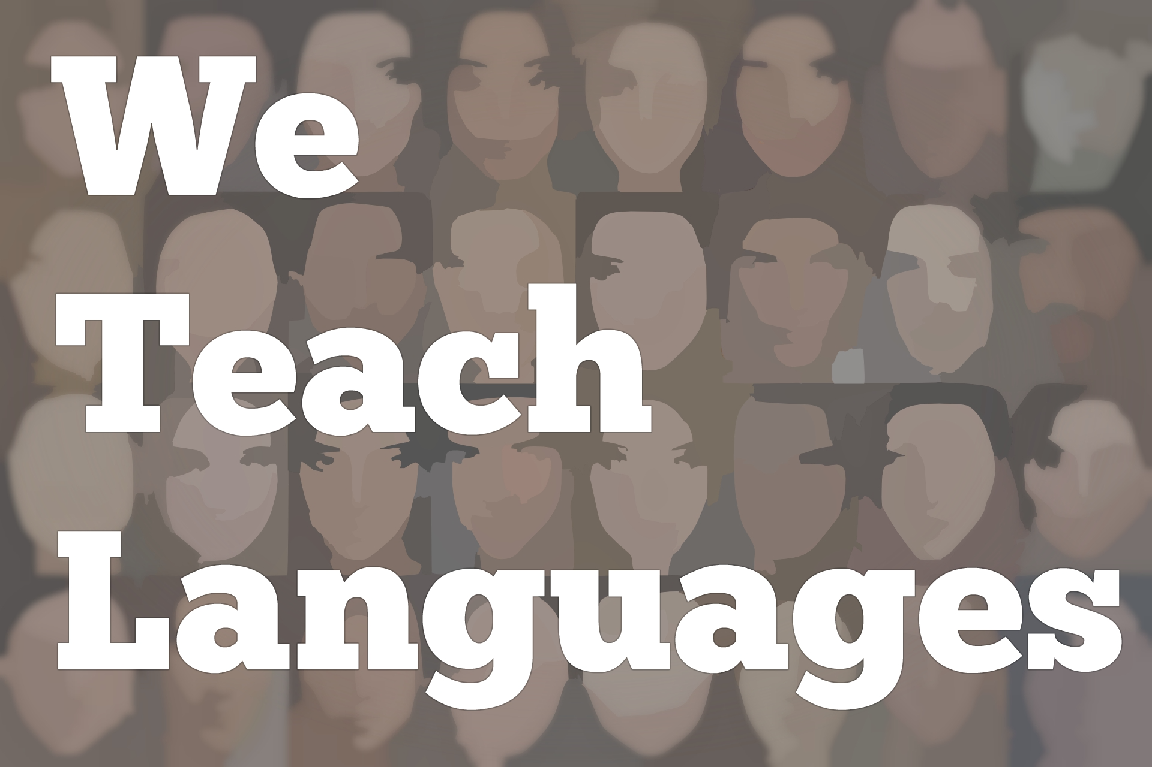
We Teach Languages Episode 133: Organizing our Instruction and the Experiential Learning Cycle
[00:00] [background music]
Automated Voice: [00:00] This is "We Teach Languages," a podcast about language teaching from the diverse perspectives of teachers.
Stacey Johnson: [00:06] I'm Stacey Johnson, and today on episode 133, I'm going to talk about how we organize our language instruction. I'm also going to give lots of specific examples, including the model that I use to plan almost everything I teach -- the experiential learning cycle.
[00:34] I'm not exaggerating when I say I use this model on a daily basis and talk about how I use this model frequently, probably almost as often as I actually use it. I use a variety of the experiential learning cycle developed by Kolb in 1984.
[00:53] If you Google Dr. David Kolb, you'll find a lot of his work online, including a lot of work that I'm not going to reference and frankly don't find as useful.
[01:03] However, his straightforward model of experiential learning, mapping out step by step what it is that helps people make meaning from experience has been a springboard that I've used to rethink how I teach.
[01:20] Today, I'm going to build on his experiential learning model and apply it to the current moment in language instruction to the best of my ability.
[01:31] Before we get to experiential learning, let's talk about how we organize our instruction just in general. I'm not going to use the term lesson planning here because to me, that implies a much more detailed process than what I'm going to talk about.
[01:47] I am talking about organizing instruction, just the system we use to decide how and what we teach, not the process of actually mapping out specific lessons or activities or units. I'm thinking of this as the rack that we hang the clothes on that gives the clothes shape or the skeleton that the body's on that gives the body shape.
[02:15] It's the structure within the lesson that's repeated and consistent and familiar to teacher and students that makes all that decision-making about what to teach on a daily basis just much more streamlined and helps us to ensure that we're hitting all the important stuff, no matter what activities we plan to do.
[02:37] This kind of organization will happen on two levels. There's the big picture stuff, like what is it students need to be able to do by the end of an academic year or articulated across years, and how do we cycle things in and out?
[02:55] I can see how the experiential learning cycle could help to make sense of that. I'm not sure it's the best tool for that big picture stuff that corresponds to curriculum planning. What I'm really talking about is that more micro-level planning, like what am I actually going to do when I walk into the classroom? What's going to happen tomorrow?
[03:18] How do you organize an actual lesson or series of activities? Do you have a structure that you can fit your lesson planning onto? For me, as a teacher, the organizational approach I choose helps me make sense of how to select and order instruction to ensure it is of maximum benefit to students.
[03:38] The organization also serves the same purpose as what many of us might call a method. It gives us a clear shape and expectations for practice. It helps us decide which things work for us, which things don't. It's a decision-making tool, and it can be really useful. As I said earlier, to give shape to our teaching.
[04:02] Obviously, I'm not the only person who has an organizational system for their teaching. I've read or heard actually lots of really interesting ways to organize instruction. I thought maybe a good way to start would be to look at some other people's ideas instead of starting with my approach.
[04:22] The first two that I'm going to put in the same category as organizing instruction in a way that is conceptually consistent with overall teaching goals. How do we want students to perform as results of our teaching? OK, let's organize instruction that way, organizing instruction with the end in mind.
[04:47] The first person I want to highlight is Lance Piantaggini, who was on the podcast last year for episode 108. In the fall, wrote a blog post where he summarized his current approach to organizing instruction. I'm going to give you some background.
[05:05] Lance's goal for his classes can be summed up in two words -- maximize input. I'm speaking for him here but I believe that he would agree with my [laughs] assessment there. He calls his organizational structure talk and read, and it really is as simple as it sounds.
[05:26] In his blog post, which I will link to in the show notes so that you can go read from his own words, he talks about how he breaks up his 40-minute lesson into two pieces.
[05:36] The first half is dedicated to talking activities. He's actually the one doing the bulk of the talking here. He lists a bunch of the talking activities he typically will do, then he does a brain break. The second half is dedicated to reading activities. He has a lot of those listed in the post as well.
[05:57] This organizational system allows him to categorize useful activities either as talking activities, brain breaks, or reading activities. When he's thinking through, "What do I need to do for tomorrow?" it's the same structure.
[06:12] Giving students that predictability they need to feel safe, because it's the same thing every day. Also, minimizing the choices he has to make as an instructor, while also maximizing the input his students are receiving. By selecting a variety of interesting activities from the list, he also is keeping it fresh every day.
[06:35] That's his system. It's clearly based on his overall goals for his students. The second teacher whose system for organizing instruction I want to highlight is Meredith White, who has also been on the podcast very briefly, back in episode 80.
[06:53] Meredith is also thinking about her overall goals for her students in the final assessment and thinking about, what will her students need to do to demonstrate success? For her, that's an IPA, or an Integrated Performance Assessment.
[07:07] An IPA is an assessment tool where students examine an authentic resource and then engage in interpretive and/or personal and presentational communication, all based on their understanding of that authentic resource.
[07:23] Now, this is an assessment model, but Meredith organizes her daily instruction around the concept using what she calls every day IPA. I love this.
[07:34] It means that every day, students are going to look at a resource, do some interpretive activity to make meaning, do some interpersonal activity to have a conversation and make sense of it with each other, and then do some writing or speaking activity where they demonstrate presentational ability.
[07:49] I'm going to add links in the show notes both to the episode that she appeared on, but also a couple of resources where Meredith describes her approach in more detail. It is definitely worth your time to check that out.
[08:06] Those first two I said go into a category that I would call organizing instruction with your course goals in mind. I think a second approach to organizing instruction that is really worth reading up on is by thinking about how the brain works and how to best align our instruction to work with our students brains, rather than against them or in spite of them.
[08:32] I'm going to recommend a few things for you to read. One in particular is a blog post by Sara-Elizabeth Cottrell that I would put into the required reading category. This blog post is called "Is Your Lesson Plan Out of Whack?" It's linked in the show notes or you can search for it on her blog, Musicuentos.
[08:51] It is a fantastic summary of several different brain-based approaches to designing instruction. The big idea here is that students are especially tuned in to what we do at the beginning and the end of class. Their brains only have about a 10-minute or so focus before they need a break.
[09:12] We can provide structure by organizing our instruction to meet our students' brains' needs. Putting the important stuff, book ending, the class period, and making sure our students have lots of opportunities to move and use their bodies, to take breaks between activities etc.
[09:35] If you haven't heard of brain breaks before, guys, language teachers everywhere, [laughs] so many language teachers have generously posted many different kinds of brain breaks online, on their blogs or on social media, for us to explore, use, and adapt.
[09:53] In the show notes, I compiled a list of some of the brain breaks I found from around the Internet. If you have lists or specific examples that you use, I would love it if you would add your examples or links in the comment section or tag us on social media.
[10:12] The first one was organizing instruction with our end goals in mind. The second one was organizing instruction with the brain in mind. The third one is the one that I use. I would say this is organizing instruction with experiential learning in mind.
[10:31] I teach language this way. Also, every workshop, every conference presentation, every graduate-level education course, lecture, every single thing I teach, I use the experiential learning model to help guild my decision making. It has been so good [laughs] to me over the years.
[10:52] It's hard. Experiential learning is an inductive approach to making sense of our life experiences. The model I use, which I mentioned earlier is called experiential learning model, is a very simple four-step format that describes the way people make sense of their lived experiences.
[11:12] I am going to really quickly go through those four steps in general, not specific to language but the way the original model conceptualizes these four steps.
[11:22] It starts, number one, with a phase called concrete experience, which is the thing that happened, the thing we read, or the interaction we were a part of. It's the experience. It's the data we collected, our brains collected, and the experience we had.
[11:41] Number two, the second stage, is called reflective observation. I like to say that this is the stage where we mine our internal resources. This is when we look back on the original experience.
[11:55] We parse it. We process it. We thoroughly engage with it. We connect that experience with our other lived experiences, with our thoughts and feelings, and with our own intellectual ability to make sense of it.
[12:09] The third stage is abstract conceptualization. This is the stage where we connect the experience and all of the ideas we have about the experience with ideas that are outside of ourselves with larger concepts. I call this stage mining our external resources.
[12:33] This is where we bring in theory. We bring in generalizations and bigger rules. We bring in other people's experience. We connect this experience that we had to the wider world. We give the experience context and connection.
[12:50] The fourth and final stage is called active experimentation. In this stage, we reenter the experience, but now with all the knowledge we've gained along the way.
[13:00] We try it out for ourselves. We make the experience our own. We test the knowledge we've gained to see if it holds. We revise our ideas to fit the new way that we're experiencing this thing.
[13:18] In just a minute, I'll get back to how this connects to language teaching. I want to point out first that basing instruction on the experiential learning cycle is an inductive approach to learning.
[13:30] An inductive approach starts with specific examples and asks students to work their way up to the broad rules and generalizations. That's inductive.
[13:42] A deductive approach starts with the rules, and then asks students to apply that rule in specific cases. Any approach that focuses on comprehensible input and authentic language in context is going to be an inductive approach because it starts with the language itself.
[14:04] On the other hand, what many would call the traditional models of language instruction, those are deductive approaches, those where you start with the grammar rule and a vocab list. Students learn those things and try to apply them into real interactions.
[14:23] The classic model is called PPP, which stands for present, practice, produce. You present the grammar rule. You give students opportunities to practice with that grammar rule in a limited context, and then you get them to produce it on their own.
[14:41] This is the ultimate and deductive approaches. It starts with the abstract, and then asks students to experiment with that abstract concept in concrete situations.
[14:51] However, I happen to believe, and the Research on Language Acquisition tends to support this, that language is learned inductively. The question becomes, "How can we give students more meaningful experiences with language? How can we walk them through the steps that will help them fully make sense of those experiences?"
[15:15] The problem with an approach like PPP isn't that it's inherently not useful. I don't think that's the problem. The problem is that it leaves out the first two steps of the experiential learning cycle.
[15:32] Instead of starting with language and allowing students opportunities to fully process that language before moving on to the more abstract aspects, a PPP approach starts right with the abstract, asks students to immediately produce, and never actually gives students to do what is a fully half of the learning experience.
[15:59] If we want to give students a full complete opportunity for learning, the experiential learning cycle can help us organize our instruction in a way where we're not leaving anything out. It's pretty likely that you're already using some techniques that are based on an inductive experiential model. I am going to mention four.
[16:25] The first one is the PACE model for teaching grammar. Have you ever used the PACE model? If you haven't, I've linked to some PACE-related resources in the show notes. With everything in this episode, there's a ton of links in the show notes. Definitely go visit.
[16:43] If you have used PACE, you'll probably notice that the steps line up perfectly with the experiential learning model. PACE asks you to start with authentic examples of language that feature the grammar point in question. That would be the concrete experience.
[17:03] You ask students to thoroughly process those bits of language that you've provided for meaning. That's reflective observation.
[17:10] Third, draw attention to the important grammatical elements and ask students to work together to co-construct the pattern or the rule. That's abstract conceptualization.
[17:22] Finally, give students the opportunity to use what they've learned to express themselves, which is active experimentation. The PACE model uses that same inductive experiential approach applied specifically to teaching grammar inductively.
[17:41] Grammar isn't the only thing you can teach inductively. If you've used the IMAGE model for teaching culture, you might also notice that this model starts with an image as the experience, then asks students to observe, make connections, and explore that image, really straightforward connections to that inductive four-step experiential process.
[18:07] Now, I think task-based language teaching, or TBLT, is probably more popular outside of the United States than inside, but if you are a TBLT aficionado, you might be wondering how does this line up with an inductive experiential approach? [laughs] Well, actually, everything that students do as part of the pre-task and the task fits into the concrete experience stage.
[18:39] Reflective observation would be the planning and report where students think back on what they did. They might make abstract connections in the analysis and the practice stages, and move right into another task which asks them to apply what they've learned and that would be active experimentation.
[19:00] The cool thing about TBLT is it's also conceptualized as a cycle. Students take what they've learned from one task and apply it to the next task, and the experiential learning cycle is conceptualized the same way.
[19:14] Finally, the fourth tool for organizing instruction that I want to mention is multiliteracies pedagogy.
[19:22] Some of you might be using this in various ways in your own teaching or it might be something that you work with or study. If you're interested in learning more about multiliteracies, Kate Paesani and Heather Willis Allen are two scholars who've written pretty extensively about the potential of a multiliteracies pedagogy and L2 instruction.
[19:43] They also have both been guests on previous episodes of the podcast, so obviously, I put links to their episodes and to some of their work about multiliteracies in the show notes for you to explore.
[19:55] The general gist is that a multiliteracies approach starts with a text, a rich, culturally-embedded, probably literary text, and asks students to engage with that text through what multiliteracies would frame as knowledge processes. These are situated practice which has a pretty clear connection to concrete experience.
[20:21] Overt instruction, which is connected to abstract conceptualization. Critical framing and then transformed practice, which has a really clear connection to active experimentation. All that to say it's not a coincidence that many of the techniques that we find so effective in the classroom all seem to be connected to the experiential learning model that I use.
[20:45] They're connected because all of these rely on an inductive approach to instruction, and the experiential learning cycle describes that inductive approach to learning in its most basic form and walks us through what that process looks like for most learners. Let's talk about what an experiential learning model might look like in the language classroom.
[21:09] A few years ago, I was presenting about experiential learning at a conference and I ask the folks there in the audience, "What do you think of when you think of experiential learning?"
[21:22] People gave some really good examples like following a recipe, or service learning in the local community, drinking Cuban coffee -- which I love that example, I could do that right now actually [laughs] -- doing an internship abroad, listening to music, and some others as well.
[21:40] All excellent examples and definitely all of those could be examples of concrete experiences that students can make meaning from and lead to language learning.
[21:52] Experiential learning can also be much smaller experiences. Things like listening to or engaging in a short conversation, hearing a funny joke, reading a short poem, talking about the weather, learning about a new friend.
[22:09] All of the things that just happen to us, all the conversations we have, everything we read and watch, these are all experiences. Whether those experiences turn out to have meaning for us and whether they lead to learning, well that has a lot to do with two things. [laughs] One, how interested we are in the experience, and two, how well we process the experience after the fact.
[22:34] Now, here is the thing. Presenting a verb chart and showing students the differences between all of the different pronouns and conjugations for a specific verb, this is actually not an experience. This is an abstract concept that doesn't have real-world authentic communicative value.
[22:57] When we talk about experiences, things that you would do in life that would have meaning for you in life outside of their ability to teach students language, those are experiences.
[23:09] If we can find compelling, authentic ways of communicating in the classroom, then the experiential learning cycle can help us organize our instruction to walk students through the steps they need to make meaning.
[23:26] Here is how I conceptualize Kolb's model with language teaching in mind. In this model, we start with a concrete experience with language.
[23:36] As I said earlier, it might be an interaction with the L2 community, with another speaker, with an authentic resource, with a leveled reader that was created specifically for language learners. The important thing is that students start their experience with language as communication, not language as a static object of study, but language that has something to say to them.
[24:02] Now, I just call this stage input. Instead of concrete experience, which is the appropriate terminology, [laughs] when I'm teaching language, this is the input stage. Whatever it is I'm doing to get comprehensible, interesting, authentic language experiences to my students, that's the input and that's step one.
[24:22] The second stage, which as you'll remember is reflective observation, in a language classroom I call this processing. Sometimes my students need to do some journaling about what they're experiencing. Sometimes they need help parsing the structures or making meaning from the actual words on the page.
[24:42] Sometimes we are sorting, and categorizing, or connecting sentences to pictures, or answering comprehension questions, or doing deeper textual analysis. Sometimes we're thinking through our experiences and how they connect to other experiences that we've had, or how we make sense of them, or how we're feeling about them.
[25:05] There is all sorts of ways that we process experience and meaning in the language classroom and I put all of that into the reflective observation category and call it processing.
[25:17] The third stage is abstract conceptualization for Kolb, but for me, I call it conceptualizing, and that's because I think the important part here is that we're making connections between the experience we've processed and our thoughts about those experiences and other concepts that are outside of ourself.
[25:38] This might be cultural knowledge about the target culture, grammar concepts, or it might be a deeper understanding of how certain genres of text work so that we can see the inner workings in the language experience we're having now.
[25:55] It could even be that I bring in another reading or a video to give students missing information so that they can do a better job of making meaning from the original text.
[26:06] One of my favorite ways to do conceptualizing is to have students talk to each other and share their knowledge and experiences with each other and have them jump to conclusions based on those two data points.
[26:20] The idea here is that we're expanding our understanding using tools from outside of ourselves and building up from those isolated experiences to bigger more connected ideas. Finally, we have the try-it-out stage.
[26:35] I usually think of this stage as having two steps. The first is highly scaffolded language production that sticks very close to the original input and limits the number of variables students have to juggle. Eventually, students are ready to move on and work with fewer supports.
[26:51] There are so many ways that this can look in the classroom. The idea is that I don't have to rack my brain every day about how to organize my instruction because I know I need to start with some sort of authentic language experience, give students time to process it for meaning, then connect it to larger concepts, and then give students an opportunity to try it out and make it their own.
[27:20] A while back, I put together a video for my own students to explain to them how this experiential learning model would look in my Spanish 101 course. I'm going to post that in the show notes for you in case you're interested in having a look.
[27:35] I also presented last year at the TESOL conference on how we can use the experiential learning model as a guide to help us as teachers make progress in our own professional development. I have linked to that in the show notes as well. I know this episode is just way too much information and way too many links in the show notes. [laughs]
[27:57] [background music]
Stacey: [27:58] I do hope it might be useful for some folks who maybe feel like their lessons are missing essential elements or a clear structure. If you have any questions or comments about today, about what we've talked about, I would be very happy to hear from you.
[28:14] If you have more links to add to the show notes, please pass them along or just leave them in a comment on the episode page on our website, weteachlang.com. I would love to say a special thank you to the PEARLL Language Resource Center for partnering with us to provide transcripts and other professional development resources related to the episodes.
[28:40] You can learn more about PEARLL by going to pearll.nflc.umd.edu. Thank you so much for listening. Bye-bye.

Podcast transcripts are provided through a partnership with PEARLL (Professionals in Education Advancing Research and Language Learning), a Title VI Language Resource Center at the National Foreign Language Center at the University of Maryland. Find additional transcripts: www.pearll.nflc.umd.edu/podcast

Transcription by CastingWords

