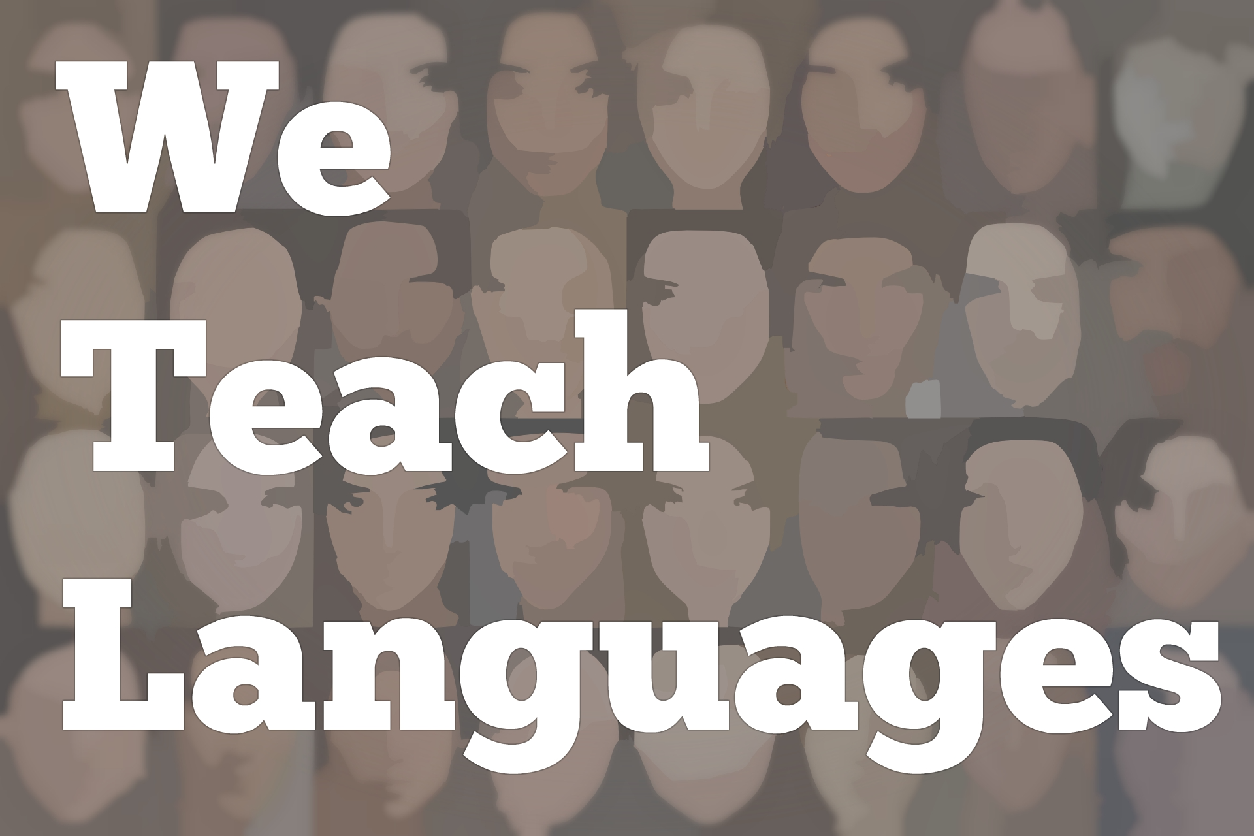
We Teach Languages Episode 144: Turkish German, Immigrant Authors, and Afrofuturism in Germany with Priscilla Layne
[0:00] [background music]
Stacey Johnson: [0:00] This is "We Teach Languages," a podcast about language teaching from the diverse perspectives of teachers.
[0:06] I am Stacey Johnson, and today on episode 144, I get to share an interview I conducted with Dr. Priscilla Layne, all about her work, teaching German, and specifically a course she teaches on Turkish German, and the research she conducts which involves immigrant authors writing in German, and Afrofuturism.
[0:36] A really fun episode, and for those of you who teach German, there are also a lot of resources that Dr. Layne mentions, and that we've linked in the show notes for those of you who are interested in finding more avenues for including diverse representations of German and Germany for your students.
[1:01] To get started, I am going to ask our guest to introduce herself and tell us a little bit about who she is and where she works.
[1:10] [background music]
Dr. Priscilla Layne: [1:15] My name is Priscilla Layne. I am associate professor of German at the University of North Carolina in Chapel Hill. I teach primarily German language and culture, usually focusing on the 20th and 21st centuries.
[1:31] When I teach language, it tends to be third year and up, some more advanced language classes. In terms of culture, sometimes I'll teach literature and film in German, so like I have a class on Turkish German culture. That's in German.
[1:46] I also teach several classes in English, so teaching text and translation or film classes is like ways to get students interested in German who might not have considered taking the language.
Stacey: [2:00] I am sorry. I have to get off track from our plan already. Turkish German class sounds amazing. Can you tell me [inaudible] ?
Dr. Layne: [2:09] Sure. I'm trying to think when I even became interested in Turkish German culture. Some point in grad school, my doctoral advisor, Deniz Göktürk, works on Turkish German culture, and the text really spoke to me, possibly, because I come up from a family of immigrant.
[2:28] My mother and father both immigrated from the Caribbean. My mother immigrated from Barbados, my dad immigrated from Jamaica. I was the first one in the family born in the US.
[2:39] Growing up, I struggled with a lot of questions about identity. I wasn't Caribbean enough for my family. I was an American enough for the [laughs] kids. This feeling kind of in-between. Then as a teenager, I got drawn to punk music, something rebellious because I was tired of the norms and just wanted something different.
[3:02] When I first read Turkish German text, so some of my favorite authors are Emine Sevgi Özdamar and Feridun Zaimoğlu. When I first read their texts, I think they really spoke to me, because they thematize the immigrant experience, but not in a clichéd way. In their text, immigrant is not a victim. There's someone who has a sense of self, who's looking to explore, who's courageous.
[3:29] Going to a different country for the first time is courageous regardless of how much you speak the language. It's a big thing to go to another place. I think that's what first attracted me to Turkish German text, but then, more generally, in my research, I've always been interested in German national identity.
[3:48] What does it mean to be German? How to German see themselves? How does that change over time? Working on Turkish-German culture helped me build on to that. For my class, my class I was excited about...In order to develop it, I got a grant from the Center for Middle Eastern Studies that allowed me to go to Cologne to this archive.
[4:10] There's this archive called DOMiD. I can't remember the full acronym -- [Deutsch] . It goes along those lines. It's a center that collects all these materials on postwar immigration, the experience of guest workers. I was able to get the rarest interesting texts, primary sources, quotes from guest workers, talking about their experience, novels, and poems.
[4:40] The class I was able to develop was exciting for me because basically, we started in the early '60s, talking about Turkish guest workers coming to Germany as part of new contracts. Then looked at how different generations change over time and how Germans interacted with these immigrants.
[5:03] How the presence of Turkish Germans have changed the way Germans see themselves or maybe people have to renegotiate what it means to be German. That's a really fun class for me to teach. I'm always shocked because I realized now that when I advertise the course, most students see Turkish German. They have no idea [laughs] what I'm talking about, which is weird.
[5:25] Because someone who works on German studies or goes to Germany a lot, Turkish Germans are, I think, the largest minority group. They're very present. You know they're there. For a lot of American students who maybe haven't traveled to Germany or don't know much about German culture, it's just a whole new category they've never thought of.
Stacey: [5:47] Why do you think so many people, including people who studied German, might be unaware of the diversity that exists in Germany? I can't parse why we'll see Germany is such a monolith.
Dr. Layne: [6:03] German teachers are in a tough position to try to get more students involved. German has this reputation of being a hard language. It's hard. People think of World War II, and it's strict. There are all these negative connotations.
[6:21] Maybe during the Cold War or in the early 20th century, it was more practical, but nowadays, Spanish is super important if you live in the US. There are a lot of Spanish speakers. French could be really important with people, refugees or immigrants, who come and are French-speaking.
[6:41] German, I think, in terms of the practicality of it isn't often thought of. Germany is very important in the EU. If you're interested in politics and maybe working on policy, German could be a very useful language. For that reason, often German teachers reliance certain stereotypes to make it seem fun.
[7:04] Everybody thinks of soccer, or they think of beer, pretzels, or something. That gets students excited. It's fun, but it's the same old image. Yeah, it would be really great if teachers break away from that and try to incorporate different elements of the diverse society that is Germany.
[7:27] Another thing is, I think a lot of German programs are in areas where you have traditionally heritage speakers if you're in the Midwest, if you're in the Northeast.
[7:37] Sometimes, when these communities were either people who are related to German immigrants who came over 100 years ago or communities where they're German people who maybe came 50 years ago -- I've been living in the US for a while --sometimes they can have a conservative view. They want to preserve. It's about preserving heritage, and they may be a little more resistant to changing.
[8:03] I would hope that moving forward, we can find a way to update the image of what Germany is. Definitely, if you go to a big city nowadays, it's nothing what I expected when I first went. I expected to see people walking around and later hose in because that's what I saw in the media when I was a kid.
[8:25] It is the responsibility of teachers to update that image and just let students know Germany is a lot more colorful and complicated than it is often portrayed.
[8:38] I would also say that there is a movement within language teaching, as they say, to stop fetishizing the native speaker, to stop upholding the native speakers. This is the perfect example, and you want your German to sound like that because the reality is that most students German is not going to sound like the native speaker.
[9:01] Those of us learning a foreign language, we all have our little accent, and that doesn't mean we can't be understood. Immigrants in Germany who lived there, let's say, 40 years and speak perfect grammar but have an accent. Why should we belittle those people? Why should we look down on that?
[9:21] There's a textbook offered online that I really like. It's called "Grenzenlos Deutsch," an initiative between several female faculty members who belong to the organization of women in German. They took this feminist approach saying that we're going to create a textbook. That's open-access, available online.
[9:45] Another thing they said was, "We're not just going to focus on Germany. We're going to look at Austria, other German-speaking countries, but also we're going to record non-native speakers speaking dialogues for our students." I just think that's wonderful because yeah, let's embrace everyone who speaks the language and not just people who are native speakers.
Stacey: [10:06] I genuinely can't imagine what my life would be like if it weren't for all of the non-native English speakers that I [inaudible] , get to hear their accents, and get to enjoy everything that they bring to my life.
Dr. Layne: [10:21] I understand that it can be a little scary if you introduce a dialect that you don't feel comfortable explaining to students. I know when it comes to Spanish, all over Latin America, there are different variations that you may not necessarily be familiar with. In terms of Turkish German, some of the authors drop in Turkish words. [laughs]
[10:44] I took two years of Turkish because I wanted to become fluent. I haven't made it yet. Even if you have no Turkish background, just googling, looking up the word, or reaching out to someone who does know some Turkish or can explain it. I would say, "Don't be afraid." You can be honest with students. "I'm not sure what they mean here."
[11:08] I've actually worked with high school teachers in Germany who wanted to say teach a hip hop text in English. They hired me to explain this thing to them. That's the thing. There's all kinds of lingo.
[11:24] Instead of being afraid because you can't explain every single word, maybe just flip the classroom, have students guess, "What do you think this means? Be open to making mistakes and not knowing everything.
Stacey: [11:40] That's fantastic. It really also honors the community that the text comes from. I'm imagining a German high school teacher teaching a hip hop text, and saying to their students, "This is a community I'm not a part of, and they have entire linguistic norms and tools that I don't have access to yet, and so I don't know everything."
[12:00] This is something I'm aspiring to and honor the community where this coming from as using tools that not everyone has access to. I love that.
Dr. Layne: [12:10] Yeah, I agree.
Stacey: [12:13] I also wanted to ask you about your research because I got so excited just reading about your research online. I wanted to ask you specifically about your current context. What are you working on right now?
Dr. Layne: [12:25] I usually have many, many irons in the fire. I have a lot of interests, and I have a hard time saying no, [laughs] which can be really a problem. I would say the main thing I'm working on right now is my second book, which is on Afrofuturism, so Black German Afrofuturism.
[12:42] It's a book. It's a project that came out of my first book. It developed very organically. I feel almost steamrolled by it because I finished my first book and all of a sudden I was knee-deep in this other book.
[12:58] Basically, in my first book, the final chapter, I look at poetry by this Black German author, Philipp Khabo Koepsell who writes in German in English. He's German and South African. He's lived in South Africa. He is very engaged in issues of post-colonialism, race, etc.
[13:19] I noticed that in some of his more recent palms, there was a lot of unusual imagery of space, technology, and aliens or something. I was just like, "What is this" [laughs]
[13:32] The word Afrofuturism just appeared in...It just materialized in my mind. I was like, "I know I've heard this before, but I'm not really sure what that means." I would say the past five or six years has been this journey of me really digging into looking at the origin of the word and the history like what has happened since, what are the authors, what's the music, the art?
[13:57] The cool thing about Afrofuturism is it's just multifaceted. It's science fiction. It's speculative fiction. People writing about technology and blackness. It's film. It's painting and sculpture. It's a lot, and sometimes it's still overwhelming, trying to keep on top of debates about it.
[14:20] What made me interested in this topic was most of my work deals with looking at the representation of people of color in Germany, other Black Germans, Turkish Germans. It's often a very, very tragic material because racism happens -- racism, Islamophobia, discrimination against people based on their citizenship status. That happens.
[14:48] When I found these texts that I described as Afrofuturist, what was different was I felt like there was more room for hope because it's a lot about imagination. It's like, "What could Germany look like in 2050?" or, "What would it look like if we went to space?"
[15:06] One of the things that's fun about it is a lot of these authors, they draw on American tech, like Octavia Butler is pretty well-known in the Black German circles interested in Afrofuturism. One of Butler's books, "Dawn," she imagines this post-apocalyptic setting where Earth has been destroyed, I think, by nuclear war, and a few humans have been saved. They're on the spaceship.
[15:33] This alien race that saved them has three genders -- male, female, and a neutral non-gender. In order to procreate you need all three. She wrote this in the '70s, so that's amazing to think about that and how that relates to current debates about gender, transgender and non-binary.
[15:57] I feel like one of the things that Black German artists do is...Part of what's so freeing of Afrofuturism is you don't just imagine what could this be in the future, but what if we had five genders? What if we had this or that? For me, it's freeing, because a lot of our problems when it comes to racism is that we don't think of different solutions.
[16:25] I feel like this really resonates with what's going on right now with the police brutality because we hear the same solutions, "Oh, body cams. We will have them found more reports. We'll have them do different training." It's kind of more of the same. It doesn't change instead of saying, "OK, none of that is work. What can we do completely differently?"
[16:46] That's what Afrofuturism challenges us to do. If you could imagine any world, what world would you want, and how do we get there? That's primarily what I've been working on right now.
[16:59] The book is about Black German narrative and performance on the stage that either engages with sci-fi, speculative fiction, or fantasy in order to critique racism in Germany and imagine different futures. [laughs] I can't wait to be finished, just so it can be published.
Stacey: [17:23] It sounds amazing. I'm honestly such a huge fan of science fiction and Afrofuturism writing specifically that I'm pretty sure going to pick up your book to learn more about. It's in English right?
Dr. Layne: [17:36] Yeah, it's in English.
[17:37] [laughter]
Stacey: [17:37] I'm super excited about that. I wanted to tie it in. Recently, we've had a couple of episodes. In episode 141, Vijay Ramjattan said, "Your teaching is your activism." In episode 142, Jonathan Rosa said that we can imagine new ways of education. We don't have to reproduce structures that we've been doing all along.
[18:08] What I'm hearing from you, for me, just really tied those two things together. If the natural conclusion of my teaching is my activism, and I don't have to reproduce the same structures I can imagine something new, and you're telling me what Afrofuturism is, those are the people who are doing the imagining.
[18:27] If I, as a language teacher, can't imagine what things will look like, how it could be different. There are actually authors and artists out there already doing the work of imagining a better world, and I can apply those lessons. I own teaching. What you just talked about really rounded out for me something that's been a common theme on the podcast lately.
Dr. Layne: [18:51] Oh, no, that's neat. I'm glad. All the statements that you mentioned from the other interviewees, I agree with. I especially liked that idea your teaching is your activism because I like to think of it in that way. I am a very politically minded person, but I'm an introvert. [laughs] I'm shy, so I tend not to be out.
[19:14] I always think that if all I can do is to open my students' minds, maybe one of them, we'll later on in life do something great to help our society that I'm really proud that I can do that.
Stacey: [19:28] I think that just thinking about the sheer volume of humans that you have coming through your classroom every year and experiencing Germany from just a new perspective, seeing a new way of looking at something that they already love. That is going to have a huge cumulative effect on your community and on the students you have contact with.
[19:50] I really appreciate your work, and I'm so grateful for you sharing insights with us today.
[19:57] The last thing that I wanted to ask you is, if you have any resources, if there's German teachers who are teaching the first couple years of the language, and they are looking for resources to maybe include more of these kinds of issues around racial and ethnic diversity in Germany or amplifying voices that are outside of that stereotype, do you have resources you can recommend for us?
Dr. Layne: [20:21] Yeah, I would say if they want to look into Black German organizations and activism, some groups they can look up one is called The Initiative. Initiative, I try to mention in Deutschland, so ISD. Another one is called Each One Teach One, often shortness EOTO, so E-O-T-O.
[20:44] In terms of issues of police brutality, there's an organization. I have to double-check the name of the organization, but it's named after a man who died in a prison in Germany. His name was Oury Jalloh. It's O-U-R-Y J-A-L-L-O-H. There's an organization in his name dealing specifically with police brutality.
[21:12] In terms of texts, there's actually a play written by a Black German that deals with racial profiling within a broader story about...It's about two Black German siblings, who go to Nigeria for their father's funeral. There's all kinds of conflicts going on. Their Nigerian family feels like they're too German.
[21:38] They have a hard time integrating into that life in Nigeria, but they also feel alienated from Germany based on their experiences with racism, and then one of the siblings encounters racial profiling on a train, gets arrested, and takes the police to court, which is actually a short scene in the play, even if they just want to deal with that scene.
[22:01] Interestingly, that plays written in English. This is a Black German author, Olumide Popoola, who lives in London, and she prefers to write in English. She told me, partly because it gives her a broader audience, but also because I'm working on the topic of racism. A lot of the theory she's read, the texts are in English. It's easier for her to write in English.
[22:24] One of the things I definitely want to convey to German teachers is that I often feel...Because of, say, a Black German in Texas in English, they'll feel like, "Well, that's not appropriate for the German classroom. It has to be in German." I say, "Why does it have to be in German?"
[22:40] You could have students translate it from English into German. There are other activities you could do with an English text. To me, what's more important is this is a text that tells us about the lived experience of Black people in Germany. For me, it's a German text regardless of what language it's in, and just try to be creative and find ways that students can use it.
[23:06] Philipp Khabo Koepsell who I mentioned. If they Google him, he's done spoken word. He has some videos on YouTube. I can maybe send you a link if you want to share it. That's another way and something else you can do in the classroom. He has poems in German and English. Some have both languages. I think that's a really fun exercise.
"[23:29] Why does he switch to English here? What's going on?" I definitely want to drive home the idea that don't be afraid to use something in English in your classroom. Just find creative ways to convey. Students will understand why it's relevant for Germany, but just find other ways to get the language practice if you happen to use an English text.
Stacey: [23:53] It's fantastic. I love that. I'm a really big fan of showing students what real actual language use looks like. Real and actual language uses often bilingual, multilingual, all mixed up together. I want that advice.
Dr. Layne: [24:09] There's also a ton of films that [inaudible] . There's a short film that most people know pretty well called "Schwarzfahrer." There's a film called "Kleine Freiheit," which I think deals with a friendship between a Black child and a child of Middle Eastern descent who are friends in Germany and dealing with drugs and violence.
[24:33] There's film by a Black German director called " [indecipherable] ," that deals also with disability, people who are losing their sight, and relating back to racism. Teachers should just try to draw through different materials, whether it's text, music, spoken word, film. There are a variety of resources out there.
Stacey: [25:01] Also, they're really going to have to seek out those resources. If they're still imagining Germany the way it was in their German classroom and college or the way it was when they studied abroad, that might not actually represent the reality of Germany the way most people live there.
[25:17] Finding ways to connect with that authentic community, take in all that music, art, culture, spoken word, you share it with your students.
Dr. Layne: [25:26] I would plug that text on "Impuls Deutsch," which does a really great job integrating Black German, German Jewish, Turkish German, German American issues. Impuls Deutsch is this new textbook that was pioneered by Niko Tracksdorf and Steffen Kaupp. Steffen Kaupp is a former student of mine. He was my PhD student.
[25:51] That's how I heard about it. They wanted to have as much diversity as possible, and really, it's just reflecting what Germany looks like -- people who are differently abled, people of color, different religions, people with different citizenship status. They brought on board different experts for the different categories.
[26:12] I worked on the Black German text. They've just done a really wonderful job of integrating everything throughout the entire book. For the whole book for second-year German, you'll have Black German activities scattered throughout.
[26:28] For instructors who want to be more inclusive but don't know how to do that yet, if they can get a copy of the book and think about if it can be useful, it would be a really good first step, kind of [Deutsch] or entry into like, "How do I teach a German that is much more diverse than it's normally portrayed?"
[26:52] [background music]
Stacey: [26:54] This has been an absolute joy to talk to you today. I'm so glad [inaudible] .
[27:00] If you have questions or comments related to today's episode, we would love to hear from you. You can reach out to us multiple ways. All of them are available at our website, weteachlang.com/contact. You can also find us on Facebook and Twitter @weteachlang.
[27:20] We would like to say a very special thank you to the PEARLL Foreign Language Resource Center for partnering with us to provide transcripts and other professional development resources related to the episodes You can learn more about PEARLL by going to pearll, P-E-A-R-L-L.nflc.umd.edu. Thanks so much for listening. Bye-bye.
Podcast transcripts are provided through a partnership with PEARLL (Professionals in Education Advancing Research and Language Learning), a Title VI Language Resource Center at the National Foreign Language Center at the University of Maryland. Find additional transcripts: www.pearll.nflc.umd.edu/podcast

Transcription by CastingWords

