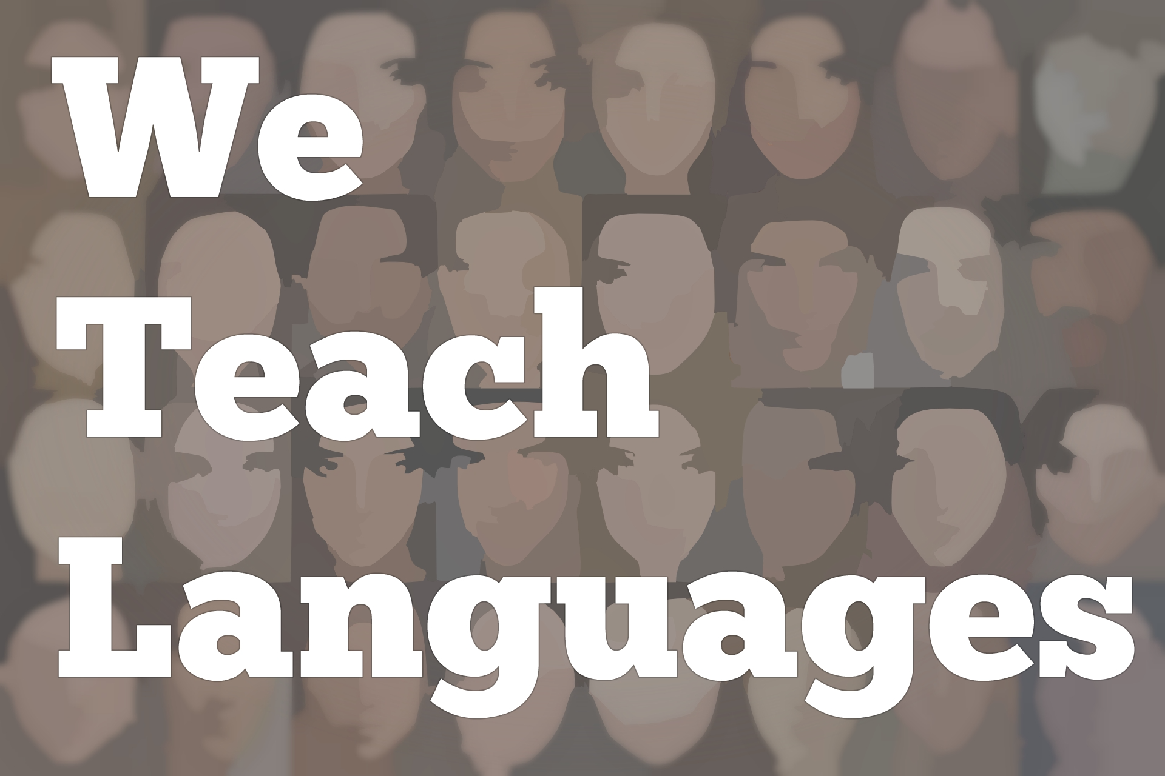
We Teach Languages Episode 23 (rerun): Performance Assessment, Can Dos, and ACTFL resources with Paul Sandrock

Announcer: [00:00] This summer, the We Teach Languages podcast team is taking a few weeks off from producing new episodes to remind you of some of our greatest hits. The episode you're about to hear is a rerun from the first year of the podcast.
[00:14] If you're new to the podcast, this'll give you a little taste of some of the great episodes you can find on our website at weteachlang.com. Now, onto our episode.
[00:25] [background music]
Stacey Margarita Johnson: [00:30] This is We Teach Languages, a podcast about language teaching from the diverse perspectives of real teachers. I'm Stacey Margarita Johnson, and today on episode 23, we get to hear from Paul Sandrock, the director of education for the American Council for the Teaching of Foreign Languages, or ACTFL.
[00:52] I have gotten so much value from being a member of ACTFL over the years. I've used a lot of their resources to develop my assessments and to think through my teaching.
[01:04] I'm really excited to have Paul here today to talk specifically about performance assessments and some of the resources that ACTFL has to offer on that front and just to give his perspective, sort of a birds eye view of what's happening in the field and what teachers can use in their classrooms.
[01:21] [music]
Stacey: [01:26] I'm so excited to be here today with Paul Sandrock of the American Council for the Teaching of Foreign Languages, which is my professional organization. I know many listeners also belong to ACTFL.
[01:39] I am especially excited because ACTFL is going to be here in my hometown of Nashville in November. Welcome, Paul.
Paul Sandrock: [01:47] Thank you so much, Stacey. It's a pleasure to be part of your podcast series and join a wonderful group of educators sharing their views on some really critical issues.
Stacey: [01:59] We have had a really cool bunch of educators. I know that you have a long history in the profession and also just with your prominent role at ACTFL. I'm really excited to hear what you have to say about one of the issues that's been a thread throughout the podcast so far, which is performance assessment.
[02:18] Before we get into that, I was hoping you could tell us a little bit more about your role at ACTFL.
Paul: [02:24] Absolutely. I am the Director of Education at ACTFL, and that means that I get to deal with all things very closely connected with language teaching with classroom. It's the educators from pre-K through graduate level.
[02:41] The projects that I oversee are everything from working on the standards, collaborating around the can-do statements, classroom assessment issues, and curriculum design, program reviews. All of that is part of my work at ACTFL.
Stacey: [02:59] That sounds really exciting. Several of our guests on the podcast so far have mentioned how their teaching has transformed when they began using performance assessment instead of more traditional kinds of tests. I know that you have been working with performance assessment for years.
[03:17] I was hoping you could tell some of our listeners who maybe haven't ventured into performance assessment yet but might be thinking about it, what is performance assessment, and why should teachers use it.
Paul: [03:29] That's really a great question and an excellent way to frame it. It takes me right back to my days teaching Spanish, middle school and high school, and I think about how in my first years of teaching, I was focusing on exactly that, my teaching. I wasn't so focused on the student learning.
[03:53] My assessments were basically a collection of everything that I had taught because I thought I was being as effective as I could be. If I taught it, they should certainly remember it and be able to reproduce it, which is totally not understanding how language acquisition happens.
[04:09] Instead of thinking about my teaching, I needed to be thinking about the evidence in front of me, my students. How are they using what I have coached them on, what I have presented, what we have practiced, what I've been trying to develop? Given that they were only good novices or good intermediates or trying to reach that advanced threshold, what could they do with what they know?
[04:35] That totally transformed my thinking in the classroom. It started me realizing that at the end of a unit or at the end of a semester, it was ridiculous to have my assessment look like every quiz I had already given, every assignment. It was just more and harder and everything that was irregular. It was expecting that they would be able to remember all of that.
[05:04] Again, instead of going back to saying, "Where should they be as a really good novice? Do I have evidence that they're able to use these tools that I've been working on but not as I use them or with total perfection or like a native speaker? Can they be really good novices with the tasks that I would set up or really good intermediates depending on what level I was coaching them toward?"
[05:30] That, to me, transformed my thinking that performance assessment wasn't simply something that happened at the end or outside of my classroom, but had to be consciously in my thinking every single day.
[05:44] It started me moving from just thinking about that as my end of unit or end of semester assessment into, OK, today, what's the evidence that they've acquired some new element in their language performance that's better than what they had yesterday or different from or adding to, expanding what they had yesterday.
[06:07] I started to really think that even my formative checks weren't just how do you and explaining it, but really giving them an opportunity to show, to demonstrate that they could actually use it because that ownership was so, so, so important.
Stacey: [06:25] That's wonderful. If a teacher is just starting to think about performance assessment, do you have any advice for maybe first steps that someone should take to get into it, or do you just jump in?
Paul: [06:38] [laughs] A little bit of both. I think it's almost empowering ourselves as educators to say we all want our students to be able to use language in a real way. We want them to go home and proudly demonstrate what they can do, not just take a piece of paper that has a letter grade or a number grade at the top of it and say to their parents, "This is what I did in school today."
[07:06] It's like "Oh, I had a conversation with..." or "I was actually online looking at this resource and I understood that." That's a performance assessment. It's they're using language for a meaningful purpose. That is part of the transformation that I would say just think in a daily setting, in a unit setting, or at an end of semester or end of year exam type of setting, what would you be proud and what would your learners be proud that they can do.
[07:37] You just start to bring that in as the way that you think about assessment differently.
Stacey: [07:44] We've mentioned the word performance several times, and I know other word that comes up a lot when we talk about performance assessment is proficiency. Some people might have trouble distinguishing between what is performance and what is proficiency. How do those two terms interact? What should we know about those?
Paul: [08:05] To me, it's a continuum. At one end of the continuum is I'm teaching it. I can make sure you know these 10 vocabulary words, how to conjugate this verb, where certain words come in in word order, how you switch things, or how you frame a question. I can teach it. I can check that you understand it. I can focus on that one thing. That is just focusing on the achievement of that very minute little detail of an objective.
[08:36] At the far other end of that continuum is you've just been dropped off in Shanghai, Berlin, Mexico, Martinique, wherever, and you are surviving. You're functioning. Well, somewhere in between is this whole growth of moving from what I taught and making you demonstrate that just in the moment and this big global proficiency at the other end.
[09:07] In my classroom, I'm continually moving you closer and closer towards being ready for being dropped off in that country. I think that's where performance is still within my classroom. It is still going to be within that coaching. It's almost like we intervene. We just don't let it happen -- language learning happened by osmosis.
[09:35] We are strategic in what we do in our classrooms so that puts it not in that pure proficiency at the far end of the continuum where you are fully and absolutely in an authentic encounter. It's also not at the other end where I only want to know do you this word, do you know this form, do you know what a preposition is.
[09:57] It's the in-between piece that we move from just the facts about language to that independent control of language. In between is where the performance lies. It's going to be familiar territory, and it's going to have that aspect of the teacher coaching it. What that does is help the learner rise to a higher level than what they could actually do in the real world because of that familiarity.
[10:28] That builds confidence, and that builds strategies for surviving and being able to make the most of what they know and can do. That's the difference between the two, of partly where is that assessment taking place?
[10:45] That performance assessment is taking place within an instructional setting. Proficiency is fully outside of curriculum, outside of that preparation, but I have to make sure that my work in the classroom, my performance assessments, are leading towards the confidence I need to be able to function in a proficiency assessment.
Stacey: [11:11] That's excellent. One thing I love about some of the resources that I've used from ACTFL also is, makes the alignment between my performance assessment and my desired proficiency levels for my students really clear.
[11:26] I can tell my students that we're shooting for a specific proficiency level. I'm going to measure their performance as we go along, using the same terminology. It gets us all on the same page.
Paul: [11:36] Absolutely. Let me just add another thought on that idea, Stacey. That is that every proficiency rater and trainer around proficiency will talk about getting "thick" at a level. Getting the wide, the width, the breadth at a level.
[11:54] It's not always this linear sequence, like I move quickly from novice high to intermediate low to intermediate mid to intermediate high to advanced low. It's like, that cone gets wider and wider and wider, which means I need more experience at a level before I am fully comfortable to function independently at the next higher level.
[12:14] I think about that in my classroom. I say, "OK, my second-year high school class, I'm really trying to get you being able to function sometime even more independently at intermediate low." That's my range.
[12:26] When we work on a unit, if we've spent two months on one topic, I'm getting you pretty comfortable within that topic, and your performance is rising to the height of that range. When we start the next unit, the next topic, suddenly, that familiarity is gone, and you drop down to more like that novice.
[12:47] You're not functioning like that intermediate low anymore, from novice high to intermediate low. I need to go through unit after unit, and each time, your performance stays at a little higher level, and doesn't drop down quite as much. That's an important concept, what you were alluding to as well.
Stacey: [13:06] I have used, for myself and also with my method students in my teacher methods course, we use the "Implementing Integrated Performance Assessment" book through ACTFL. We get a lot of value out of it, just the examples, the testimonials from teachers, and the rubrics.
[13:25] It just gives us a really clear road map for how to create summative assessments using the IPA model. I was wondering if you could tell us about some resources ACTFL has, in addition to obviously that one, to help teachers get started or deepen their knowledge of performance assessments for their own classroom.
Paul: [13:43] Thank you, yes. What I find is that we need more examples and discussion of the design of those kinds of assessments. It's just really to start to change our mindset, as I was saying earlier, from just thinking about, "I'm testing you on what I taught, and therefore, my summative assessment has to be everything I taught," to, "I taught you a lot of tools."
[14:12] It might be vocabulary. It might be grammatical structures. It might be language functions. You've learned how to ask questions. You've learned how to describe things. You have all these tools. In my assessment, I don't need to trick you into showing that you have mastered every single one of those tools.
[14:29] I just need to give you a real motivating, engaging opportunity to try to use all those tools to be successful in accomplishing the task. That, to me, is at the heart of the performance assessment. The integrated performance assessment simply says that each mode can build on the other modes.
[14:51] I might start out with just a brainstorming conversation with someone on a particular topic, and we're sharing the way that topic impacts our lives. Then perhaps we do, in effect, research -- maybe we read an article, watch a video -- to get more information.
[15:10] I show what I learn from that, and then I may put it together in a response on a blog. I have that interpersonal task, an interpretive task, and a presentational task, all on one topic.
[15:22] Some of the resources to help with that are some of the virtual learning modules that ACTFL has that will lead people into deeper thinking of some of the criteria to keep in mind as we are designing tasks, as we're thinking about how to evaluate them, some examples.
[15:39] That's what I find are the most powerful are simply a lot of different examples. This is what we do in a lot of the workshops that we do. The publications that we sponsor are certainly wonderful resources as well.
[15:54] I would highlight "The Keys to Planning for Learning," now coming out in its second edition, which provides an excellent template for doing both lesson and unit design. Again, going through the thinking of, how do I design appropriate formative and summative tasks at a unit level and even formative at a daily level?
Stacey: [16:17] That's excellent. I would love to provide some links to the listeners to the learning modules and some of the publications. Maybe you can help me get my hands on some links that we can fit in the show notes for folks.
Paul: [16:33] Absolutely. An easy way to access all of these resources is at our website. It is actually to go to the Assessment and PD tab, because that's where all of the professional development resources are. You will see a link in one of the dropdown menus to the virtual learning modules. You can open that up and look at the variety of different modules in the learning catalog.
[16:59] You will also see in publications -- you can access the books that are in our bookstore there. Under the guidelines and manuals, you will have the link also to the can-do statements. The can-do statements, as you know, are under revision and are about to be released, which is very exciting.
[17:19] The can-do statements provide an excellent set of examples of what would performance look like in each of the three modes of communication, as well as a new addition around intercultural communication.
[17:36] How do I investigate and how do I interact using language? It's where language meets culture, to really develop that attitude of being that cultural intermediary in interculturality.
Stacey: [17:47] That's excellent. I'm a big fan of the can-do statements, and I can't wait to see the revised version.
Paul: [17:55] It's going to be really exciting to see how that plays out in deepening our understanding of how these can come into our unit planning, our daily thinking as well, and our assessment design.
Stacey: [18:09] I am incredibly grateful for the time you've taken today to walk us through performance assessment. ACTFL has been such a huge part of my professional growth over the last 17 years that I've been a teacher. I'm just really excited to have the chance to talk with you and share resources you've shared with me today with listeners.
Paul: [18:30] This is great. Stacey, thank you so much, and to all of your listeners, too, thank you so much for trying to take on the task of redesigning our assessment. We know in the end it's going to pay off for our learners. I think it's amazingly motivating and engaging to think about performance assessment.
[18:49] Thank you so much for the time.
Stacey: [18:51] It was my pleasure.
[18:52] [music]
Stacey: [18:55] As we build up to the ACTFL convention in November, which, by the way, is going to be in Nashville, which is where I live and work and also in my home state so I'm really excited for everyone coming to Nashville, we've gotten a lot of questions here at the podcast about can we go into a little more depth about what performance assessment entails, maybe some resources for those of us who are a little further along and would like to deepen our knowledge.
[19:24] If you are one of those people who's either getting started with performance assessment or would like to deepen your knowledge of performance assessment in your language classroom, I would encourage you to go to the show notes, click on some of those links, and explore what ACTFL has to offer in that arena. I've used quite a few of those resources myself and have found them just really beneficial.
[19:42] I also think that for those of you who are going to the ACTFL convention in a couple of months, it's going to be an unbelievable opportunity just to network with other people who are sort of on the same path you are, maybe mentor people who aren't quite as far along that path, or get mentorship from people who are a little further along, to do some networking that you can expand into an online professional community after the convention is over, and just generally think through or talk through our practices with other people who know exactly what it's like to be in your position.
[20:16] [background music]
Stacey: [20:17] I can't wait, and I look forward to meeting many of you there as well.
Announcer: [20:23] If you would like to comment or give feedback on the show or be a guest on the show yourself, let us know. You can find us on Twitter @weteachlang, you can comment on any of the episodes on our website, or you can send a text message or leave a voicemail on our Google voice number, which is (629) 888-3398.
[20:46] If you leave us a voicemail, we may even play your question or comment on the air. Don't forget to tell your friends and colleagues about the show. Thank you so much for listening. Bye-bye.
Podcast transcripts are provided through a partnership with PEARLL (Professionals in Education Advancing Research and Language Learning), a Title VI Language Resource Center at the National Foreign Language Center at the University of Maryland. Find additional transcripts: www.pearll.nflc.umd.edu/podcast
Transcription by CastingWords

