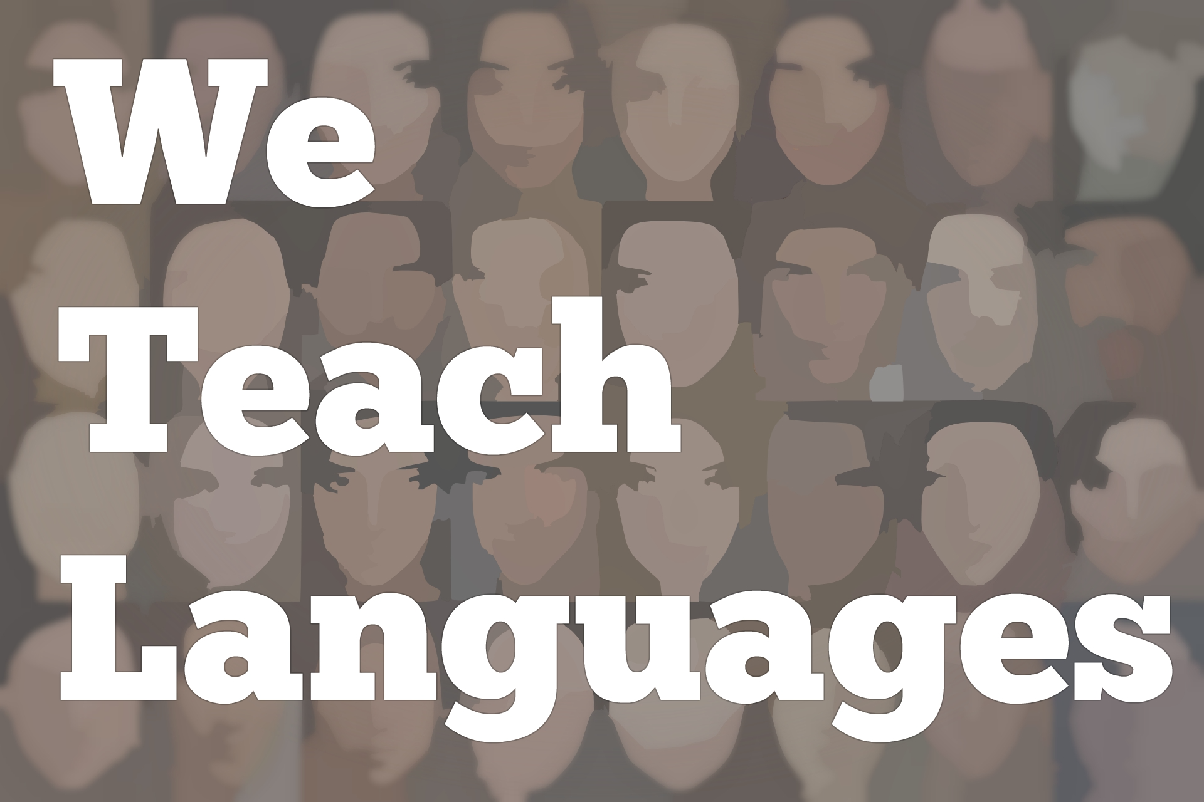
We Teach Languages Episode 96: Language Learning through Digital Games with Jonathon Reinhardt
[0:00] [background music]
Stacey Johnson: [0:00] This is "We Teach Languages," a podcast about language teaching from the diverse perspectives of teachers.
[0:12] I'm Stacey Johnson. Today on Episode 96, Meghan McGinley interviews Jonathon Reinhardt about the relationship between learning and play, specifically, the practical and theoretical relationship between language learning and digital games.
[0:32] [music]
Meghan McGinley: [0:36] We're here today with Jonathon Reinhardt, associate professor of English applied linguistics and second language acquisition and teaching at the University of Arizona. Thanks for joining us today, Jon.
Jonathon Reinhardt: [0:50] Thank you, Meghan. I'm excited to be part of your broadcast.
Meghan: [0:54] Your most recent book, "Gameful Second and Foreign Language Teaching and Learning -- Theory, Research, and Practice," published less than a month ago, is a wonderfully informative guide that ties together game literacy and its effective proxies both inside and outside of the classroom.
[1:13] Before we launch into specifics about your new book, I'd like to take a moment to discuss your teaching context, your students and your work at the University of Arizona.
Jonathon: [1:25] My background is as a language learner. Long ago, I was a German major. Then I discovered linguistics. I took French and Japanese. I loved language learning and I traveled. I loved international travel. I learned of the field of TESOL while I was abroad. I decided I would go on and get a master's in applied linguistics.
[1:50] Then I taught in Japan for a few years -- five years. Then I taught in the US in Chicago in intensive English programs. Then the Internet happened, and technology happened. All along this time, digital games were around. I played some as a kid. Not too many.
[2:10] As I got into computer-assisted language learning and technology, I saw the potential of technology to motivate learners of languages to engage them. Games seem to have this, I don't want to use the word magic, but it seems almost mysterious ability to engage and actually teach and involve a learner in learning the content about the game.
[2:41] I got my PhD in applied linguistics. It's funny. I told the story after I successfully defended my dissertation. My dissertation director, Steve Thorn, handed me a copy of World of Warcraft and he said, "Jon, we have to play this game together and see what happens, and see how language is used and how language learning..."
[3:01] He was so excited about it. I was like, "Thank goodness. I've just defended my dissertation successfully. Let's play." I got into it very much. Julie Sykes was with us. We played as a team or a guild in World of Warcraft. This is maybe 12 years ago. From there, games and learning just hooked me.
[3:23] Right now, I am a professor in the English department, but I run the MA and Teaching English as a Second Language program. I also work in the PhD program in second language acquisition and teaching. I have students coming through who have various interests in working with games and technology, and we work on different projects together.
Meghan: [3:43] As a doctoral researcher in the domain of literary and cinematic game and play, one of the prevailing narratives that I've come up against is the idea that ludic spaces are fundamentally incompatible with productivity. This, in turn, gives way to the common misconception that play, in a larger sense, is antithetical to work. Yet, as Richardson development shows, this is largely misstated.
[4:12] What does your research tell us about the false dichotomy between work and play? What are some ways in which digital game usage in second and foreign language teaching helps to unravel this narrative?
Jonathon: [4:28] Boy, that's such a big question. It's so interesting too. It's something I think a lot about because we have to understand that...I get into this in my book. Thinking about how play is related to learning and how play is related to culture, and how, by some accounts, if you look at some of this research in sociology, philosophy, and history, all over the place. Definitely in the learning sciences.
[4:54] This idea that play and learning go hand in hand. All you have to do really is observe kids when they're playing and see how play comes naturally. Play involves all of these elements of mimicry, of competition, of things that are really fundamental to our culture. Some theorists think that play actually gives rise to culture and that it's a key element to it.
[5:23] In terms of why do people think that play is unproductive, in this attempt to define what play is, we use frameworks and theories that are around us. Play must be opposite to work because play is something that children do and work is something that adults do. Play is fun and work is not fun.
[5:46] You have to wonder, well, maybe the problem is that work is not fun. When work really became a central part of our lives in the past, this idea that somehow we needed to take the fun out of work in order to make it work better, in order to make it function better.
[6:07] I do think there's some historical connection there. I don't think in the past, before the industrial revolution really, that people necessarily thought of productive activity as not being playful. If you want to talk about productive activity as being restorative or generative, it certainly is in many ways.
[6:31] If we want people to work hard and keep working, we have to somehow separate play from that working activity in order to make them even more productive. There are historical and cultural reasons why we think of play and work separately, but if we just look around us at how kids learn, how we ourselves learn when you think of language, language learning...
[6:56] I come from a background, my parents are singers. They're musicians, and they would sing in different languages. Playing always involved singing in different languages. I got into the joy of making new sounds and listening and hearing new fun sounds. You think of language play and how important that is. There are theories that look at how important that is to learning processes.
[7:22] If we really look at how learning happens and what's important to learning, especially in language learning, we know as teachers and as learners that taking a playful perspective or a playful, what I call in the book a gameful attitude towards learning it, can actually be helpful and actually be productive.
[7:42] I could go on forever talking about this topic. [laughs]
Meghan: [7:45] It's really fascinating. To hear that your parents were musicians. As a classically trained musician myself growing up, one of the points that you bring up in your book is this idea of repetition for mastery. Not holding any clout. As a musician, I know you master things through repetition.
Jonathon: [8:07] Exactly.
Meghan: [8:07] So, games really help us go back into this realm where we use them in order to master, if you will, our language skills.
Jonathon: [8:17] And become familiar with them and internalize them and make them our own. Right now, I'm trying to learn Spanish. I'm older. It's definitely more of a challenge than it was learning a language when I was in college. One of the things I'm trying to do is just have fun making the sounds over and over again. Learn music, learn songs, learn poetry, learn rhymes.
[8:42] Just say things for the sake of saying them, even if I'm just saying them to my dog. Just practicing. Just getting it out there and saying it over and over again, and trying to become familiar and comfortable with it and make it part of me. That's the gameful or playful approach or attitude that we need to bring into language learning, for sure.
Meghan: [9:06] I absolutely agree. One of the overarching issues of developing game-based environments, that's to say games that are specifically designed for language learning, is the "chocolate-covered broccoli syndrome."
Jonathon: [9:22] [laughs]
Meghan: [9:24] How can we avoid this chocolate-covered broccoli syndrome? How does it relate to the overall long-term commercial viability of game-based environments?
Jonathon: [9:36] The chocolate-covered broccoli idea is...If you don't think that kids dislike broccoli...That's a Western idea. When I was in Japan and teaching, I would try to use the idea of broccoli to learn I like, I don't like, and all the kids would like, "Oh, I like broccoli." I said, "Wait, what?" There's a cultural aspect there we need to consider.
[9:57] The idea of chocolate-covered broccoli is oh, here kid. Have a piece of candy. They're like, "Oh, great. Chocolate. I love it." They bite into it, and they realize that it's actually in disguise, it's broccoli, which they don't like which is healthy for them.
[10:14] Educational games, traditionally, have really suffered from this problem in that the designers have to balance the learning goals, the needs for these learning objectives to be met, and entertainment. Terms like edutainment have been invented to try to hit that balance. I think the problem is that you're trying to fool the player. You're trying to fool the kid and not be honest with them.
[10:42] What I say in the book and what I advocate is to promote this gameful disposition or this literacies about what gaming is and how gaming works and how we need to take agency and control. If we're taking control of our learning, we have to recognize that part of the goal of playing in the game is going to be to learn something as well as to have fun.
[11:07] To deal with it, it's important when we're working with games, if they're educational or they're commercial off the shelf or that kind of games, to be honest with the players and the learners upfront, and say look, while you're playing this game, what is your purpose in doing it.
[11:23] Are you going to accidentally learn something? Let's say, this is a good game for learning this kind of language, [inaudible] language, a certain set of vocabulary, and one of your goals will be to learn the language.
[11:37] If we're honest with students, if we give learners the agency to take control of their own learning by saying yes, there's broccoli, but there's also chocolate. Both of them are part of why game-based learning can work.
[11:53] This is an important thing for designers of game-based learning environments to recognize, to be honest with the learners upfront. Let them know what the goals are, allow them to set their own goals. Give them options.
[12:06] Make sure that there are fun elements in it as well, and don't necessarily worry about having all the fun elements necessarily be perfectly connected to every single learning outcome because maybe one of the goals is to promote enjoyment, to engage the learners.
[12:24] Then think about having meta-level discussions about gaming and what gaming is, what a game is, why games are fun. Can games teach and how can they teach? Is this a way that you think you could learn a language by?
[12:42] Especially with high school age, college age, and adults, this can work well, but even with kids. Developing the kid's gaming literacies can help them then approach any kind of educational game or even non-educational game with a learnful attitude. That's the term I developed in the book. A learnfulness to balance out that gamefulness.
Meghan: [13:06] There are definitely a lot of transferrable skills when we talk about developing gamefulness and learnfulness. Shifting our attitudes from playing to learn to learning to play.
[13:19] In your book on the theoretical side of game and play, you've employed 20th century French intellectual and sociocultural theorist, Roger Caillois, and his game categorizations from his seminal work "Man, Play and Games." How did his work inform your understanding of digital games in the second and foreign language classroom?
Jonathon: [13:44] I have to say it goes back to Guy Cook's book on "Language Play, Language Learning," which is fantastic book that I read when I was in grad school written in 2000, that really talks a lot about Caillois and how the theory of play can inform our understanding about what is involved in learning.
[14:07] Once I started to read it, I was just fascinated in how can we taxonomize or how can we understand what is involved in play. I started to see parallels between this understanding of competition, mimicry, chance, and what he calls vertigo, but I think of it as upsetting the norm or transformation of these four categories.
[14:36] I looked and actually, there's deeper roots to this that go all the way back to ideas in Greek philosophy and Greek early medicine of the four humors, personality types. You look at Carl Jung's work, you look at some of the famous well-known personality tests like Myers-Briggs. Some of these all have...They're co-relatable. I talk a little bit about it in the book.
[15:01] Then I came across a very interesting game studies scholar named Richard Bartle who developed this player type test. He talks about people being achievers or killers or explorers or socializers. I thought another scholar or a game studies person made connections between his work and then this idea of these four play categories from Caillois, and I thought this is really fascinating.
[15:31] I went even further and found the thing that's multiliteracies framework that the New London Group put together in '96 also has those parallels. Experiential learning by David Kolb, he did that in the '70s and '80s, also has this parallel.
[15:46] I thought this is a great way for us to be able to understand what play is and how it might connect to learning. Then thinking about it in terms of digital games, which Guy Cook didn't talk at all about...I highly recommend that book. It's one of my favorites. He didn't talk about digital games at all.
[16:03] I thought this is now what we're talking about and what we're thinking about. How is learning happening with play in these different ways? When I really started thinking about it, I thought I just wanted to be careful that it wasn't going to advocate the idea of, OK, you're an achiever type, therefore you should play competition games and you learn by setting goals.
[16:26] I wanted to be clear that a lot of the research on play styles and learning styles really shows that in fact, it's a lot more fluid. It's a lot more dynamic than we might give it credit for. When I've done some research, and I've asked students, what kind of game do you play? Then I look at how they actually play games, I see there are big differences.
[16:47] They might say they enjoy sports games, but then they really enjoy interactive fiction, or they don't necessarily like one genre of game but then when we play it in a classroom, then they enjoy it because they're playing for different purposes.
[17:03] The section of my book [indecipherable] a grain of salt. It's important to realize that these are interesting ways to think about play, but we have to take the big picture in mind and understand that play and learning are dynamic ecological processes and we need to not think that there's an easy answer that A equals B equals C. That was some of my work there, but I'm still totally fascinated by it.
[17:31] Then when I found out and I read that J. K. Rowling actually designed the four Hogwarts houses based on these four categories, I just thought...
Meghan: [17:41] Were they really?
Jonathon: [17:43] Yeah. Gryffindor is competition. Chance I think is Hufflepuff. Exploration and mimicry, imitation is Ravenclaw. Then, of course, Slytherin is [inaudible] , is vertigo. They are the secretly evil ones who are going to upset the balance. When I saw that, I was like, "Oh, wow. So many people are thinking about this in ways we may not even be realizing."
Meghan: [18:11] So fascinating. I'm also seeing a link between how you've interpreted Caillois' vertigo as upsetting the norm with potential and VR technologies and digital gaming.
Jonathon: [18:24] Definitely. There's some real potential there for not just learning, not as language learning, but I think different sorts of therapy, also different kinds of learning.
[18:38] There's so much potential for foreign language learning and virtual reality that if we can harness because of that immersive quality that can really transform your experience as you have it. We have yet to discover everything that we can do.
[18:54] The question is will it happen because it's going to be expensive. I don't necessarily think it's going to be as soon as people might like. It might happen in a backwards way. Somebody might develop some other way of interacting and then they realize, this has great potential for language learning. Yeah, it's definitely there.
Meghan: [19:14] My current dissertation advisor, Dr. Lynn Ramey, is working on an immersive environment. She's a trained medievalist. One of the issues that she comes up against is how to engage students with a time period that is completely foreign to them and that they see in television and in films as being so radically different and displayed as dirty and people talk differently.
[19:43] She has developed this immersive environment where it's teaching language, but at the same time, it functions as an RPG where students go in, they learn language, but they also have to perform tasks like putting together a manuscript. You have to go and chop down the tree and process the paper and really teach the students how intensive it was to actually write and learn language in the Middle Ages.
Jonathon: [20:14] That's awesome. That's great. That makes me think. One of the ways that I'm trying to learn Spanish is that I'm watching this TV show. Now that Netflix has opened up so many shows in other languages, one of my favorites has become, it's called "El Ministerio del Tiempo," that's "The Ministry of Time." This is a Spanish series taken maybe from eight or nine years ago. It has its fans.
[20:39] The premise is that basically there is this ministry, this government ministry full of people who have to travel through time to fix mistakes or make sure that things are going the right way. I think, wow, wouldn't that be an awesome game.
[20:53] If I could be one of those time travelers and accompany people on and suddenly I have to go back and make sure that the right person is on the boats that are going to the [inaudible] . I just think, man, there's so much learning there.
[21:10] If I have that framework where I have this overarching narrative which is to save time or to fix time, to make sure that these things don't go wrong and it's this time traveler narrative.
[21:23] Then I think that might give those kinds of little tasks where you have to go in and fix a manuscript or unlock a treasure chest or something that can be really direct language focused might give that some overarching narrative context.
[21:40] There are so many possibilities to combine narrative and gaming and immersion and those things. It sounds like it's a really interesting project. I'm definitely going to keep my eye on that. [laughs]
Meghan: [21:55] There's so much potential. You've mentioned Guy Cook and Richard Bartle. Do you have any other recommendations through suggestions for language instructors who would like to implement digital games in the second and foreign language classroom?
Jonathon: [22:13] The big suggestion that I always have to give people is don't be afraid to play games. Play those games a lot. When you're playing think, wow, how am I using language to play this game and how am I also using my game literacies that I transfer from another context to learn to play the game.
[22:32] What's your favorite video game in English? Play that. Then find the version of it in a language that you'd like to learn and test that out. That's one thing, is immerse yourself in the practice of gaming.
[22:46] Then think about how would students of the target proficiency level of the background that I need to work with, how would they approach this game? Could I do it in the classroom or might it be something that they would do outside of the classroom?
[23:05] Then if you want to do research, when you think about looking at learning in these spaces, we have to recognize that games and the study of games is very disciplinary. There is applied linguistics and second language acquisition and language pedagogy, but there's also game studies and game design.
[23:24] It wasn't until I really started reading some of those works that I really started to make these connections. One of my favorite pieces that really opened my eyes was by Katie Salen and Eric Zimmerman. Wow, that really opened my eyes and I thought, wow, there are people thinking about games in this way. Not necessarily thinking about its connection to learning.
[23:45] But then there's also a lot of people doing interesting work in educational gaming too that isn't really going to be part of your applied linguistics and your language teaching training. Maybe a little bit in your CALL class, but not as much as I think there needs to be if you really want to get into it.
Meghan: [24:02] Jon, thank you so much for such a wonderful, engaging and informative interview. I'll place some of the authors and game designers that you've mentioned in the interview into the notes so people can explore further. Thank you again for joining us.
Jonathon: [24:22] Thanks so much, Meghan.
Stacey: [24:24] We would love to hear your feedback on this topic. You can reach out to us on social media. We're on Twitter and Facebook @weteachlang or on our website weteachlang.com. You can also send us an email, weteachlang@Gmail.com or send us a voicemail or text message to our Google Voice number (629)888-3398.
[24:48] [background music]
Stacey: [24:53] We want to especially thank the PEARLL Foreign Language Resource Center, who has partnered with the podcast to provide transcripts and other resources for the episodes. You can learn more about PEARLL and see everything they have to offer by going to pearll.nflc.umd.edu. Thanks so much for listening. Bye-bye.

Podcast transcripts are provided through a partnership with PEARLL (Professionals in Education Advancing Research and Language Learning), a Title VI Language Resource Center at the National Foreign Language Center at the University of Maryland. Find additional transcripts: www.pearll.nflc.umd.edu/podcast

Transcription by CastingWords

